**ACKNOWLEDGMENTS**

We are grateful to the William and Flora Hewlett Foundation for their generous financial support for this project.

We appreciate the contributions made by our outstanding country experts to the study: Bernice Serwah Ofosu-Badu of Ghana Statistical Service and Ahmed Makbel, Ministry of East African Cooperation, Tanzania.

Contents

EXECUTIVE SUMMARY 9

1. INTRODUCTION 11

2. BACKGROUND 12

3. EMPIRICAL METHODOLOGY 14

3.1 Statistical Matching 14

3.2 Estimating Time Deficits 16

3.3 Adjusting Poverty Thresholds 28

4. TIME AND CONSUMPTION POVERTY OF EMPLOYED INDIVIDUALS 32

4.1 Ghana 32

4.1.1 Gender Differences in Employment Characteristics and Time Poverty 32

4.1.2 Consumption Poverty and Time Deficits 43

4.2 Tanzania 49

4.2.1 Gender Differences in Employment Characteristics and Time Poverty 49

4.2.2 Consumption Poverty and Time Deficits 60

5. TIME AND CONSUMPTION POVERTY OF EMPLOYED HOUSEHOLDS 65

5.1 Ghana 67

5.1.1 Hidden Poverty among Households 67

5.1.2 Single and Double Binds of Deprivation 73

5.1.3 Time Deficits and the Distribution of Household Economic “Welfare” 75

5.1.4 Household Structure and Poverty 82

5.2 Tanzania 98

5.2.1 Hidden Poverty among Households 98

5.2.2 Single and Double Binds of Deprivation 102

5.2.3 Time Deficits and the Distribution of Household Economic “Welfare” 104

5.2.4 Household Structure and Poverty 111

6. THE IMPACT OF EMPLOYMENT ON TIME AND CONSUMPTION POVERTY: SIMULATION RESULTS 126

6.1 Simulation Methodology 127

6.2 Ghana 133

6.2.1 The Impact of Simulated Paid Employment on the Time and Consumption Poverty of Individuals 133

6.2.2 The Impact of Simulated Paid Employment on the Time and Consumption Poverty of Households 142

6.3 Tanzania 148

6.3.1 The Impact of Simulated Paid Employment on the Time and Consumption Poverty of Individuals 149

6.3.2 The Impact of Simulated Paid Employment on the Time and Consumption Poverty of Households 157

7. CONCLUSION 163

REFERENCES 165

**LIST OF FIGURES**

**Figure 3‑1** Threshold Hours of Household Production (weekly hours per household) 21

**Figure 3‑2** Person’s Share in the Total Hours of Household Production (percent) by Sex and Location, Persons 15 to 70 years 23

**Figure 3‑3** Distribution of Weekly Hours of Employment (percent) by Sex and Location, Persons 18 to 70 Years 27

**Figure 4‑1** Distribution of Employed Persons by Area, Sex, and Hours of Employment, Ghana 34

**Figure 4‑2** Hours of Employment and Incidence of Time Poverty: Employed Persons, Ghana (percent) 35

**Figure 4‑3** Average Hours of Required Household Production, by Hours of Employment and Sex: Employed Persons, Ghana 37

**Figure 4‑4** Percent of Total Employment in Each Employment Status by Sex, Ghana 40

**Figure 4‑5** Time Poverty Rates by Employment Status and Sex (percent), Ghana 41

**Figure 4‑6** Average Weekly Hours of Employment and Required Household Production, by Employment Status and Sex, Ghana 41

**Figure 4‑7** Time Poverty Rates by Official Poverty Status, Area of Residence, and Sex (percent), Employed Persons (15 to 70 years of age), Ghana 44

**Figure 4‑8** Average Weekly Hours of Employment and Required Household Production, by Sex and Adjusted Consumption Poverty Status and Sex, Ghana 47

**Figure 4‑9** Time Deficit of Time-poor Employed Men and Women (average weekly hours) by LIMTCP Poverty Status, Ghana 49

**Figure 4‑10** Distribution of Employed Persons by Area, Sex, and Hours of Employment, Tanzania 51

**Figure 4‑11** Hours of Employment and Incidence of Time Poverty: Employed Persons, Tanzania (percent) 53

**Figure 4‑12** Average Hours of Required Household Production, by Hours of Employment and Sex: Employed Persons, Tanzania 55

**Figure 4‑13** Percent of Total Employment in Each Employment Status by Sex, Tanzania 57

**Figure 4‑14** Time Poverty Rates by Employment Status and Sex (percent), Tanzania 58

**Figure 4‑15** Average Weekly Hours of Employment and Required Household Production, by Employment Status and Sex, Tanzania 59

**Figure 4‑16** Time Poverty Rates by Official Poverty Status, Area of Residence, and Sex (percent), Employed Persons (15 to 70 years of age), Tanzania 61

**Figure 4‑17** Average Weekly Hours of Employment and Required Household Production, by Sex and Adjusted Consumption Poverty Status and Sex, Tanzania 64

**Figure 4‑18** Time Deficit of Time-poor Employed Men and Women (average weekly hours) by LIMTCP Poverty Status, Tanzania 65

**Figure 5‑1** Incidence of Household Time Poverty by Area of Residence and Official Poverty Status, Ghana 68

**Figure 5‑2** Average Consumption Deficit (nominal yearly values) of Employed Consumption-Poor Households by Subgroup, Ghana 72

**Figure 5‑3** Distribution of Employed Households by LIMTCP (percent), Ghana 73

**Figure 5‑4** Incidence of Household Time Poverty by Area of Residence and Adjusted Consumption Poverty Status, Ghana 75

**Figure 5‑5** Household Time Poverty Rate (percent) by Decile of the Ratio of Consumption Expenditures to LIMTCP Poverty Threshold, Ghana 77

**Figure 5‑6** Average Weekly Hours of Required Household Production per Household (left panel) and Average Household Size (right panel) by Decile of the Ratio of Consumption Expenditures to LIMTCP Poverty Threshold, Ghana 78

**Figure 5‑7** Household Consumption Expenditures and LIMTCP Poverty Line by Decile of the Ratio of Consumption Expenditures to LIMTCP Poverty Threshold (average yearly values in nominal cedi), Ghana 79

**Figure 5‑8** Monetized Value of Household Time Deficits as a Percent of Household Consumption Expenditures of Time-Poor Households by LIMTCP Poverty Status, Ghana 80

**Figure 5‑9** Household Time Deficits of Time-Poor Households by LIMTCP Poverty Status (weekly hours), Ghana 81

**Figure 5‑10** Monetized Value of Household Time Deficits as a Percent of Household Consumption Expenditures by Decile of the Ratio of Consumption Expenditures to LIMTCP Poverty Threshold, Ghana 82

**Figure 5‑11** Rate of Time Poverty (percent) by Type of Household, Employed Households, Ghana 87

**Figure 5‑12** Average Household Time Deficits and Monetized Value of Time Deficits (as a percent of consumption expenditures) of Time-Poor Employed Households by Type of Household and Consumption Poverty Status, Ghana 88

**Figure 5‑13** Distribution of Employed Households by Type of Household and LIMTCP (percent), Ghana 90

**Figure 5‑14** Time Poverty Rates of Employed Men and Women (15 to 70 years of age) in Married-Couple Households with Children (percent), Ghana 91

**Figure 5‑15** Employment and Required Household Production of Employed Men and Women in Married-Couple Households with Children (weekly hours), Ghana 92

**Figure 5‑16** Incidence of Time Poverty among Employed Husbands and Wives (15 to 70 years of age) in Households with Children (percent), Ghana 94

**Figure 5‑17** Weekly Hours of Required Household Production among Employed Husbands and Wives (15 to 70 years of age) in Households with Children (average values), Ghana 96

**Figure 5‑18** Distribution of Employed Husbands and Wives (15 to 70 years of age) by LIMTCP (percent), Ghana 98

**Figure 5‑19** Incidence of Household Time Poverty by Area of Residence and Official Poverty Status, Tanzania 99

**Figure 5‑20** Average Consumption Deficit (nominal yearly values) of Employed Consumption-Poor Households by Subgroup, Tanzania 102

**Figure 5‑21** Distribution of Employed Households by LIMTCP (percent), Tanzania 103

**Figure 5‑22** Incidence of Household Time Poverty by Area of Residence and Adjusted Consumption Poverty Status, Tanzania 104

**Figure 5‑23** Household Time Poverty Rate (percent) by Decile of the Ratio of Consumption Expenditures to LIMTCP Poverty Threshold, Tanzania 105

**Figure 5‑24** Average Weekly Hours of Required Household Production per Household (left panel) and Average Household Size (right panel) by Decile of the Ratio of Consumption Expenditures to LIMTCP Poverty Threshold, Tanzania 106

**Figure 5‑25** Household Consumption Expenditures and LIMTCP Poverty Line by Decile of the Ratio of Consumption Expenditures to LIMTCP Poverty Threshold (average monthly values in nominal Tanzanian Shillings [TSh]), Tanzania 107

**Figure 5‑26** Monetized Value of Household Time Deficits as a Percent of Household Consumption Expenditures of Time-Poor Households by LIMTCP Poverty Status, Tanzania 108

**Figure 5‑27** Household Time Deficit of Time-Poor Households by LIMTCP Poverty Status (weekly hours), Tanzania 109

**Figure 5‑28** Monetized Value of Household Time Deficits as a Percent of Household Consumption Expenditures of Time-Poor Households by Decile of the Ratio of Consumption Expenditures to LIMTCP Poverty Threshold, Tanzania 111

**Figure 5‑29** Rate of Household Time Poverty (percent) by Type of Household and LIMTCP Consumption Poverty Status, Employed Households, Tanzania 115

**Figure 5‑30** Average Household Time Deficits and Monetized Value of Time Deficits (as a percent of consumption expenditures) of Time-Poor Employed Households by Type of Household and Consumption Poverty Status, Tanzania 117

**Figure 5‑31** Distribution of Employed Households by Type of Household and LIMTCP (percent), Tanzania 119

**Figure 5‑32** Time Poverty Rates of Employed Men and Women (15 to 70 years of age) in Married-Couple Households with Children (percent), Tanzania 120

**Figure 5‑33** Employment and Required Household Production of Employed Men and Women in Married-Couple Households with Children (weekly hours), Tanzania 121

**Figure 5‑34** Incidence of Time Poverty among Employed Husbands and Wives (15 to 70 years of age) in Households with Children (percent), Tanzania 123

**Figure 5‑35** Weekly Hours of Required Household Production of Employed Husbands and Wives (15 to 70 years of age) in Households with Children (average values), Tanzania 124

**Figure 5‑36** Distribution of Employed Husbands and Wives (15 to 70 years of age) by LIMTCP (percent), Tanzania 126

**Figure 6‑1** Actual and Simulated Official and LIMTCP Poverty Rates for Individuals by Region, Ghana 134

**Figure 6‑2** Actual and Simulated Time Poverty Rates of Consumption-Poor Employed Individuals, by Sex, Ghana 136

**Figure 6‑3** Distribution of Job Recipients by Sex and Simulation LIMTCP (percent), Ghana 138

**Figure 6‑4** Distribution of Job Recipients by Sex, Initial Time Poverty Status, and Simulation LIMTCP (percent), Ghana 140

**Figure 6‑5** Distribution of Job Recipients by Initial Time Poverty Status, Initial Job Status, and Simulation LIMTCP (percent), Ghana 142

**Figure 6‑6** Official and LIMTCP Consumption Poverty of Employed Households, Actual and Simulated, Ghana 144

**Figure 6‑7** Simulated Time and Consumption Poverty of Consumption-Poor Employed Households by Actual Time Poverty Status (percent), Ghana 146

**Figure 6‑8** Simulated Time and Consumption Poverty of Recipient Households by Time Poverty Status (percent), Ghana 148

**Figure 6‑9** Actual and Simulated Official and LIMTCP Poverty Rates for Individuals by Region, Tanzania 150

**Figure 6‑10** Actual and Simulated Time Poverty Rates of Consumption-Poor Employed Individuals by Sex (percent), Tanzania 152

**Figure 6‑11** Distribution of Job Recipients by Sex and Simulation LIMTCP (percent), Tanzania 154

**Figure 6‑12** Distribution of Job Recipients by Sex, Initial Time Poverty Status, and Simulation LIMTCP (percent), Tanzania 155

**Figure 6‑13** Distribution of Job Recipients by Initial Time Poverty Status, Initial Job Status, and Simulation LIMTCP (percent), Tanzania 156

**Figure 6‑14** Official and Time-Adjusted Consumption Poverty of Employed Households (percent), Tanzania 158

**Figure 6‑15** Simulated Time and Consumption Poverty of Consumption-Poor Employed Households by Time Poverty Status (percent), Tanzania 160

**Figure 6‑16** Simulated Time and Consumption Poverty of Recipient Households by Time Poverty Status (percent), Tanzania 162

**LIST OF TABLES**

**Table 3‑1** Surveys Used in Constructing the Levy Institute Measure of Time and Consumption Poverty for Ghana and Tanzania 15

**Table 3‑2** Thresholds of Personal Maintenance and Nonsubstitutable Household Activities 18

**Table 3‑3** Threshold Hours of Commuting by Hours of Employment and Location (weekly hours of employed persons, 15 to 70 years old) 25

**Table 3‑4** Hourly Wages of Domestic Workers by Area (nominal amount in national currency) 31

**Table 4‑1** Incidence of Time Poverty by Sex and Employment Status (persons 15 to 70 years of age), Ghana 33

**Table 4‑2** Poverty among Employed Persons (15 to 70 years of age): Official versus Adjusted, Ghana 45

**Table 4‑3** Distribution of Employed Persons (15 to 70 years of age) by LIMTCP and Incidence of Time Poverty, Ghana 46

**Table 4‑4** Factors Affecting Employed Women’s Required Hours of Household Production, Ghana 48

**Table 4‑5** Incidence of Time Poverty by Sex and Employment Status (persons 15 to 70 years of age), Tanzania 50

**Table 4‑6** Poverty among Employed Persons (15 to 70 years of age): Official versus Adjusted, Tanzania 62

**Table 4‑7** Distribution of Employed Persons (15 to 70 years of age) by LIMTCP and Incidence of Time Poverty, Tanzania 63

**Table 5‑1** Poverty among Employed Households: Official versus Adjusted, Ghana 69

**Table 5‑2** Aggregate Annual Consumption Poverty Gap by Measure of Poverty, Ghana (in millions of US$) 71

**Table 5‑3** Distribution of Individuals in Employed Households by Type of Household, Ghana 84

**Table 5‑4** Poverty among Employed Households by Type of Household: Official versus Adjusted, Ghana 85

**Table 5‑5** Poverty among Employed Households: Official versus Adjusted, Tanzania 100

**Table 5‑6** Aggregate Annual Consumption Poverty Gap by Measure of Poverty, Tanzania (in millions of US$) 101

**Table 5‑7** Distribution of Individuals in Employed Households by Type of Household, Tanzania 112

**Table 5‑8** Poverty among Employed Households by Type of Household: Official versus Adjusted, Tanzania 113

**Table 6‑1** Simulated Consumption and Time Poverty Status of Consumption-Poor Employed Adults, Ghana 135

**Table 6‑2** Simulation Job Recipients by Actual Time Poverty, by Sex and Job Status, Ghana 137

**Table 6‑3** Hard-Core Poor Households, by the Composition of Eligible Adult Labor Force Engagement, Ghana 145

**Table 6‑4** Household Time Deficits for Time-Poor and Time-Nonpoor Households, Actual and Simulation, Ghana 147

**Table 6‑5** Simulated Consumption and Time Poverty Status of Consumption-Poor Employed Adults, Tanzania 151

**Table 6‑6** Simulation Job Recipients by Actual Time Poverty, Sex, and Job Status, Tanzania 153

**Table 6‑7** Hard-Core Poor Households, by the Composition of Eligible Adult Labor Force Engagement, Tanzania 158

**Table 6‑8** Household Time Deficits for Time-Poor and All Households, Actual and Simulation, Tanzania 161

# EXECUTIVE SUMMARY

Time constraints that stem from the overlapping domains of paid and unpaid work are of central concern to the debates surrounding the economic development of developing countries in general and countries of sub-Saharan Africa in particular. Time deficits due to household production are especially acute in these countries due to the poor state of social and physical infrastructure, which constrains the time allocation people can choose. Their consequences are particularly serious for women due to the disproportionate cost of household responsibilities they bear, which are closely intertwined with labor market outcomes.

Standard measures of poverty fail to capture hardships caused by time deficits. This report applies a methodological approach that incorporates time deficits into the measurement of poverty, known as the Levy Institute Measure of Time and Consumption Poverty (LIMTCP), to the cases of Ghana and Tanzania. The LIMTCP explicitly recognizes the role of time constraints and, as such, has the potential to meaningfully inform the design of policies aimed at poverty reduction and improvement of individual and household well-being. In addition, we conduct a simulation exercise assessing the impact of paid employment provision on official and LIMTCP poverty rates.

Ghana and Tanzania present two contrasting cases in terms of their recent economic trajectories. Ghana is commonly regarded as an African success story due to its solid output growth performance and strong reductions in consumption poverty over the last 30 years. In contrast, the performance of the Tanzanian economy has been modest both in terms of output and poverty reduction.

Our analysis reveals the prevalence of time deficits in Ghana and Tanzania and demonstrates that accounting for them raises the poverty rate. Time deficits are a greater concern in Tanzania, with 42 percent of the working-age population there being time-poor compared to 27 percent in Ghana. In both countries, time deficits are mostly confined to employed individuals and affect women much more than men, primarily due to the gender disparity in the division of household responsibilities. Accounting for time deficits in Ghana results in the adjusted poverty rate among employed persons of 30 percent, which is 8 percentage points higher than the official poverty rate of 22 percent. This represents nearly a million additional people joining the ranks of the working poor. In Tanzania, the adjusted poverty rate is 10 percentage points higher than the official poverty rate of 26 percent, corresponding to close to two million additional people in the ranks of the working poor.

Employment creation is commonly viewed as an important tool for tackling poverty.  Our simulations demonstrate that providing paid employment indeed reduces official and adjusted poverty rates in both countries. The drop is more sizable in Tanzania than in Ghana, taking place primarily in rural areas. In Tanzania, the official poverty rate drops by 20 percentage points whereas the adjusted poverty rate drops by 24 percentage points, reducing the extent of hidden poverty. In Ghana, the official and adjusted poverty rates decrease by 14 percentage points, leaving the extent of hidden poverty unchanged. It is notable that the steeper drop in Tanzania's poverty rates as a result of paid employment assignment would leave its new poverty rates below those of Ghana.

Our simulations further illuminate that, whereas income from paid employment indeed makes increases in consumption possible, the provision of paid employment can also increase the incidence and depth of time poverty. In fact, in Tanzania time poverty rates among consumption-poor employed individuals spike by 14 percentage points as a result of paid employment provision whereas in Ghana the equivalent increase is close to 5 percentage points. Moreover, the time deficit in Tanzania increases by 4.8 hours compared to 1.6 hours in Ghana. Hence, the already high time deficits grow even more as a result of paid employment provision and this growth is stronger in Tanzania than in Ghana.

Our findings highlight that the “buying off” of time deficits may be challenging for many households that are above the adjusted poverty line and exercising that option even for many middle-income families may be viable only by cutting back on other expenditures (e.g., clothing or healthcare) or going into debt. Hence addressing time deficits would require approaches that are universal rather than targeted only at the poor.

This analysis has strong implications for policies aimed at poverty reduction. It emphasizes the need to account for alleviating not only income but also time constraints. It also has strong gender relevance, as time poverty is more relevant for women due to their disproportionate burden of household responsibilities. Our study argues that policies aimed at improving women’s labor market outcomes can also succeed at improving their well-being only if time constraints are addressed.

# INTRODUCTION

Time constraints that stem from the overlapping domains of paid and unpaid work are of central concern to the debates surrounding the economic development of developing countries in general and countries of sub-Saharan Africa in particular. Time deficits due to household production requirements are especially acute in these countries due to the poor state of social and physical infrastructure, which constrains the time allocation people can choose. Their consequences are particularly serious for women due to the disproportionate cost of household responsibilities borne by women in terms of care for children, the sick, and the elderly; fetching fuel and water; and cooking and cleaning. These responsibilities take up a sizable portion of women’s time and contribute considerably to gender inequalities in unpaid work time. They are also closely intertwined with labor market outcomes, preventing women from utilizing employment opportunities and developing their human capital, which in turn perpetuates gender inequalities in labor markets and contributes to gender-biased poverty.

The goal of this report is to apply a methodological approach that incorporates time deficits into the measurement of poverty in the cases of Ghana and Tanzania (see Zacharias et al. [2012] for Argentina, Chile, and Mexico; Zacharias et al. [2014a] for Turkey; Zacharias et al. [2014b] for Korea; and Zacharias [2017] for a conceptual discussion). We apply a broader measure of poverty, known as the Levy Institute Measure of Time and Consumption Poverty (LIMTCP), which explicitly recognizes the role of time constraints and, as such, has the potential to meaningfully inform the design of policies aimed at poverty reduction and improvement of individual and household well-being. In addition, we conduct a simulation exercise assessing the impact of acquisition of paid employment on official and LIMTCP poverty rates.

The next section of the report provides a brief background on the economic paths and poverty dynamics of Ghana and Tanzania. A section on empirical methodology follows. In it, first we discuss the use of statistical matching in generating a synthetic dataset that combines time use data with income and expenditure data, as well as detailed individual and household-level characteristics. Second, we elaborate on the methodology of accounting for time deficits in the measurement of poverty thresholds. We then present the results of the application of this methodology to the cases of Ghana and Tanzania, as well as outcomes of the simulation exercise. We summarize our findings and discuss future research directions in the conclusion.

# BACKGROUND

Ghana and Tanzania present two contrasting cases that differ in the economic trajectories they have taken in the recent past.

Ghana is commonly regarded as an African success story due to its growth performance over the last 30 years. Its per capita GDP has increased every year between 1985 and 2013, and accelerated starting with the early 2000s. Between 1985 and 2000, the country experienced an average annual growth rate of 1.7 percent, which increased to an average growth rate of 3.9 percent after the year 2000. This growth was associated with the expansion of the service sector while the agriculture sector contracted. Significant discoveries of oil reserves in 2007 further contributed to its recent strong performance, with the economy growing at 12 percent in 2012. However, the growth of the industrial and manufacturing sector has been sluggish. Ghana belongs to the group of lower-middle-income countries with a per capita GDP of $1,432.20 in 2014 current prices (WDI 2018).

In contrast, the performance of the Tanzanian economy has been modest. It had performed poorly up until the early 2000s, experiencing declines in GDP per capita from 1991 to 1994, after which it has registered moderate gains in per capita GDP. Between 2001 and 2013, real per capita GDP grew at an average rate of 3.5 percent as agriculture contracted and industries—such as communications, financial intermediation, construction, and transport—expanded. Tanzania belongs to the group of low-income countries with per capita GDP of $950.40 in 2014 current prices (WDI 2018).

These differences between the two countries are also manifested in the changes in consumption poverty. The strong performance of the Ghanaian economy has been associated with reductions in poverty. The poverty headcount ratio was high, at 51.7 percent, during 1991–92 and went down to 39.5 percent in 1998–99, 28.5 percent in 2005–06, and 24.2 percent in 2012–13. In the case of Tanzania, the gains have not translated into the same degree of reduction in poverty. The poverty headcount was substantially lower in Tanzania than in Ghana at 38.6 percent in 1992. However, it decreased only to 35.7 percent by 2000–01, to 34.4 percent in 2007, and further down to 28.2 percent in 2011–12, dropping in total by 10.4 percentage points between 1992 and 2012, compared to the 27.5 percentage point reduction in Ghana (McKay, Pirttilä, and Tarp 2015; Arndt et al. 2015). Despite the better starting conditions (lower poverty rate) in Tanzania, the poverty reduction progress achieved by Ghana was enough to reach a poverty level below the one seen in Tanzania by 2011/12.

Some of these declines can be linked to GDP growth, although the responsiveness of poverty measures to the growth in output and consumption in both countries has been modest. In Ghana, the elasticity of poverty with respect to per capita GDP was -0.5 and the elasticity of poverty with respect to per capita private consumption was -1.2 between 2005/06 and 2012/13 (McKay, Pirttilä, and Tarp 2015). In the case of Tanzania, the elasticity of poverty with respect to per capita GDP was -0.82 for the period 1991–2001, -0.21 for the period 2001–2007, and

-0.80 for the period 2007–12. The elasticity of poverty with respect to per capita private consumption was -0.24 for 2001–07 and -0.86 for 2007–12 (Arndt et al. 2015).

It is also noteworthy that there has been substantial geographic variation in the poverty reduction. In Ghana, whereas rural poverty consistently declined (although it remains higher than in urban areas), urban poverty in areas other than Accra in fact increased (McKay, Pirttilä, and Tarp 2015). In Tanzania, the reductions in poverty were driven by the improved poverty picture in Dar-es-Salaam, in which the poverty headcount decreased from 28.1 in 1992–93 to 4.0 in 2011–12, whereas the corresponding decrease in other urban areas was from 28.7 to 21.5 and in rural areas from 40.8 to 33.4 (Arndt et al. 2015).

Arguably, the achievement of poverty reduction requires a multifaceted strategy that combines improvements in individual capabilities of men and women with the economic restructuring and strengthening of macroeconomic foundations (e.g., fisheries and salt sector, artisanal mining as a way to escape agricultural poverty, cereal price increases, microfinance and informal credit, fuel subsidy reform, inflation control). In addition, the development of social assistance and welfare infrastructure can contribute substantially to improved poverty outcomes.

Most measures of poverty have focused on the income or consumption dimension of poverty, largely ignoring other key dimensions of economic deprivation, such as time deficits. The issue of time constraints is particularly relevant in settings, such as sub-Saharan African countries, in which the lack of social and physical infrastructure forces households to spend a considerable amount of time on household production, such as food production, childcare provision, and gathering fuel and water (see, e.g., Fontana and Natali [2008]; Kes and Swaminathan [2006]). As such, ignoring time deficits that stem from the necessity to engage in household production paints, at best, an incomplete picture of individual and household well-being and renders invisible the role requirements of household production play in constraining individuals’ access to economic opportunities and improvement in their earnings capacity. Incorporating time deficits into the measurement of poverty also highlights strong gender implications of poverty reduction efforts due to the fact that women generally bear the majority of domestic responsibilities in their households.

# EMPIRICAL METHODOLOGY

## Statistical Matching

The measurement of time and consumption poverty requires microdata on individuals and households with information on time spent on household production, time spent on employment, and household consumption expenditures. Given the importance of the intrahousehold division of labor in our framework, it is necessary to have information on the time spent on household production by all persons[1] in multiperson households. While good information on household production was available in the time use surveys (TUS) and good information regarding time spent on employment and household consumption expenditures was available in the household expenditures survey, good data on all the relevant information required is not available in a single survey for either country. In order to handle this problem, we use a statistical matching procedure to link records in the household expenditures survey with records from the TUS so that hours of household production can be imputed for each individual in the expenditure survey. Basic information regarding the surveys is shown in Table 3-1.

**Table 3‑1 Surveys Used in Constructing the Levy Institute Measure of Time and Consumption Poverty for Ghana and Tanzania**

|  |  |  |  |
| --- | --- | --- | --- |
| **Country** | **Relevant survey subject** | **Name** | **Sample size** |
| Ghana | Consumption expenditures and employment | Ghana Living Standards Survey (GLSS) 2012-13[2] | 72,373 persons in 16,772 households. There were 52,771 individuals of age 10 years or older. |
| Time use | Ghana Time Use Survey (GTUS) 2009 | 9,297 persons of age 10 or older in 4,193 households. The study used a 24-hour diary, divided into one-hour slots to record activities. Data was collected from June to July 2009. |
| Tanzania | Consumption expenditures and employment | Tanzania Household Budget Survey (THBS) 2011/12[3] | 46,593 persons in 10,186 households. There were 39,265 individuals of age 5 years or older. |
| Time use | Integrated Labour Force Survey, Time Use Module 2006 (Tanzania Time Use Survey or TTUS) | 10,553 persons of age 5 years or older in 3,140 households. Each targeted household member was meant to be visited for seven consecutive days, and asked what they had done during each hour of the previous day. |

The surveys are combined to create the synthetic file using constrained statistical matching (Kum and Masterson 2010). The basic idea behind the technique is to transfer information from one survey (“donor file”) to another (“recipient file”), pairing records from both surveys based on how statistically similar they are based on common observable characteristics, and taking into account how many individuals they represent in the population (weights).

In this study, the donor file is the time use survey (Ghana Time Use Survey [GTUS] or Tanzania Time Use Survey [TTUS]) and the recipient file is the expenditure survey (Ghana Living Standards Survey [GLSS] or Tanzania Household Budget Survey [THBS]). Time allocation information is missing in the recipient file but is necessary for our research. Statistical matching is used to impute the required time allocation information of each individual in the expenditure survey (recipient file) provided that the individual’s age falls within the age range of individuals for whom time diary information was collected in the TUS (donor file). As shown in Table 1, the relevant age range of GTUS was 10 years or older, while for TTUS it was 5 years or older. Each individual record in the recipient file is matched with a record in the donor file, where a match represents a similar record in a statistical sense, based on several common variables in both files. The variables are hierarchically organized to create the matching cells for the matching procedure. Some of these variables are considered as strata variables, i.e., categorical variables that we consider to be of the greatest importance in designing the match. For example, if we use sex and employment status as strata variables, this would mean that we would prioritize a match between individuals of the same sex and employment status. Within the strata, we use a number of variables of secondary importance as match variables, which are used to create a similarity index (propensity score) that is used as the variable to pair records between both surveys. The matching progresses by rounds in which strata variables are dropped from matching cell creation in reverse order of importance.

For every recipient in the recipient file, an observation in the donor file is matched with the same or nearest neighbor based on the rank of their propensity scores. The quality of the match is evaluated by comparing the marginal and joint distributions of the variable of interest in the donor file and the statistically matched file (see Rios Avilla [2016] for a detailed description of the statistical matches).

## Estimating Time Deficits

We estimated time deficits for individuals aged 15 to 70 years. We restricted our attention to individuals in this age group because they constituted the bulk of the employed population (79 percent in Tanzania and 86 percent in Ghana). Labor market information is available from the expenditure surveys used in the study for individuals 5 years and older in Tanzania and Ghana. Persons between the age of 5 and 15 years made up about 18 percent of the employed population in Tanzania; 90 percent of these 4.4 million young workers lived in rural areas. In Ghana, the young accounted for 12 percent of the employed population and 73 percent of these 1.7 million workers lived in rural areas. However, for the purposes of our current research, we exclude the child workers from the calculation of time deficits.

To estimate time deficits, we begin with an accounting identity: the physically fixed total number of hours available to any individual (i.e., 24 hours in a day or 168 hours in a week) equals the sum of time spent on employment, household production, personal maintenance, nonsubstitutable household production, and everything else (e.g., spending time with friends and family, watching TV, etc.). We next define the committed time of the individual as the sum of: (1) *required* weekly hours of personal maintenance and nonsubstitutable household production; (2) *required* weekly hours of household production; (3) *required* weekly hours of commuting; and (4) *actual* weekly hours of employment. An individual suffers from a time deficit if their committed time is greater than the number of hours in a week.

The minimum required weekly hours of personal maintenance were estimated as the sum of: minimum necessary leisure (assumed to be equal to 10 hours per week); [4] nonsubstitutable household activities (assumed to be equal to 7 hours per week); and the weekly average (for all individuals aged 15 to 70 years) of the time spent on personal care. Personal care was defined as: sleeping, eating and drinking, and caring for personal hygiene. Weekly average hours spent on personal care were estimated from the TUSs. We found that the time spent on eating and drinking in Ghana was unusually short (only 4.4 hours per week or 38 minutes per day). Our conjecture is that this is an artifact of the manner in which information on eating and drinking was collected in the TUS. Therefore, we assumed that the threshold value for eating and drinking was equal to the actual average time in Tanzania (11.1 hours per week). The resulting estimates are shown below in Table 3-2. The line labelled “Total” is our estimate of the required weekly hours of personal maintenance and nonsubstitutable household production and applies uniformly to every individual aged 15 to 70 years.

**Table 3‑2 Thresholds of Personal Maintenance and Nonsubstitutable Household Activities**

|  |  |  |
| --- | --- | --- |
|  | **Tanzania** | **Ghana** |
| **Total** | **98.2** | **93.0** |
| Personal maintenance | 91.2 | 86.0 |
| Personal care | 81.2 | 76.0 |
| Sleep | 62.0 | 60.9 |
| Eating and drinking | 11.1 | 11.1 |
| Hygiene | 8.1 | 4.0 |
| Necessary minimum leisure | 10.0 | 10.0 |
| Nonsubstitutable household  activities | 7.0 | 7.0 |

The difference in the amount of time spent weekly on personal care between the two countries came from the lower amount of time devoted to personal hygiene in Ghana. Nevertheless, our previous research on Latin America suggests that the time spent on personal hygiene by Ghanaians is similar to that by individuals in Chile (Greater Santiago) and Argentina (City of Buenos Aires).

The thresholds for household production hours are set at the *household* level; that is, they refer to the total required weekly hours of household production to be performed by the members of the household, taken together. Our definition of household production consists of activities that provide unpaid domestic and caregiving services for own use and activities of collecting wood and water for own use. According to the United Nations System of National Accounts (United Nations et al. 2009, 99), collection of water and firewood falls within the “production boundary” because such activities result in the production of goods rather than services. In principle, therefore, people who engage in these activities should be considered as “employed” even if they are not engaged in any other activities usually considered as constituting “employment.” However, it is quite unlikely that this principle was implemented to ascertain the usual labor force status in the expenditure surveys that we used in our study.

In Ghana, the main question in the GLSS determining the classification of the person as employed or nonemployed was the following: “*Did (NAME) do any work for pay, profit, family gain or did (NAME) produce anything for barter or home use during the last 7 days even if it was for only one hour*?”[5] In Tanzania, there were five questions in the HBS that sought to determine whether the person worked for pay, for own nonfarm business, for family business without pay, as an apprentice, or on the family farm.[6] On the basis of these questions, neither survey can be expected to classify as “employed” people who engage in the collection of water and firewood for own use and engage in no other activities usually considered as employment. Such individuals would either fall into the unemployed or inactive category. However, collection of water and firewood is absolutely essential for the household to reproduce as a unit and the time spent on these activities should be included in household production.[7]

In principle, the thresholds represent the average amount of household production that is required to subsist at the poverty level of consumption expenditures. The reference group in constructing the thresholds consists of households with at least one nonemployed adult and consumption around the poverty line. Our definition of the reference group is motivated by the need to estimate the amount of household production implicit in the official poverty line. Since poor households in which all adults are employed may not be able to perform the amount of household production implicit in the poverty line, we excluded such households from our definition of the reference group. On the other hand, since poor households may also be characterized as having many nonemployed household members, we may overstate the requirements of household production. Given the high employment rates in both countries, however, we consider this a minor problem in estimating the household production thresholds.

Unfortunately, our preferred source of data for estimating the thresholds, the TUS, did not contain any information regarding consumption or poverty status of households. Therefore, we had to estimate the thresholds from the matched data file because it contains information on consumption expenditures, poverty status, and (imputed) time allocation. We defined households with consumption expenditures not less than 75 percent and not more than 150 percent of their poverty line as subsisting at a poverty level of consumption expenditures. We then selected households with at least one nonemployed adult (a person 18 years or older) from this group to constitute our reference group.

In the next step, average hours spent by households were calculated for 12 subgroups in the reference group, formed on the basis of the number of children and adults in the household. The calculated average hours of each subgroup in the reference group was set as the required hours of household production for each subgroup in the population. The only exception to this procedure was in Tanzania for the subgroup of households with a single adult. In this case, the number of observations available in the reference group was too small (only 21) to form reliable estimates. Therefore, we changed the definition of the reference group by dropping the condition that the single adult should be nonemployed. We assigned the average hours spent on household production by households with a poverty level of consumption expenditures, differentiated by the number of children, as threshold hours for single-adult households. The estimates obtained are shown in Figure 3-1.

**Figure 3‑1 Threshold Hours of Household Production (weekly hours per household)**

1. **Tanzania**

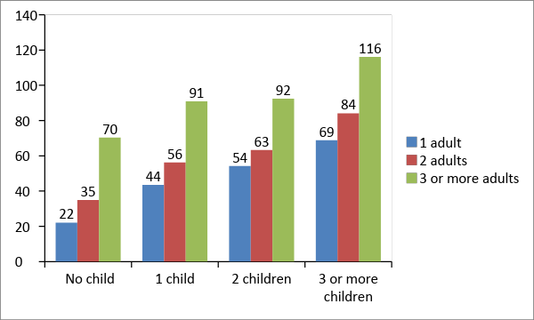

1. **Ghana**

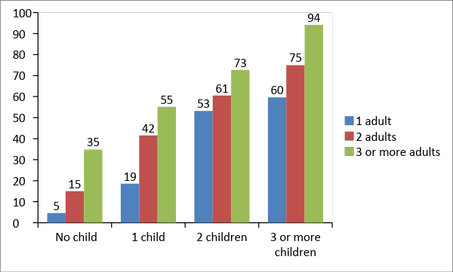

Our expectation is that the required hours should show a positive gradient with respect to adults and a positive gradient with respect to children. That is, the required hours of household production for the household as a whole should increase when there are more adults in the household, and when there are more children in the household. Our expectation is confirmed by the estimates.

Just as with personal care, the Ghanaians in the reference group seem to generally spend less time on household production than their Tanzanian counterparts. The threshold hours are especially lower in Ghana for households with no children and households with one child. Households with three or more adults and with two or more children also devote less time to household production in Ghana than Tanzania. It would be interesting to explore the sources of these differences; however, for our purposes here, we take the estimates from the data as indicative of the time devoted to household production needs.

After we estimated the threshold hours of household production, we determined each individual’s share of their household’s actual household production. This was done using the matched data. We assumed that the share of an individual in the threshold hours would be equal to the share of that individual in the observed total hours of household production in their household. Consider the hypothetical example of a household with only two adults in Tanzania. If the synthetic data showed that the adults spent an equal amount of time on household production, we divided the threshold value of 35 hours equally between them. However, the equal sharing of housework between the sexes is the exception rather than the norm, as indicated in Figure 3-2.

**Figure 3‑2 Person’s Share in the Total Hours of Household Production (percent) by Sex and Location, Persons 15 to 70 years**

1. **Ghana**

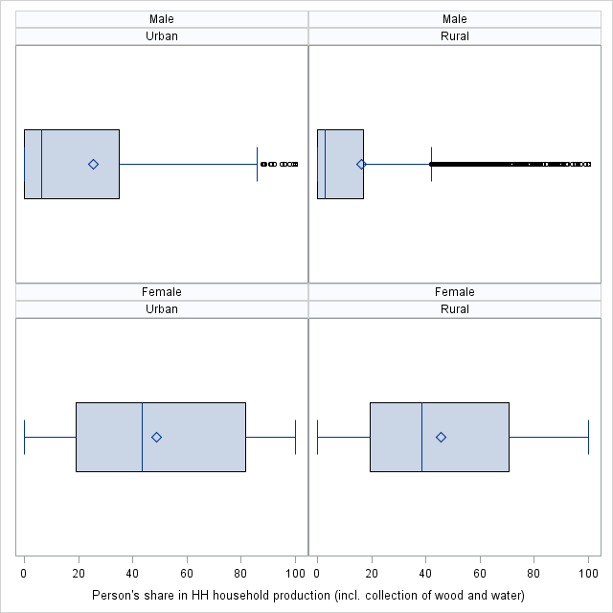

**B. Tanzania**

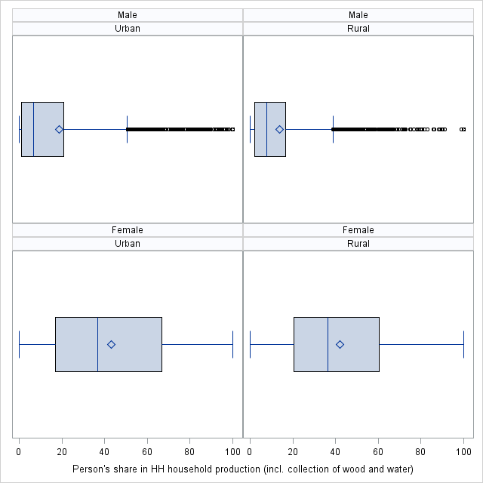

The left and right edges of the box indicate the intra-quartile range (IQR), i.e., the range of values between the 25th and 75th percentiles. The marker inside the box indicates the mean value. The line inside the box indicates the median value. The picture clearly shows that men’s share is much lower, as most of the distribution for men lies to the left of the distribution for women.

We derived the thresholds for commuting time to work from the TUSs (Table 3-3). Our exploratory analysis showed that the hours of employment and location had an important impact on the hours of commuting. However, since we cannot reasonably assign commuting time for each possible hour of employment, we assigned thresholds based on the full-time (more than 36 hours per week) versus part-time (35 hours or less per week) employment status of the employed. We assumed that the average values of commuting constitute the threshold values of commuting. Our estimates showed that workers in rural areas did more commuting than workers in urban areas; we also found that Tanzanian workers did, on average, more commuting than their Ghanaian counterparts.

**Table 3‑3 Threshold Hours of Commuting by Hours of Employment and Location (weekly hours of employed persons, 15 to 70 years old)**

|  |  |  |
| --- | --- | --- |
|  | **Full Time** | **Part Time** |
| **Tanzania** |  |  |
| Dar-es-Salaam | 8.4 | 3.9 |
| Other urban | 7.7 | 5.8 |
| Rural | 9.5 | 7.5 |
| **Ghana** |  |  |
| Urban | 7.0 | 3.2 |
| Rural | 8.4 | 5.7 |

The final step in calculating the time deficits for individuals consists of obtaining the actual weekly hours of employment. We used the hours reported by individuals in the THBS and GLSS. The survey concept of hours of employment differed across the countries. For Tanzania, the THBS collected information on “usual” weekly hours of employment. But, 36 persons that are classified as currently employed had no information regarding their hours. In order not to lose this information during our calculations, we imputed the number of usual hours worked using the average among all working people, based on age groups (five groups), education, sex, and region.

For Ghana, the GLSS collected information on “actual” weekly hours of employment. However, the problem of missing values for hours was more prevalent here than in Tanzania. Missing values were encountered for 2,121 observations. Because of the relatively larger number of observations, we used a more complex method of imputation than in Tanzania. We first imputed industry, occupation, and employment status, since these also had missing values and were needed for the imputation of hours. These were imputed by first collapsing the four-digit codes for industry and occupation into 10 industries and occupations. Missing values for industry of main activity were replaced using the modal value for the listed occupation and then missing values of occupation were replaced with the modal value for the listed industry.[8] Each missing value of employment status was then replaced with the modal value of employment status for the listed industry and occupation pair. We then proceeded to impute actual hours of employment using an ordinary least squares regression. We first ran the regression only for those whose employment status was as family farmers. As the dependent variable we used the value of actual hours (since the log of actual hours was more skewed than the variable), and for independent variables we used age, age squared, sex, level of educational attainment, and relationship to the household head of the individual as well as the number of persons in the household, number of children under 6 years of age, number of children aged 6 to 17, and an indicator for polygamous households. We then ran the regression on the rest of the records, using the additional independent variables industry, occupation, and employment status. With the results of these regressions we predicted the actual hours of employment and replaced all the missing values of actual hours of employment with that value.

The distribution of weekly hours of employment shows some interesting patterns (Figure 3-3). Hours of employment show a greater deal of variation in the urban areas. The p25 value is nearly zero for both sexes in urban areas (as indicated by the starting point of the box) compared to the substantially higher p25 value in rural areas. The rate of employment in rural areas is higher than urban areas in both countries. On the other hand, the average urban individual generally works longer hours than their rural counterpart, as revealed by the comparison of the vertical lines inside the rural versus urban boxes (i.e., the respective median values). The exception to this is found among Tanzanian women, with the average urban woman registering fewer hours of employment than the average rural woman.

**Figure 3‑3 Distribution of Weekly Hours of Employment (percent) by Sex and Location, Persons 18 to 70 Years**

1. **Ghana**

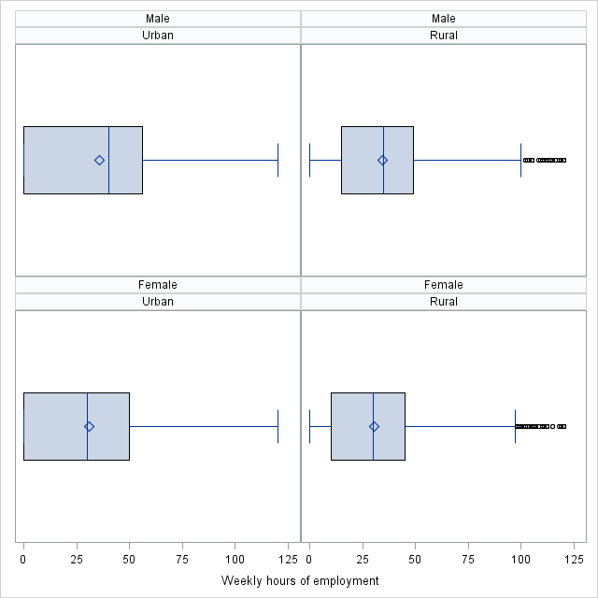

1. **Tanzania**

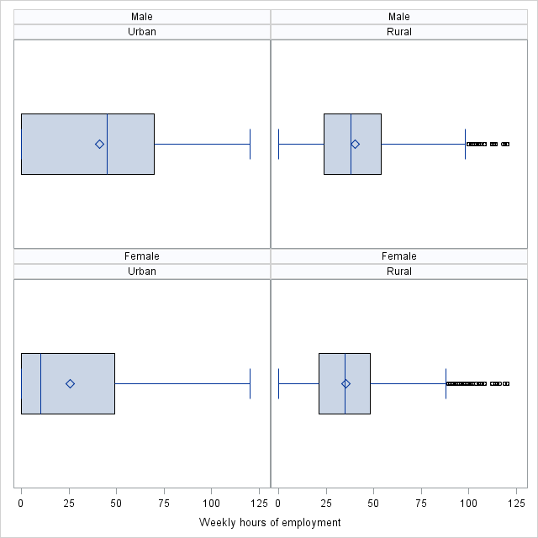

The steps described above yielded information sufficient to estimate the time deficits for all individuals aged 15 to 70 years. The household-level value of time deficits was then obtained in a straightforward manner by summing the time deficits of individuals in the household.

## Adjusting Poverty Thresholds

The general procedure behind the construction of national poverty thresholds in Ghana and Tanzania follows a variant of the well-known “cost of basic needs” approach. A minimum amount of food expenditures required for survival is first identified (food or “extreme” poverty line). Next, an estimate is chosen as the share of food expenditure in total consumption expenditures. Dividing the minimum amount of food expenditures by the chosen budget share of food yields the poverty line.

The conventional approach to poverty evaluation in both countries is to adjust the number of persons in the households according to the age and sex of its members, in order to calculate the number of equivalent adults.[9] Household consumption expenditure, adjusted for regional price differences, is then divided by the adjusted household size to obtain (adjusted or equivalent) per capita expenditures. This amount of expenditure is compared to the poverty threshold to evaluate whether the individual/household is poor. The official poverty threshold in Ghana was 1,314 cedi per annum. In Tanzania, the official poverty line was 36,482 shillings per month.

We followed a different approach here because we wanted to show how much the consumption poverty thresholds change when time deficits are monetized. For this purpose, instead of adjusting the household’s size according to the age and sex of its members, we adjust the consumption poverty threshold for the household. The adjustment is made by multiplying the consumption poverty threshold by the adjusted household size (i.e., the number of equivalent adults). The latter information was available in the expenditure surveys.

Accounting for time deficits requires the modification of the official threshold. The modification consists of adding the monetized value of the household time deficit to the threshold. We assume that the hourly value of the time deficit is equal to the average hourly wage of domestic workers, an assumption that is widely made in research on the valuation of household production. Unfortunately, detailed occupational coding required in estimating such wages are not always available in the microdata; even when detailed coding is available, the number of observations sometimes proves to be too small to produce reliable estimates, especially when we need estimates at a geographically disaggregated level. The latter is often a manifestation of the narrowness of the market for domestic workers. For both Tanzania and Ghana we encountered the problem of sparse market, though in differing ways.

For Tanzania, we estimated domestic wages by the generally used three-way geographical disaggregation: Dar-es-salaam, other urban, and rural. There did not appear to be a better source for generating the estimates than the THBS. We identified the observations on domestic worker wages in the following manner. We chose domestic workers by identifying all those individuals that indicated that their primary activity was working for pay in a private household and that their industry was household employment (“Activities of households as employers of domestic personnel,” International Standard Industry Classification code 9700) and that their occupation corresponded to household production activities.[10] To determine the hourly wage, we added the cash and in-kind pay that each of these individuals reported and divided that by the number of weeks corresponding to the period that their pay covered and their usual weekly hours of work. There were a sufficient number of observations for Dar-es-salaam and other urban areas: 241 and 118, respectively. However, there were only 20 observations available for rural Tanzania. Moreover, the estimate based on the limited number of observations showed that the average wage was higher in rural areas than in other urban areas (i.e., urban Tanzania excluding Dar-es-salaam)—a rather unrealistic scenario. To get around the problem, we imputed the wage for domestic workers using a simple method. We assumed that the mean wage differential for domestic workers between rural and other urban areas will be the same as the differential for all workers between rural and other urban areas. This differential was then applied to the actual mean wage observed for domestic workers in other urban areas to obtain the (imputed) rural wage (Table 3-4).

For Ghana, we wanted to estimate domestic-worker wages by urban and rural areas.[11] Here again, there does not seem to be a better source of data to perform the estimation other than the GLSS. Unfortunately, only 44 observations were available in the whole sample that allowed the direct identification of domestic workers using a method similar to that we used for urban Tanzania.[12] Therefore, we used the average wage of “similar workers” in the private informal sector. To identify similar workers, we used the same set of occupations, except hairdressers and beauticians (codes 5141 and 5142) and all industries. This procedure yielded 510 observations. We calculated the hourly wage using the same procedure as in Tanzania.

**Table 3‑4 Hourly Wages of Domestic Workers by Area (nominal amount in national currency)**

|  |  |
| --- | --- |
| **Tanzania (shillings)** |  |
| Dar-es-salaam | 424 |
| Other urban | 210 |
| Rural | 183 |
| **Ghana (cedi)** |  |
| Urban | 1.14 |
| Rural | 1.04 |

We considered the hourly wage obtained in the manner described above for each country as the unit replacement cost of time deficits in that country because time deficits are, by definition, deficits in the required levels of household production. Multiplying the unit replacement cost and the weekly hours of household time deficit yields the weekly monetized value of the household time deficits. We converted the weekly value into a monthly value for Tanzania because the poverty line is specified in monthly terms;[13] the conversion was into an annual value for Ghana because the official poverty line is specified in annual terms.[14]

The monetized value of the time deficit was adjusted for regional price differences before it was added to the household poverty line. We performed this adjustment by employing the same price deflator that was used in the survey to adjust household consumption expenditures used in assessing poverty. That is, we multiplied the monetized value of the time deficit by the ratio of adjusted consumption expenditures to unadjusted consumption expenditures—the ratio, in effect, constituting the implicit regional price deflator. We refer in what follows to the sum of the official poverty line and the adjusted value of time deficit as the Levy Institute Measure of Time Consumption Poverty (LIMTCP) poverty line.

Both the official poverty line and LIMTCP poverty line are compared against a measure of household consumption expenditures to assign poverty status. We used the measure of consumption that is used in official estimates of poverty. In Ghana, the consumption measure used includes expenditures on food and nonfood items, including expenditures on housing. For Tanzania, the consumption measure used to determine poverty uses the total amount of purchases on food and nonfood items, plus the imputed value of the food grown by the household.

# TIME AND CONSUMPTION POVERTY OF EMPLOYED INDIVIDUALS

## Ghana

### Gender Differences in Employment Characteristics and Time Poverty

Given our focus on time deficits, we begin with the incidence of time poverty (Table 4-1). Individuals incur time deficits when the time that they spend on employment and required household production exceeds the time that they have available after setting aside the time for personal maintenance and nonsubstitutable household production (see Section 3.2). Overall, we found that 27 percent of persons between the ages of 15 and 70 encountered time deficits. Women were almost twice as likely to have time deficits as men (35 versus 18 percent). Time deficits are confined almost entirely to the employed population in Ghana.[15] Almost half of all employed women were time-poor compared to about a quarter of all employed men.

**Table 4‑1 Incidence of Time Poverty by Sex and Employment Status (persons 15 to 70 years of age), Ghana**

|  |  |  |
| --- | --- | --- |
|  | **Time poverty rate (percent)** | **Number of time-poor persons (millions)** |
| **All** | 27.3 | 4.20 |
| **Men** | 18.3 | 1.31 |
| Not employed | 0.0 | 0.00 |
| Employed | 23.4 | 1.31 |
| **Women** | 35.0 | 2.89 |
| Not employed | 0.3 | 0.01 |
| Employed | 47.4 | 2.89 |

#### Hours of employment

For employed persons, hours of employment will naturally play a crucial role in determining the likelihood of a person incurring time deficits. We found that roughly one-third of men and women were employed for 36 to 50 hours per week—what may be considered as normal full-time work (Figure 4-1). The proportion of those who work more than 50 hours is higher among men than women, while the proportion of those who work fewer than 36 hours is higher among women than men. Occupational segregation, women’s “choice” of jobs with fewer hours in order to meet care responsibilities, educational disparities that reduce women’s access to professional jobs, and pervasive discrimination that forces women into jobs with contingent hours are probably among the key factors that are at work here (Kabeer 2012). There is also a marked contrast between the urban and rural areas: the proportion of those who work more than 50 hours is higher in the urban areas while the proportion of those who work fewer than 36 hours is higher in the rural areas. Most of this difference may be driven by the sectoral composition of employment, namely the preponderant reliance on agriculture as a means of livelihood in the rural areas. Casual labor and seasonal employment are quite prevalent in Ghanaian agriculture (Osei-Boateng and Ampratwum 2011). Further, the share of own-account workers (in farm as well as nonfarm occupations) who by choice or necessity engage in fewer hours of employment is also higher in the rural areas.[16]

**Figure 4‑1 Distribution of Employed Persons by Area, Sex, and Hours of Employment, Ghana**

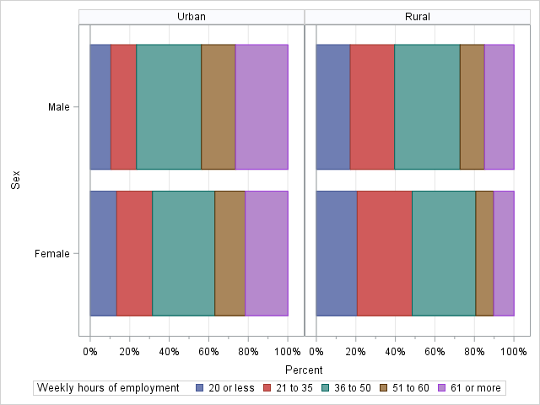

A fairly large proportion of the employed Ghanaians (31 percent) engage in what the International Labour Organisation (ILO) terms as “excessive” hours of employment—more than 48 hours per week.[17] The Labor Act of 2003 in Ghana, in fact, defines the maximum weekly hours as 40 hours per week, with few exceptions.[18] Men are more likely to engage in excessive hours than women (36 versus 28 percent) and urban areas witness a greater incidence of excessive hours than rural areas (40 versus 24 percent). We would expect the likelihood of time deficits to be greater with longer hours at the job and this is indeed what we observe in the data (Figure 4-2).

**Figure 4‑2 Hours of Employment and Incidence of Time Poverty: Employed Persons, Ghana (percent)**

**A. Ghana**

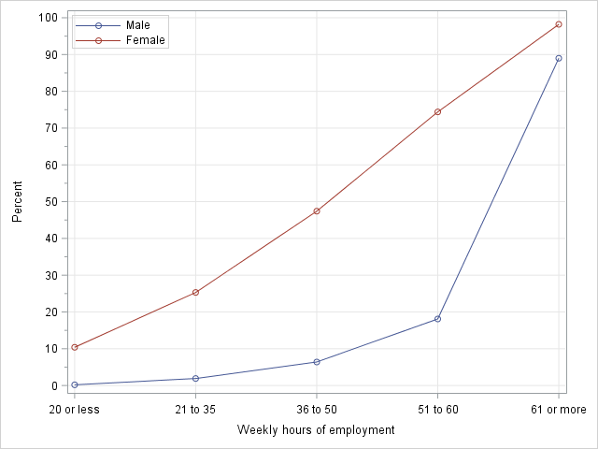

**B. Urban versus Rural**

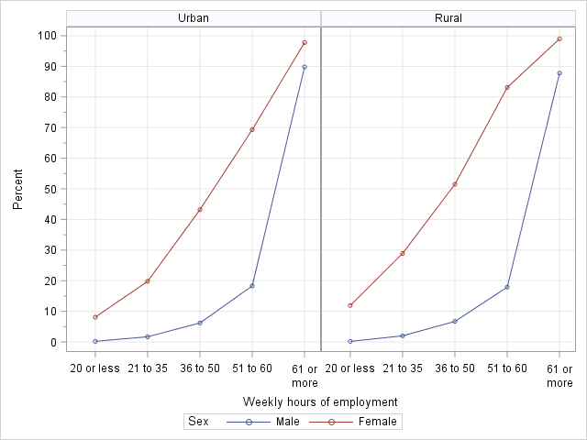

The gender gap in incidence that we already noted (Table 4-1) is evident in every hours interval. In fact, the gap widens with the increase in hours except at the very top interval (61 hours or more) where time poverty is nearly universal among both men and women. We observed earlier that the largest proportion of men and women workers worked 36 to 50 hours per week (Figure 4-1). Here, the rate of time poverty among women was 7.4 times as high as among men (47 versus 6 percent). Rural women appear to be more prone to time deficits than their urban counterparts in every hours interval, while no such difference is discernible among men. As a result, the gender gap in the incidence of time poverty among the employed is much higher in the rural areas at every hours interval.

One potential reason behind the difference in the rate of time poverty of one group vis-à-vis another group is the difference in the hours of required household production (see section 3.2). For example, suppose that people with greater hours of employment also faced greater hours of required household production relative to those with fewer hours of employment. Then, the greater hours of required household production would also contribute toward a greater risk of time poverty of those who spend more hours on the job. However, this does not seem to be the case in Ghana. As shown in Figure 4-3, the weekly hours of required household production for women and men show hardly any variation across the intervals of hours of employment. Hence, longer hours at the job rather than greater housework responsibilities appear to lie behind the positive correlation between hours of employment and time poverty rates.

**Figure 4‑3 Average Hours of Required Household Production, by Hours of Employment and Sex: Employed Persons, Ghana**

**A. Ghana**

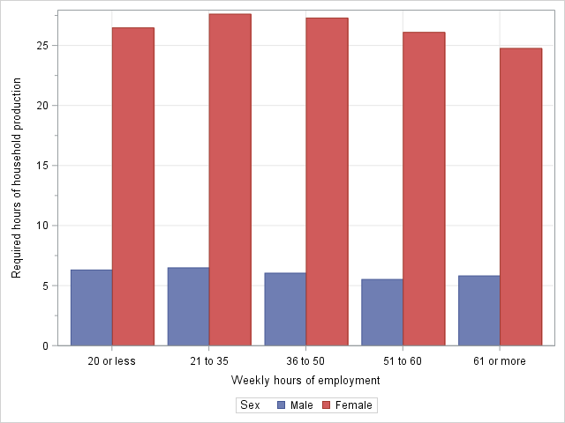

**B. Urban versus Rural**

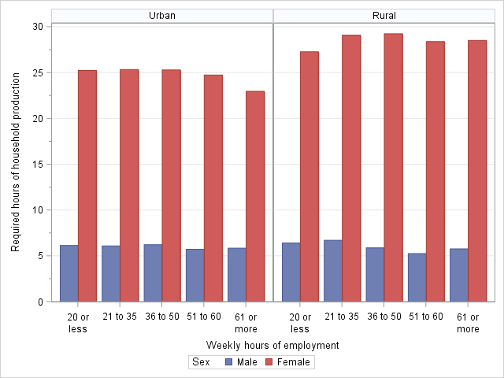

On the other hand, there is an enormous disparity between the sexes in the time requirements for household production. Employed women in Ghana need to spend, on average, 27 hours per week to meet their household responsibilities, while their male counterparts need to spend only 6 hours per week, on average. The gender disparity in the division of unpaid work is the explanation for the higher incidence of time poverty among women even after we control for hours of employment.

We had noted earlier the higher rate of time poverty among rural employed women *within every bracket of hours of employment* relative to their urban counterparts and no such difference among employed men (Figure 4-2, Panel B).[19] The explanation lies in the greater number of required hours of household production faced by rural women relative to urban women—29 versus 25 hours per week—and the identical number of hours required of men in both urban and rural areas (6 hours per week) (Figure 4-3, Panel B). What accounts for the existence of the urban-rural differential in the case of women and the absence of such differential for men?

Let us recall that the 12 thresholds for household production hours depend only on the number of adults and children (Figure 3-1) and are set at the *household* level; that is, they refer to the total weekly hours of household production to be performed by the members of the household, taken together. Households in rural areas tend to have more members than in urban areas and hence the household-level thresholds are higher in the rural areas. On average, the household-level threshold was 45 hours per week in the urban areas and 55 hours in the rural areas. The threshold applicable to an individual in a given household is obtained by multiplying the household-level threshold with the share of the individual in the observed total hours of household production in their household. Therefore, in principle, the individual share diminishes with the size of the household. However, living in larger-sized households in the rural areas did not appear to have an appreciable effect on diminishing the share of household responsibilities that fall on employed women: the average share of employed women was, respectively, 52 and 50 percent in the urban and rural areas. In contrast, a pronounced diminishing effect was evident for men, since the average share for employed men was only 19 percent in the rural areas, compared to 29 percent in the urban areas. It seems like the larger average size of rural households (relative to urban households) has an implication for the gendered intrahousehold division of labor—it tends to reduce the contribution made by employed men to household production while having no such effect on employed women. A demographic difference between urban and rural areas is mediated by gender relations that work in favor of men and results in the higher rate of time poverty among women in rural areas as compared to urban areas, after controlling for hours of employment.

#### Employment status

Gender segregation by employment status appears to be a structural feature of the Ghanaian labor market (Heintz 2005). While paid employees and the agricultural self-employed constitute, respectively, 21 and 25 percent of overall employment, they make up notably lower proportions of female employment—12 and 20 percent (Figure 4-4). Employed women were also found, relative to all employed persons, more to be in the status of nonagricultural self-employed (36 versus 26 percent) and unpaid family worker (28 versus 23 percent). Since the share of men and women are roughly equal in total employment, the estimates suggest that men are disproportionately represented in the statuses of paid employee and agricultural self-employed.

**Figure 4‑4 Percent of Total Employment in Each Employment Status by Sex, Ghana**

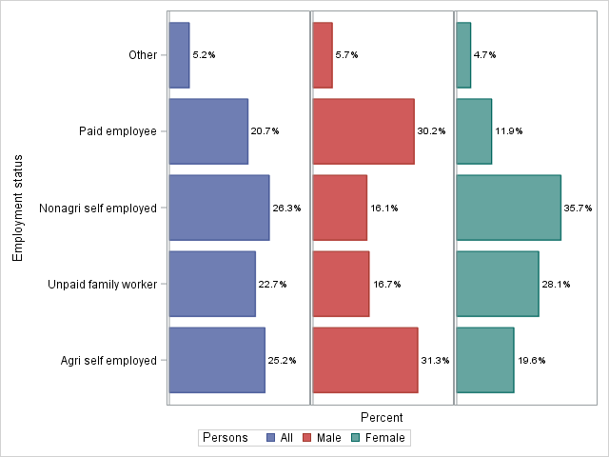

The incidence of time poverty was the highest in the category of nonagricultural self-employed for both men and women, followed by the category of paid employee (Figure 4-5). For women, the time poverty rate was virtually the same among unpaid family workers and the agricultural self-employed; male unpaid family workers had a substantially lower rate than the agricultural self-employed. Within each employment status, there exists a pronounced gender disparity, with women much more prone to time poverty.

**Figure 4‑5 Time Poverty Rates by Employment Status and Sex (percent), Ghana**

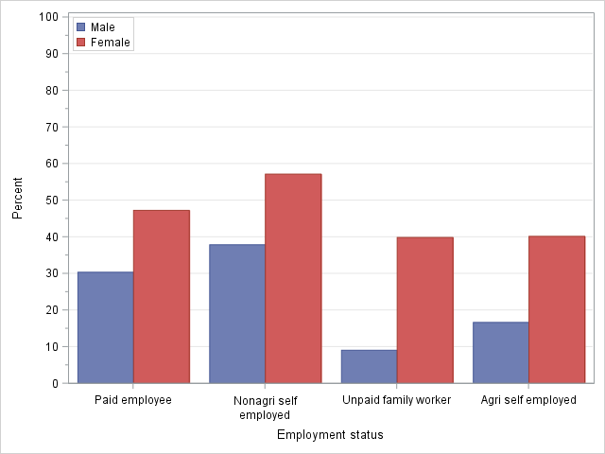

**Note:** The small category of the employment status “Other” is omitted here.

**Figure 4‑6 Average Weekly Hours of Employment and Required Household Production, by Employment Status and Sex, Ghana**

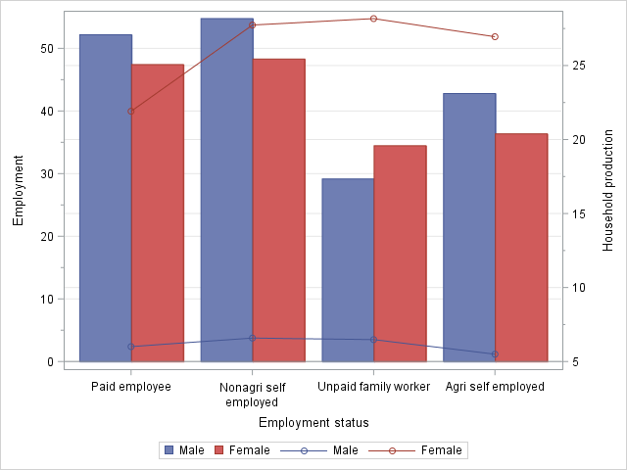

**Note:** The bars indicate hours of employment (left vertical axis) and endpoints of lines indicate hours of required household production (right vertical axis). We have omitted the small category of the employment status “Other” here.

As it turns out, the gender disparity is driven by the greater responsibility of required household production that falls upon women (Figure 4-6). While men do engage in more hours of employment than women (with the exception of the category of unpaid family workers[20]), this difference is dwarfed by the difference in hours of household production. For example, consider the case of self-employed nonagricultural workers. Male workers in this category spent, on average, *seven hours* more than women (55 versus 48), but women spent *21 hours* more on meeting household production requirements (7 versus 28). As discussed above, the ordering of time poverty rates across categories of employment status coincides with the ordering of hours of employment for men, largely because their household production requirements display little variation across categories.

This holds true for women, too, with the exception of women employed as paid employees who faced considerably lower required hours of household production than women in other categories. Their lower (individual) household production requirements could stem from lower household-level requirements and/or their lower individual relative contribution toward meeting the household-level requirements as a result of a more egalitarian division of domestic labor. Some available research suggests that women gain greater control over the household decision making process with better employment (in terms of pay and social standing) because it translates into greater economic empowerment (Maertens and Verhofstadt 2013). Assuming that, typically, a paid employee is in a better employment situation than a self-employed worker or unpaid family worker allows us to examine this intuition using our data. We do so by comparing some relevant statistics for female paid employees with the group formed by combining the self-employed women and female unpaid family workers in our sample. The latter group is referred to as “nonwage workers” for short.

Our estimates show that the lower average hours of required household production borne by female paid employees was not due to their lower share in the household-level requirements of household production. That is, they are not privileged to a more egalitarian division of household production. The average value of the individual’s share in household-level requirements was actually higher for female paid employees than female nonwage workers (56 versus 50 percent). Rather, the lower threshold for female paid employees than for female nonwage workers (47 versus 59 hours per week) appears to be driven by the smaller household size of the households in which female paid employees reside. As discussed in section 3.2, we used 12 household-level thresholds depending on the number of adults and children (Figure 3-1). Inspection of our data showed that only 20 percent of female paid employees belonged to the larger-sized groups (two adults with three or more children and three or more adults with three or more children) as compared to 40 percent of female nonwage workers. On the other hand, female paid employees were three times as likely to live alone than female nonwage workers (12.6 versus 4.2 percent). These findings indicate that compared to female nonwage workers, female wage workers may possess a greater degree of control over decisions regarding marriage and fertility, i.e., over the size and composition of their household (Van den Broeck and Maertens 2015). The household composition tends to be such that the average hours of required household production fall considerably below that of female nonwage workers.

### Consumption Poverty and Time Deficits

We next turn to examine the incidence of time deficits by official poverty status, defined according to poverty lines specified in terms of minimum necessary consumption expenditures. As is customary, consumption poverty is a household-level concept; that is, every individual that lives in a consumption-poor household is considered as consumption-poor. Time poverty was somewhat higher among the nonpoor than the poor employed persons for Ghana as a whole (37 versus 32 percent). However, when we break down the time poverty rates also by area of residence (rural/urban) and sex, it emerges that this pattern does not hold for rural employed women (Figure 4-7). The ubiquitous gender disparity in the incidence of time poverty is visible within the consumption-poor and consumption-nonpoor groups.

**Figure 4‑7 Time Poverty Rates by Official Poverty Status, Area of Residence, and Sex (percent), Employed Persons (15 to 70 years of age), Ghana**

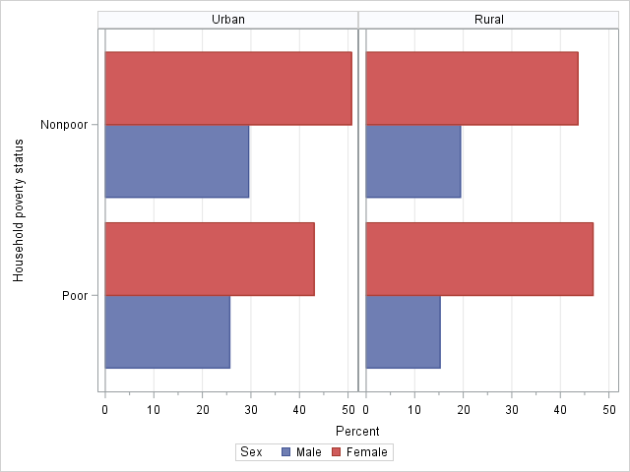

Despite the lower incidence of time poverty among the consumption-poor, the implications of being time-poor are potentially more serious for them compared to the consumption-nonpoor individuals. In fact, the rationale for our adjusted poverty thresholds lies in the differential impact of time deficits on poor and nonpoor individuals (see Section 3.3). For some households, because they have the resources to do so, time deficits could be potentially “bought off,” i.e., the required household production services could be replaced by market substitutes. Such a course of action is generally not feasible for households who already fall below the official poverty line without falling deeper into poverty. A sizeable proportion of poor urban and rural employed women (43 and 47 percent, respectively) live in such households; given the gender disparity in the incidence of time deficits, it is not surprising to find that a smaller share of poor employed men belong to such households (26 percent and 15 percent in urban and rural areas, respectively).

Furthermore, there may be other time-poor households who are officially consumption-nonpoor but would actually appear to be consumption-poor if they attempt to buy off their time deficits, the category that we referred to as “the hidden poor.” To contextualize the importance of hidden poverty for employed people, it is useful to begin by considering the picture conveyed by using the official poverty thresholds. The working poor amounted to 22 percent of all employed individuals for Ghana as a whole; in the rural areas, however, the incidence of poverty was almost *four times* as high as the urban areas (35 versus 9 percent). As a result, while the employed population is split almost evenly between the urban and rural areas, 80 percent of the employed poor live in the rural areas. There was hardly any gender disparity in the official working poverty rate (Table 4-2).

**Table 4‑2 Poverty among Employed Persons (15 to 70 years of age): Official versus Adjusted, Ghana**

|  |  |  |  |  |  |  |
| --- | --- | --- | --- | --- | --- | --- |
|  | **Poverty rate (percent)** | | | **Number of poor persons (millions)** | | |
|  | **Official** | **Adjusted** | **Hidden** | **Official** | **Adjusted** | **Hidden** |
| **Urban** | 9.2 | 16.2 | 7.0 | 0.53 | 0.93 | 0.40 |
| Male | 9.5 | 15.9 | 6.4 | 0.26 | 0.43 | 0.17 |
| Female | 9.0 | 16.4 | 7.4 | 0.27 | 0.50 | 0.23 |
| **Rural** | 34.7 | 43.8 | 9.1 | 2.06 | 2.59 | 0.53 |
| Male | 34.1 | 42.7 | 8.6 | 0.98 | 1.22 | 0.24 |
| Female | 35.3 | 44.8 | 9.5 | 1.08 | 1.37 | 0.29 |
| **Ghana** | 22.2 | 30.2 | 8.0 | 2.59 | 3.52 | 0.93 |
| Male | 22.1 | 29.6 | 7.5 | 1.23 | 1.65 | 0.42 |
| Female | 22.2 | 30.7 | 8.5 | 1.35 | 1.87 | 0.52 |

**Note:** The numbers in the column “Hidden” are obtained by subtracting the numbers in the column “Official” from those in the column “Adjusted.”

Once we accounted for time deficits, the measured poverty rate among the employed in Ghana increased by a full 8 percentage points to 30 percent (representing an increase of nearly one million people to the ranks of the working poor). The urban-rural gap in the poverty rate is a little bit diminished but still very sizeable (44 versus 16 percent). However, the greater relative increase in the urban poverty rate led to a lesser measured rural bias in poverty, as 26 percent of the poor are now urban. This reflects the disproportionate share of the Ghanaian hidden poor in urban areas (43 percent). Just as with the official measure, our measure also indicates a virtual absence of gender disparity in the incidence of poverty among the employed.

**Table 4‑3 Distribution of Employed Persons (15 to 70 years of age) by LIMTCP and Incidence of Time Poverty, Ghana**

|  |  |  |  |  |  |  |  |
| --- | --- | --- | --- | --- | --- | --- | --- |
|  | **LIMTCP classification of individuals (percent)** | | | | | **Time poverty rate (percent)** | |
|  | Consumption-poor and time-poor | Consumption-poor and time-nonpoor | Consumption-nonpoor and time-poor | Consumption-nonpoor and time-nonpoor | Total | Nonpoor | Poor |
| **Urban** | 8.2 | 8.0 | 32.0 | 51.8 | 100 | 38.2 | 50.5 |
| Male | 5.7 | 10.2 | 23.5 | 60.7 | 100 | 27.9 | 35.8 |
| Female | 10.4 | 6.0 | 39.6 | 43.9 | 100 | 47.4 | 63.2 |
| **Rural** | 16.5 | 27.3 | 15.3 | 41.0 | 100 | 27.2 | 37.7 |
| Male | 8.2 | 34.5 | 9.7 | 47.6 | 100 | 17.0 | 19.2 |
| Female | 24.3 | 20.5 | 20.4 | 34.8 | 100 | 37.0 | 54.3 |
| **Ghana** | 12.4 | 17.8 | 23.5 | 46.3 | 100 | 33.7 | 41.1 |
| Male | 7.0 | 22.6 | 16.4 | 54.0 | 100 | 23.4 | 23.6 |
| Female | 17.4 | 13.3 | 30.0 | 39.3 | 100 | 43.3 | 56.6 |

Accounting for time deficits in the measurement of consumption poverty allows us now to examine the joint distribution of time and consumption poverty among the employed (Table 4-3). First, the double bind of time and consumption poverty afflicts women more than men in both rural and urban areas. The double bind is borne by 24 percent and 10 percent of women, respectively, in the rural and urban areas compared to 8 percent and 6 percent among men in rural and urban areas, respectively. Second, the incidence of time poverty is notably higher among the consumption-poor than consumption-nonpoor for men and women in both urban and rural areas. This contrasts sharply with the finding, on the basis of the official poverty measure, that time poverty rates are generally higher among the nonpoor than the poor (Figure 4-7).

What is behind the higher time poverty rate of the employed poor, especially among female workers? As we have seen before, the differences are largely driven by differences in hours of employment and required household production. Our estimates show that poor employed women engaged in a higher number of average hours of employment than their nonpoor counterparts in the rural (40 hours versus 35 hours) and urban (50 hours versus 46 hours) areas. *And*, they also faced a higher number average hours of required household production than their nonpoor counterparts in both the rural (32 hours versus 26 hours) and urban areas (33 hours versus 23 hours). Poor employed men also worked a higher number of average hours in employment than nonpoor employed men (by about three hours) but the gap in average hours of required household production was rather small (under 40 minutes per week).

**Figure 4‑8 Average Weekly Hours of Employment and Required Household Production, by Sex and Adjusted Consumption Poverty Status and Sex, Ghana**

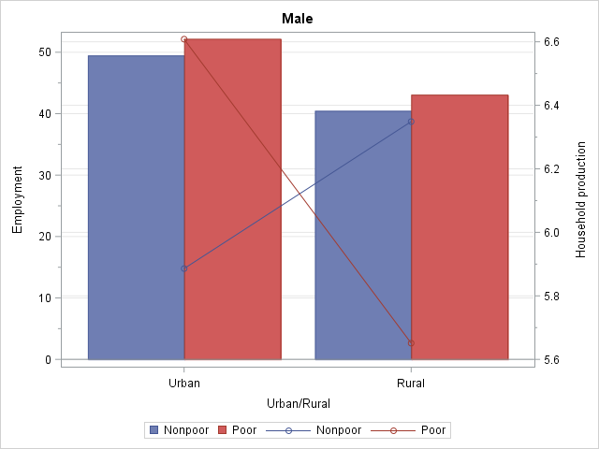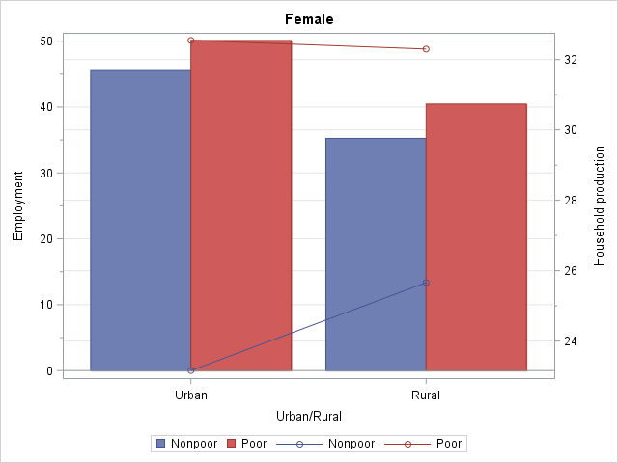

**Note:** The bars indicate hours of employment (left vertical axis) and endpoints of lines indicate hours of required household production (right vertical axis).

The fact that the employed poor women engage in more hours of employment is consistent with the commonplace observation that the strategy of eking out a livelihood by working long hours at relatively low-productivity employment is widely prevalent among them. As for the other factor behind their long workweek—required household production—we should examine the differences between poor and nonpoor women in household-level requirements of household production and intrahousehold division of household production responsibilities.[21] Similar to the differences among employment statuses, we found that the main force at work here was the lower household-level requirements rather than a different intrahousehold division of household responsibilities.

More specifically, nonpoor employed women lived in households with lower average household-level requirements of household production than poor employed women (Table 4-4). But, the share of household-level requirements that women shouldered were not, on average, notably different by poverty status, and hovered around 50 percent. In turn, the lower household-level requirements of household production among the nonpoor may reflect their lower average household size. The number of adults as well as children per household is higher among the poor, though the larger difference is to be found in the number of children. As we saw while discussing the differences among women by employment status, the complex relationship between fertility decisions and economic empowerment also appears here and requires further examination. It is worthwhile to note the sharp contrast between poor and nonpoor women in terms of their employment status. About a third of all poor women work as unpaid family workers compared to only 14 percent of nonpoor women; on the other hand, just under 5 percent of poor women are paid employees, in contrast to 15 percent of nonpoor women. Pathways out of consumption poverty *and* time poverty are thus likely to be tied partly to the expansion of decent wage employment for women. Public investment in the provisioning of care and infrastructure (e.g., water supply) that benefits disadvantaged groups can also alleviate the impoverishing effects of time deficits via lowering the thresholds of required household production.

**Table 4‑4 Factors Affecting Employed Women’s Required Hours of Household Production, Ghana**

|  |  |  |  |  |
| --- | --- | --- | --- | --- |
| **Average values** | **Urban** | | **Rural** | |
|  | **Poor** | **Nonpoor** | **Poor** | **Nonpoor** |
| **Household’s required household production (weekly hours)** | 68 | 50 | 71 | 54 |
| **Number of adults** | 2.50 | 2.27 | 2.67 | 2.33 |
| **Number of children under 18 years** | 3.02 | 1.78 | 3.35 | 2.10 |
| **Individual’s share in the household’s required household production (percent)** | 51 | 52 | 47 | 53 |

The stark gender disparity among the employed poor in the incidence of time poverty, with women facing a much higher rate of time poverty than men, is mirrored in the size of the time deficits of time-poor individuals (Figure 4-9). Indeed, our estimates showed that for Ghana as a whole, the average weekly time deficits of poor women were about *10 hours* higher than that of poor men (30 hours versus 20 hours per week). Women in the ranks of the urban working poor emerge as the worst-off group, with the average shortfall among them amounting to almost a full day and half (36 hours) per week. Nonpoor men and women incur lower time deficits than their poor counterparts—just as they did more favorably in terms of rates of time poverty. Yet, it should be noted that even in the subgroup with the smallest deficit, i.e., urban nonpoor men, the average shortfall is 14 hours per week, which exceeds the “normal” day at the job of eight hours by a comfortable margin.

**Figure 4‑9 Time Deficit of Time-poor Employed Men and Women (average weekly hours) by LIMTCP Poverty Status, Ghana**

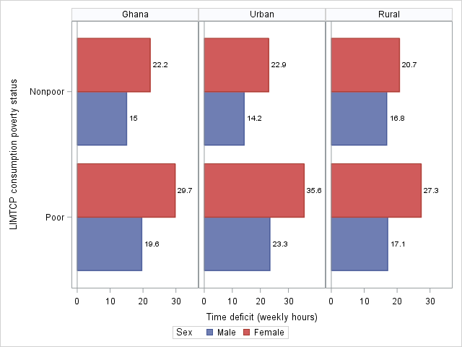

## Tanzania

### Gender Differences in Employment Characteristics and Time Poverty

The incidence of time poverty was considerably higher in Tanzania than Ghana. Overall, we found that 42 percent of persons between the ages of 15 and 70 encountered time deficits (Table 4-5). As we saw in the case of Ghana, women were more likely to have time deficits than men (49 percent versus 33 percent). The nonemployed population in Tanzania does not seem to be prone to time deficits in any notable fashion.[22] Employed women had a much higher rate of time poverty than their male counterparts—23 percentage points higher (61 percent versus 38 percent). Both employed men and women in Tanzania experience time poverty to a greater extent than Ghanaian employed men and women. An important factor at work here is the higher thresholds of household production in Tanzania that we presented earlier (see Figure 3-1). To a lesser extent, the higher thresholds for personal care (reported in Table 3-2) also contributed to the difference. The differences in time thresholds between the two countries make the comparisons of time poverty somewhat difficult—but not more so than, for example, a comparison of consumption poverty on the basis of national poverty lines.

**Table 4‑5 Incidence of Time Poverty by Sex and Employment Status (persons 15 to 70 years of age), Tanzania**

|  |  |  |
| --- | --- | --- |
|  | **Time poverty rate (percent)** | **Number of time-poor persons (millions)** |
| **All** | 42 | 9.47 |
| **Men** | 33 | 3.61 |
| Not employed | 0 | 0.01 |
| Employed | 38 | 3.60 |
| **Women** | 49 | 5.86 |
| Not employed | 2 | 0.05 |
| Employed | 61 | 5.81 |

#### Hours of employment

In order to gain insight into the factors behind time poverty, we begin by examining time spent on the job (Figure 4-11). Nearly three-fourths (74 percent) of the employed population lives in rural areas in Tanzania compared to 51 percent in Ghana. “Normal” full-time work (36 hours to 50 hours per week) was not the largest single slot of weekly hours of employment in the urban areas. Distribution of hours of employment among urban men showed a marked degree of polarization: 43 percent worked for 61 hours or more (the highest interval) and the remainder were split roughly evenly across the other four intervals. For women, too, the largest single slot was the highest interval (27 percent). The bottom three slots absorbed almost equal proportions for a combined total of 62 percent and the smallest proportion (11 percent) was in the 51 to 60 hours interval. As we saw in the case of Ghana, the bottom two rungs of the hours intervals take up a larger share of the rural employed population. “Only” 20 percent of men and 12 percent of women were employed in the highest interval. Normal hours were far more prevalent here, with a little under a third of men and women employed in the 36 to 50 hours interval.

**Figure 4‑10 Distribution of Employed Persons by Area, Sex, and Hours of Employment, Tanzania**

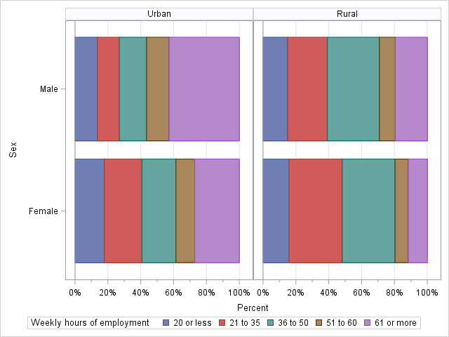

Overall, effective gender segregation in hours of employment is visible in Tanzania, as it was in Ghana, with women disproportionately concentrated in the “fewer than 36 hours per week” category. Factors that we alluded to in the Tanzanian context are also relevant here: occupational segregation, the difficulties of combining household responsibilities with employment that tend to push women toward less demanding (in terms of time) jobs, underrepresentation of women in professional occupations due to educational inequalities, and discrimination. A structural feature of both economies (as well as several others in the developing world) is chronic underemployment that reflects the lack of availability of jobs with “regular” hours. About 36 percent and 41 percent of all employed workers were employed for fewer than 36 hours per week in Ghana and Tanzania, respectively. At the other extreme, a substantial and similar percentage of workers in both countries (31 percent) engaged in “excessive” hours of employment—more than 48 hours per week. According to national law (the Employment and Labour Relations Act 2004), 45 hours is deemed as the maximum, except for supervisory employees that report to senior management.[23] It is quite unlikely that a large chunk of those working excessive hours fit this description.

Two features of the relationship between the incidence of time poverty and hours of employment that we observed earlier with regard to Ghana are also evident in Tanzania (Figure 4-11). First, there is a positive correlation between the time poverty rate and hours of employment. Second, women experience higher rates of time poverty even after we control for hours of employment, except at the interval with the longest hours at the job (61 hours or more) where time poverty is 100 percent for both men and women. In the intervals with fewer hours of employment, the gender gap in time poverty rates is huge, as we saw in the case of Ghana. In terms of urban-rural differences, men seem to differ in the risk of time poverty only at the 51 hours to 60 hours interval, where rural men experience a much higher rate of time poverty than urban men (61 percent versus 47 percent). For women, the incidence of time poverty was somewhat higher in the rural than urban areas for every hours interval except at the very top. Consequently, the gap between women and men in time poverty rates is much higher in the rural than the urban areas: 63 percent of women and 53 percent of men encountered time deficits in the urban areas as compared to 60 percent of women and 32 percent of men in the rural areas.

**Figure 4‑11 Hours of Employment and Incidence of Time Poverty: Employed Persons, Tanzania (percent)**

**A. Tanzania**

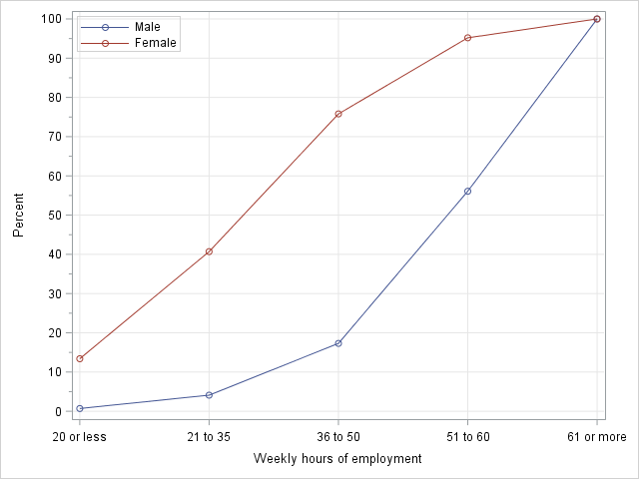

**B. Urban versus Rural**

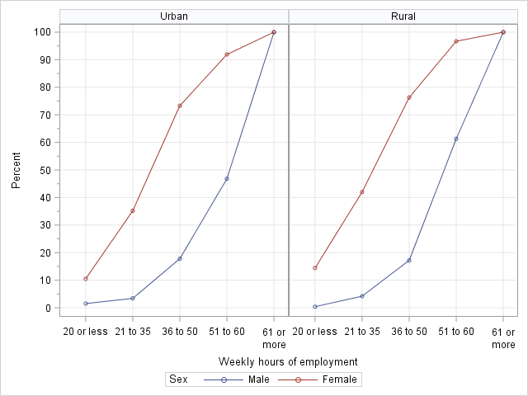

As we discussed before, one reason why those who work long hours at the job may experience a greater rate of time poverty might be if they also encountered more required hours of household production than those who worked fewer hours at the job (see section 3.2). We did not find any evidence to support this hypothesis in Ghana; the Tanzanian case is not different either (Figure 4-12). Required hours of household production do not appear to vary at all in a discernible fashion with hours of employment. The greater time poverty of those who engage in more hours of employment thus does not seem to be driven by any positive correlation between hours of employment and required hours of household production.

**Figure 4‑12 Average Hours of Required Household Production, by Hours of Employment and Sex: Employed Persons, Tanzania**

**A. Tanzania**

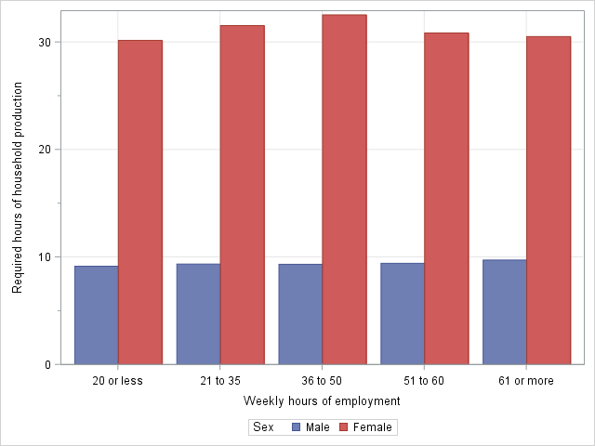

**B. Urban versus Rural**

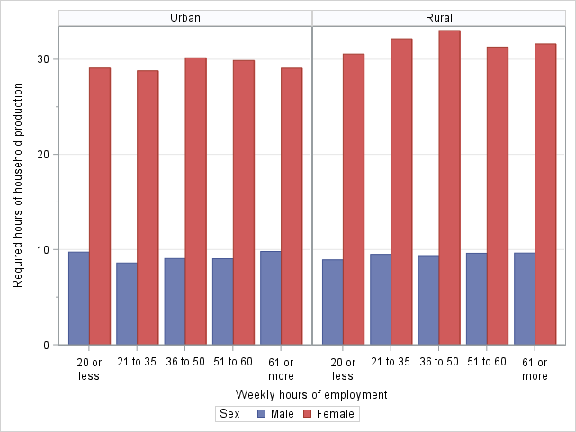

Indeed, rather than providing a clue as to why the time poverty rate increase with hours of employment, the estimates reveal why women are much more prone to time poverty than men. Average required hours of household production for employed women and men were, respectively, 31 hours and 9 hours per week. Just as in Ghana, it is the huge disparity in the division of household responsibilities that accounts for the gender disparity in time poverty among employed people. The average required hours of household production are greater for women in the rural areas, while no such gap can be observed for men (Figure 4-12, Panel B). This is once again similar to what we found for Ghana, though the extent of the urban-rural gap among women was slightly larger there. It may also be recalled that upon examining this issue further, we concluded that the greater household-level requirements of household production in the rural areas were a key factor behind this gap. In Tanzania, the average household-level threshold was 69 hours per week in the urban areas and 77 hours in the rural areas. The difference reflects the larger average household size—especially the higher number of children—in the rural areas, since household-level thresholds differ only by household size and composition (see Figure 3-1, Panel A for the thresholds for Tanzania).[24] As we discussed, the household-level threshold is converted into the required hours of the individual via that individual’s share in their household’s actual total hours of household production. It turned out that the average share for employed women was practically identical in the rural and urban areas—about 43 percent. Thus, the larger household size in the rural areas does not seem to have any impact on employed women’s share of household responsibilities. Strikingly, however, it has a strong negative impact on employed men’s share, which was 19 percent and 14 percent, respectively, in the urban and rural areas. Just as in Ghana, the larger household size in the rural areas does not translate into a greater number of required hours of household production for men, but does so for women.

#### Employment status

Information on employment status is rather limited in our Tanzanian data. In contrast to Ghana, unpaid family workers are not categorized separately in agriculture. Arguably, the extent of informal wage employment is grossly understated in Tanzania, especially in rural areas (Mueller 2015; Rizzo, Kilama, and Wuyts. 2015). The vast majority of men and women (68 percent and 79 percent, respectively) are classified as working on their own farm (Figure 4-13). About an equal proportion of men are classified as working for pay and as nonfarm self-employed (15 percent each); among women, 8 percent and 11 percent are categorized, respectively, as working for pay and as nonfarm self-employed. Since the shares of men and women are roughly equal in total employment, the estimates suggest that men are disproportionately represented in the statuses of paid employee and nonfarm self-employed.

**Figure 4‑13 Percent of Total Employment in Each Employment Status by Sex, Tanzania**

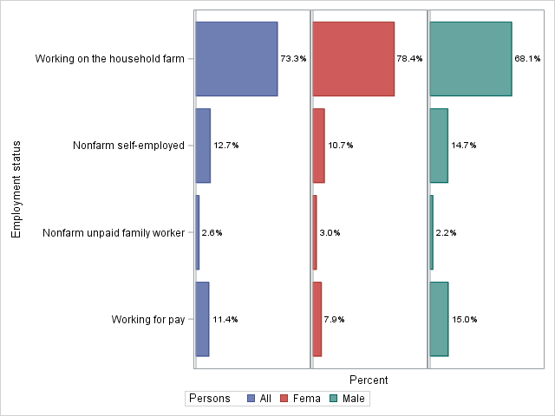

As we saw in the case of Ghana (Figure 4-4), women are more prone to time poverty than men in each employment category. Paid employees experienced the highest rate of time poverty among both men and women. The incidence of time poverty was lower in the category of nonagricultural self-employed than paid employees for women but less so for men. The time poverty rate was lowest among men and women classified as working on their own farm. However, the gender disparity was also highest in this category, which, as we saw above, had the preponderant share of employed people in Tanzania.

**Figure 4‑14 Time Poverty Rates by Employment Status and Sex (percent), Tanzania**

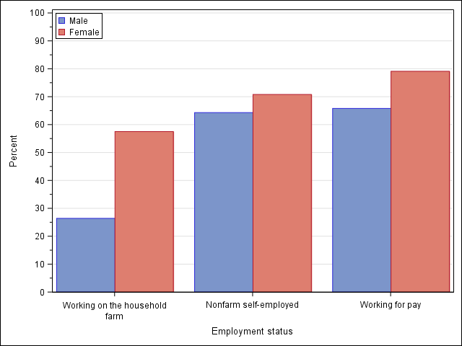

**Figure 4‑15 Average Weekly Hours of Employment and Required Household Production, by Employment Status and Sex, Tanzania**

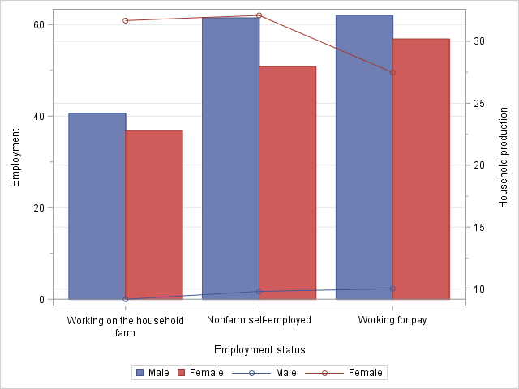

**Note:** The bars indicate hours of employment (left vertical axis) and endpoints of lines indicate hours of required household production (right vertical axis). The rather small category of unpaid nonagricultural family workers has been omitted here.

Men do engage in more hours of employment than women within each employment category (Figure 4-15). But, the gap in hours of employment is quite small compared to the gap in required hours of household production. In the category with the largest share of the population (those working on their own farm), men spent, on average, *four hours* more than women (41 hours versus 37 hours) on employment, but women spent *23 hours* more on meeting household production requirements (9 hours versus 32 hours). Unlike in Ghana, the ordering of time poverty rates across categories of employment status coincided with the ordering of hours of employment for men *and* women. However, just as in Ghana, women working as paid employees had fewer required hours of household production than women in other categories of employment. Therefore, we resorted to the same procedure to ascertain whether this difference could be due to a less unequal division of household production tasks or fewer household-level requirements of household production.

We found that the average value of household-level requirements was lower for female paid employees (72 hours) than for women categorized as working on a household farm (81 hours) and nonfarm self-employed (77 hours). This is consistent with our findings for Ghana. As we saw earlier, average household size tends to be larger in the rural areas. Given that the vast majority of female paid employees are in the urban areas, their lower household-level requirements vis-à-vis those working on the household farm clearly are a reflection of the urban-rural difference in household size. On the other hand, the difference between paid employees and the nonfarm self-employed is largely an intraurban difference, since the latter group is also found preponderantly in urban areas. An examination of our data showed that the combined share of the larger-sized groups (two adults with three or more children and three or more adults with three or more children) among female paid employees was only 23 percent as compared to 48 percent and 33 percent, respectively, among those working on the household farm and those engaged in nonfarm self-employment. However, the share of female paid employees living alone (12 percent) was much higher than those working on the household farm (3 percent) or engaged in nonfarm self-employment (6 percent). Just as in Ghana, we did not find that female paid employees experienced a more egalitarian division of household production. Their share of the household-level requirements of household production was slightly higher than those working on the household farm (45 percent versus 42 percent) and slightly lower than those engaged in nonfarm self-employment (48 percent). In sum, our findings for Tanzania reinforce the observation that female wage workers may possess a greater degree of control over decisions regarding marriage and fertility, i.e., over the size and composition of their household.

### Consumption Poverty and Time Deficits

Turning now to examine the joint distribution of time deficits and poverty status, we begin with the official definition of poverty. Like Ghana, Tanzania also employs a consumption-based measure of poverty. Hence, poverty is defined according to poverty lines specified in terms of minimum necessary consumption expenditures. Employed persons who were below the official poverty line experienced a lower rate of time poverty than those above it for Tanzania as a whole (53 versus 40 percent). This is true also when we break down the time poverty rates by area of residence (rural/urban) and sex (Figure 4-16). The overall gender disparity in the time poverty rate is also visible within the consumption-poor and consumption-nonpoor groups.

**Figure 4‑16 Time Poverty Rates by Official Poverty Status, Area of Residence, and Sex (percent), Employed Persons (15 to 70 years of age), Tanzania**

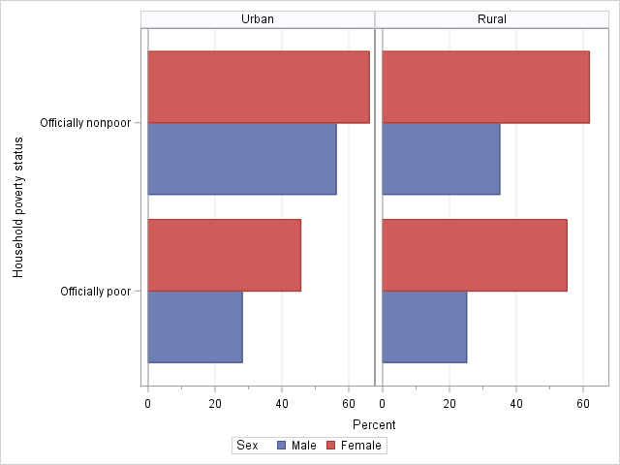

We noted earlier in our discussion of Ghana that households who fall below the official poverty line will not be able, generally, to “buy off” their time deficits without plunging deeper into poverty. Nearly half of all urban poor employed women and over half of all rural poor employed women belonged to such households. As we would expect in light of the gender disparity in time poverty, a smaller proportion—around a quarter—of urban and rural poor men were found in this category. Official thresholds hide the impoverishing effect that time deficits could potentially have on these households. Accounting for time deficits would also reveal the “hidden poor”—time-poor households who are officially consumption-nonpoor but would actually be consumption-poor if they attempt to purchase market substitutes to offset their time deficits.

Working poor, as officially measured, are concentrated somewhat more heavily in the rural areas than all employed persons. While nearly three-fourths of employed persons live in rural areas, a higher proportion of the working poor (86 percent) was rural. This is slightly higher than in Ghana (80 percent). Official poverty rates among the employed in Tanzania reflect the urban-rural divide, as the urban rate is about half of the rural rate (14 percent versus 31 percent). Gender disparity in the official rate of working poverty does exist in the urban areas in the form of a higher rate among women than men (16 percent versus 12 percent) but it is nonexistent in the rural areas (Table 4-6 ).

**Table 4‑6 Poverty among Employed Persons (15 to 70 years of age): Official versus Adjusted, Tanzania**

|  |  |  |  |  |  |  |
| --- | --- | --- | --- | --- | --- | --- |
|  | **Poverty rate (percent)** | | | **Number of poor persons (millions)** | | |
|  | Official | Adjusted | Hidden | Official | Adjusted | Hidden |
| **Urban** | 14.1 | 24.1 | 10.0 | 0.71 | 1.22 | 0.50 |
| **Male** | 12.3 | 21.9 | 9.6 | 0.33 | 0.58 | 0.26 |
| **Female** | 16.2 | 26.6 | 10.4 | 0.38 | 0.63 | 0.25 |
| **Rural** | 30.7 | 40.2 | 9.5 | 4.32 | 5.67 | 1.35 |
| **Male** | 30.9 | 40.6 | 9.7 | 2.12 | 2.79 | 0.66 |
| **Female** | 30.4 | 39.9 | 9.5 | 2.20 | 2.88 | 0.68 |
| **Tanzania** | 26.3 | 36 | 9.7 | 5.03 | 6.89 | 1.85 |
| **Male** | 25.7 | 35.3 | 9.6 | 2.45 | 3.37 | 0.92 |
| **Female** | 26.9 | 36.6 | 9.7 | 2.58 | 3.51 | 0.93 |

**Note:** The numbers in the column “Hidden” are obtained by subtracting the numbers in the column “Official” from those in the column “Adjusted.”

Accounting for time deficits leads to a massive increase in measured poverty among the employed in Tanzania: the poverty rate increased by about 10 percentage points to 36 percent, representing an addition of nearly two million people to the ranks of the working poor. The increase was relatively higher in the urban areas, as reflected in the fact that 18 percent of the adjusted poor as compared to 14 percent of the official poor lived in urban areas. It may be recalled that Ghana also revealed a similar pattern, though the urban share of the hidden poor was much higher in Ghana (43 percent versus 27 percent in Tanzania). The gender disparity in poverty between men and women in the urban areas was unchanged after accounting for time deficits, as was the gender parity among other groups considered here.

**Table 4‑7 Distribution of Employed Persons (15 to 70 years of age) by LIMTCP and Incidence of Time Poverty, Tanzania**

|  |  |  |  |  |  |  |  |
| --- | --- | --- | --- | --- | --- | --- | --- |
|  | **LIMTCP classification of individuals (percent)** | | | | | **Time poverty rate (percent)** | |
|  | Consumption-poor and time-poor | Consumption-poor and time-nonpoor | Consumption-nonpoor and time-poor | Consumption-nonpoor and time-nonpoor | Total | Nonpoor | Poor |
| **Urban** | 13.4 | 10.7 | 44.0 | 31.9 | 100 | 58 | 56 |
| Male | 10.8 | 11.1 | 42.0 | 36.2 | 100 | 54 | 49 |
| Female | 16.4 | 10.2 | 46.3 | 27.0 | 100 | 63 | 62 |
| **Rural** | 19.0 | 21.2 | 27.2 | 32.6 | 100 | 45 | 47 |
| Male | 13.1 | 27.5 | 18.9 | 40.5 | 100 | 32 | 32 |
| Female | 24.7 | 15.2 | 35.1 | 25.1 | 100 | 58 | 62 |
| **Tanzania** | 17.6 | 18.4 | 31.6 | 32.4 | 100 | 49 | 49 |
| Male | 12.4 | 22.9 | 25.4 | 39.3 | 100 | 39 | 35 |
| Female | 22.7 | 14.0 | 37.9 | 25.5 | 100 | 60 | 62 |

Let us now examine the incidence of the double bind, i.e., the proportion of people who are time-poor and consumption-poor (Table 4-7). Consistent with our findings for Ghana, women bear the burden of the double bind more than men: 25 percent and 16 percent of women, respectively, in the rural and urban areas compared to 13 percent and 11 percent among men. The poor-nonpoor gap in the time poverty rate vanishes when the line between the poverty thresholds is adjusted for time deficits. For Tanzania as a whole, about half of all employed persons incur time deficits irrespective of their adjusted poverty status. Among men, time poverty rates are identical for the poor and nonpoor in rural areas, while in the urban areas nonpoor men have a slightly higher rate. Time poverty rates are practically identical among the poor and nonpoor women in urban areas and slightly higher for poor women in rural areas. This contrasts with the finding for Ghana where the ranking of the poor and nonpoor in terms of their time poverty rate was sharply reversed when we switched from the official to the adjusted consumption poverty thresholds.

**Figure 4‑17 Average Weekly Hours of Employment and Required Household Production, by Sex and Adjusted Consumption Poverty Status and Sex, Tanzania**

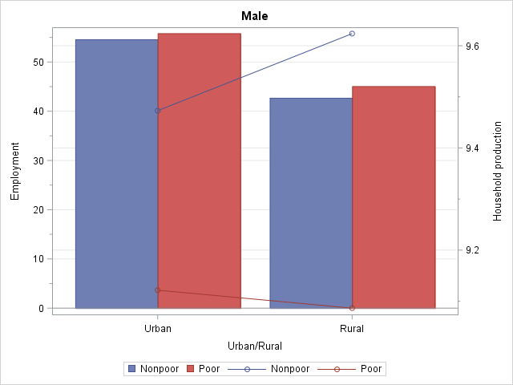 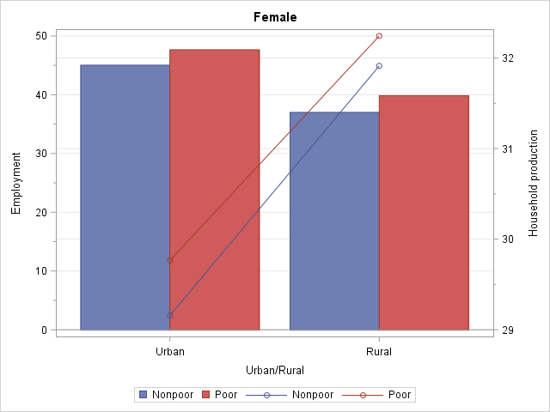

**Note:** The bars indicate hours of employment (left vertical axis) and endpoints of lines indicate hours of required household production (right vertical axis).

What is behind the absence of a notable difference in the incidence of time poverty between the poor and nonpoor groups? Based on our previous analyses, we should expect that there is a concurrence between the groups in terms of hours of employment and required household production. This is indeed confirmed by the data (Figure 4-17). Our estimates show that within urban and rural areas, the average hours of employment show very little difference between poor and nonpoor persons. Similarly, the difference in the average hours of required household production is also quite small. For men, the average falls between 9 hours and 10 hours for all four groups. For women, there is a small urban-rural difference (3 hours per week) in the average hours of required household production but there is no gap between poor and nonpoor women in either area.

In contrast to the pronounced gender disparity among the employed poor in rate of time poverty, there seems to be hardly any difference in the average size of the time deficits of time-poor and consumption-poor individuals for Tanzania as a whole (Figure 4-18). We found a national average difference of only 2 hours in weekly time deficits between poor men and women (29 hours versus 27 hours). This is quite different from Ghana where the poor women’s average time deficit was about 10 hours higher than that of poor men. The gender gap among the poor is higher in urban than in rural areas. However, just as in Ghana, working poor women are the worst-off in terms of the average shortfall: the magnitude of the shortfall, at 37 hours per week, is almost identical to that in Ghana. Further, those above the poverty line fare better than those below it. But, even for the group with the lowest average shortfall (rural nonpoor men), the amount of shortfall still amount to 21 hours per week—almost a full day.

**Figure 4‑18 Time Deficit of Time-poor Employed Men and Women (average weekly hours) by LIMTCP Poverty Status, Tanzania**

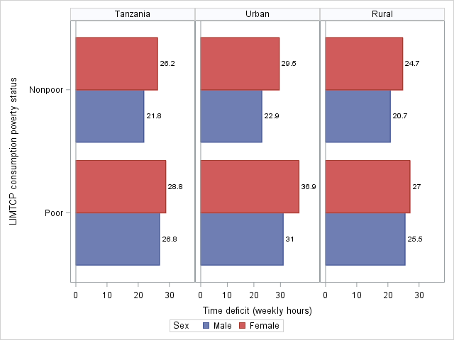

# TIME AND CONSUMPTION POVERTY OF EMPLOYED HOUSEHOLDS

We define “employed households” as households with an employed head, spouse, or both (the employed person should also be between 15 and 70 years of age—the age group for our estimates of time deficits). Almost all employed persons (97 percent in both countries) live in employed households. Therefore, there is no loss of continuity in terms of the underlying sample because of the shift from employed persons (the population we have been discussing in the previous sections) to employed households (the primary unit of analysis in this section).

It is useful to consider the relationship between individual-level and household-level rates of time poverty. Let us recall that a household is considered as time-poor if at least one member of the household is time-poor. We know that, by definition, the following relationships must hold:

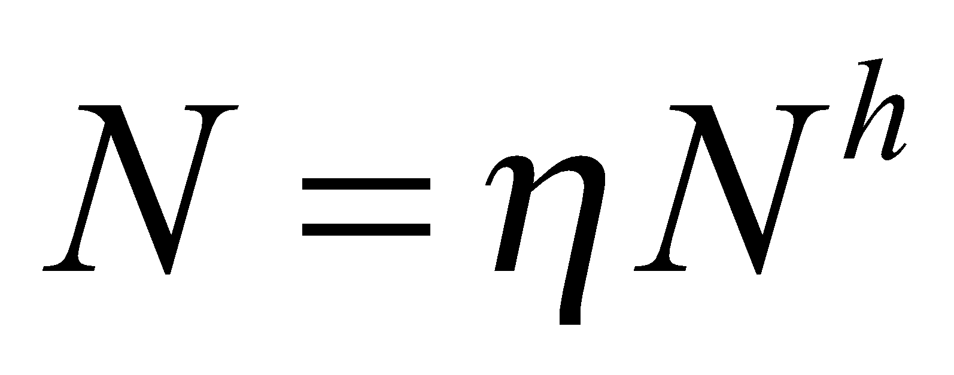 (1)

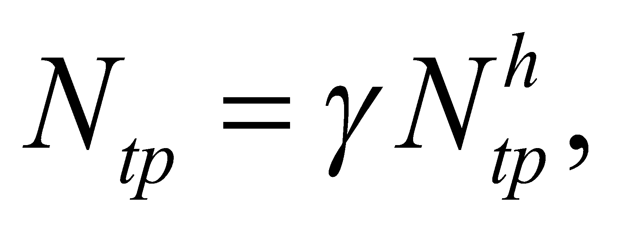 (2)

where is the total number of employed persons, is the average number of employed persons per household, is the total number of households, is the total number of employed time-poor persons,  is the average number of time-poor persons per time-poor household, and is the total number of employed time-poor households. Recalling now the definition of the poverty rate (the number of poor divided by the population) and denoting by  and 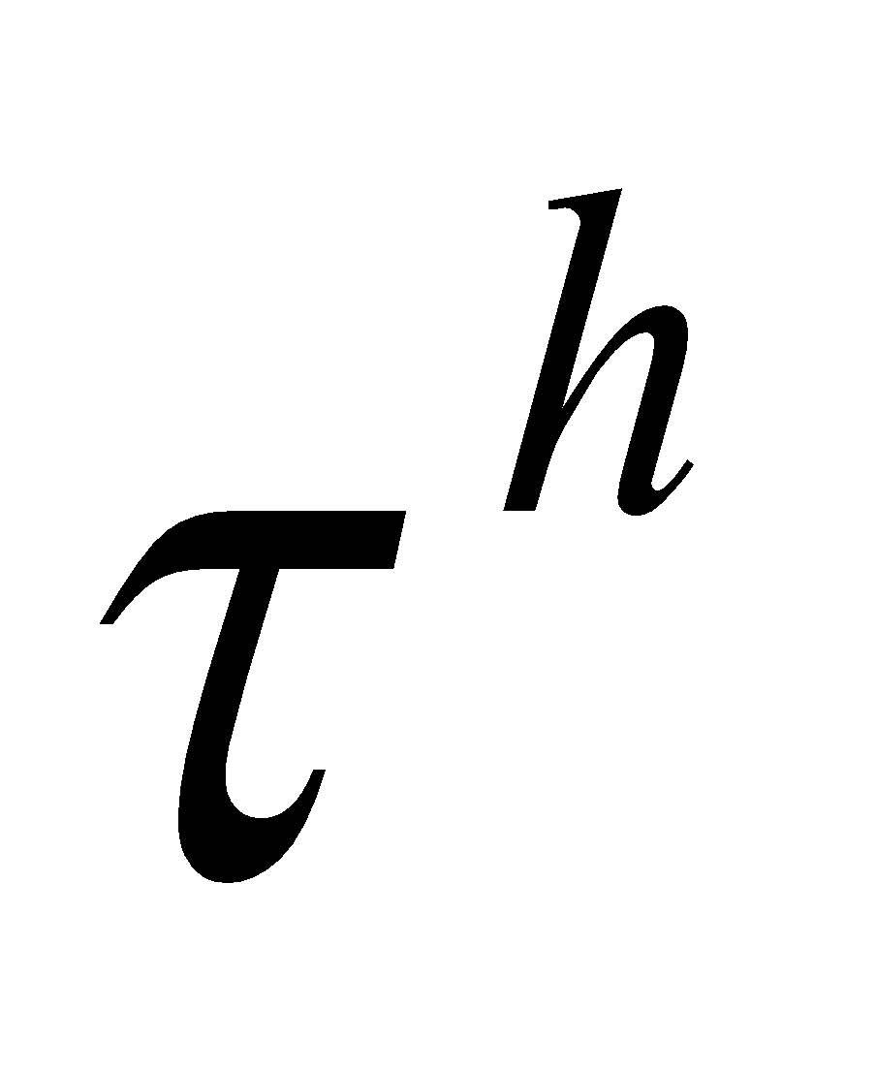 the individual- and household-level rates of time poverty, respectively, we can derive the following relationship:

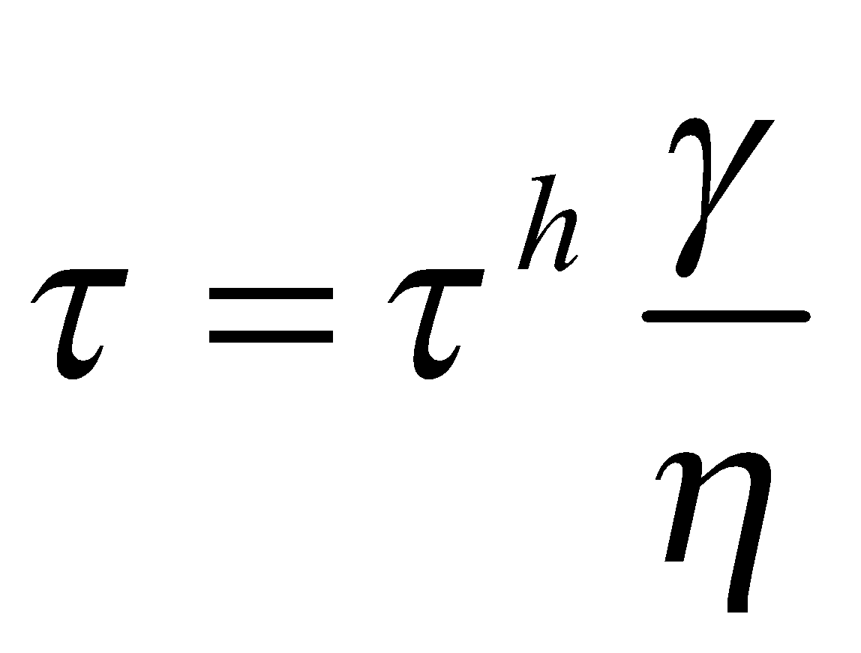 (3)

That is, the individual-level time poverty rate is a scalar multiple of the household-level time poverty rate with the multiple being a ratio of two household-level characteristics.[25] The average number of employed persons per household is an indicator of its level of economic activity. It is likely to be a function of demographic structure, economic circumstances, and social norms. A similar set of forces would also shape the average number of employed time-poor persons per time-poor household, which can be thought of as a measure of the extent of time poverty faced by time-poor households. In general, the average number of employed persons per household will exceed the average number of employed time-poor persons among time-poor households[26] and hence the household-level time poverty rate will be higher than the individual-level time poverty rate. However, the extent to which the ratio would fall below one will be different among population subgroups; consequently, the rankings of subgroups in terms of time poverty rates can display reversals depending on whether the household or individual is chosen as the unit of analysis. For a given level of the household time poverty rate, a higher would imply a greater number of time-poor persons and hence a higher individual time poverty rate; on the other hand, a higher would imply a larger number of employed persons and hence a lower individual time poverty rate. We will discuss some instances of such reversals in what follows.

## Ghana

### Hidden Poverty among Households

Our estimates showed that 3.23 million (55 percent) of the 5.88 million employed households[27] were time-poor, i.e., they had at least one time-poor individual. This is nearly double the rate of time poverty among employed individuals that we reported earlier (Table 4-1). While there was not much of a difference in the incidence of time poverty by urban-rural status, there was a marked disparity between officially poor and nonpoor households (Figure 5-1). The rate of time poverty among poor households was 10 percentage points higher than among nonpoor households (63 percent versus 53 percent). Rural areas displayed a higher poor-nonpoor gap in time poverty than urban areas.

**Figure 5‑1 Incidence of Household Time Poverty by Area of Residence and Official Poverty Status, Ghana**

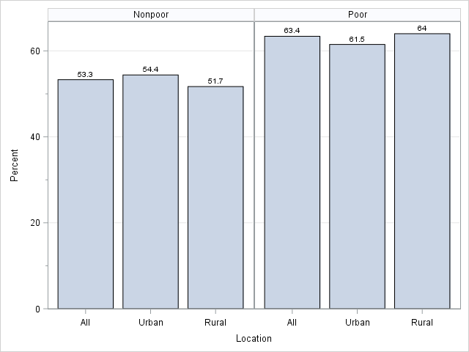

As we noted before (see text above Figure 4-7), the individual-level time poverty rate was lower among the officially poor than the nonpoor (32 percent versus 37 percent)—a pattern that is opposite to what we just observed at the household level. The explanation, as suggested by equation (3), above, lies in the higher average number of employed persons among poor households (2.6 versus 1.8) rather than the difference in the average number of time-poor persons per household (1.3 for both groups). In turn, the higher average number of employed persons in poor households was simply a reflection of the larger average number of the relevant people (persons 15 to 70 years of age, for whom time deficits were calculated) in poor households rather than a higher within-household employment rate. On average, in both poor and nonpoor households, four out of every five individuals in the aforementioned age group worked.

We discussed before the impoverishing effects of time deficits in the context of the estimates for individual-level poverty (Table 4-2). It is, therefore, quite natural that we find that the LIMTCP or adjusted poverty rate among households was substantially higher than the official rate (Table 5-1). The difference of 7.4 percentage points represents roughly 440,000 hidden poor households—an increase of 45 percent in the number of consumption-poor households. Urban areas showed a near doubling (93 percent) and rural areas an increase of less than one-third (31 percent) in the number of consumption-poor households once time poverty is taken into account. As a result, only a thin majority (53 percent) of the hidden poor were located in the rural areas. This finding regarding the urban-rural distribution of the hidden poor amplifies our observation made in discussing individual-level poverty estimates: the hidden poor are decidedly more urban than the official poor because 70 percent of the latter was rural households. Obviously, this is a reflection of the much smaller rural-urban gap in the hidden poverty rate than in overall poverty rate.

**Table 5‑1 Poverty among Employed Households: Official versus Adjusted, Ghana**

|  |  |  |  |  |  |  |
| --- | --- | --- | --- | --- | --- | --- |
|  | **Poverty rate (percent)** | | | **Number of poor households (millions)** | | |
|  | **Official** | **Adjusted** | **Hidden** | **Official** | **Adjusted** | **Hidden** |
| **Ghana** | 16.5 | 23.9 | 7.4 | 0.97 | 1.41 | 0.44 |
| Urban | 6.9 | 13.2 | 6.3 | 0.22 | 0.43 | 0.21 |
| Rural | 28.2 | 36.9 | 8.7 | 0.75 | 0.98 | 0.23 |

**Note:** The numbers in the column “Hidden” are obtained by subtracting the numbers in the column “Official” from those in the column “Adjusted.”

Why is the urban-rural gap so much smaller in the incidence of hidden poverty? By definition, the hidden poor are composed of officially nonpoor households who are time-poor, but do not have the resources to “buy off” their time deficits. We can use this definition to understand and answer the question.

If none of the officially nonpoor households were time-poor, the hidden poverty rate would be zero. Therefore, one factor that determines the magnitude of the hidden poverty rate is the percentage of officially nonpoor, but time-poor, households. This percentage was much higher in the urban than the rural areas (51 percent versus 37 percent). Now, if the officially nonpoor households that incurred time deficits were all able to “buy off” their time deficits, the hidden poverty rate would be zero. The hidden poor are those who cannot buy off their time deficits. Thus, the other factor that determines the size of the hidden poverty rate is the percentage of hidden poor households in the number of officially nonpoor, but time-poor, households. This percentage was notably lower in the urban than the rural areas (13 percent versus 24 percent)—a reflection of the higher average consumption expenditures in urban relative to rural areas. Since the hidden poverty rate is the product of the two factors,[28] the opposing differences in them counteract one another and pull the rates in the two locations close to each other.[29]

Ignoring time deficits leads to a biased picture of the poverty gap or the unmet consumption needs of the consumption-poor households. The poverty gap is defined as the difference between a consumption-poor household’s poverty threshold and consumption expenditures. For the officially poor households that are time-poor, the addition of the monetized value of time deficits to their poverty thresholds results in a bigger measured deficit in their unmet consumption needs. The hidden poor have a poverty gap of zero when official thresholds are used to gauge poverty; however, recognizing the impoverishing effects of time deficits, the monetized value of their time deficits should also be taken into account. Our estimates showed that when time deficits are ignored, the aggregate value of the poverty gap amounted to US$948 million and, when they are incorporated into the measurement of poverty, the value increased almost twofold to US$1,743 million (see Table 5-2). As a proportion of GDP and government final consumption expenditures in 2013, the value of the aggregate adjusted poverty gap was 3.6 percent and 18.3 percent, respectively. While the requirements of national resources for poverty alleviation may appear to some as formidable, it should be emphasized that the actual requirements are bound to be substantially smaller for an appropriately designed strategy centered on employment and supplemented by income support programs. Such a strategy can have sizeable positive multiplier effects on aggregate output as well as government revenues—a topic that we will address in our future research.

**Table 5‑2 Aggregate Annual Consumption Poverty Gap by Measure of Poverty, Ghana (in millions of US$)**

|  |  |
| --- | --- |
|  |  |
| Official | 948 |
| Adjusted | 1,743 |
| **Percent of government expenditure** | |
| Official | 9.9 |
| Adjusted | 18.3 |
| **Percent of GDP** |  |
| Official | 2.0 |
| Adjusted | 3.6 |

**Note:** Government expenditure is measured as government final consumption expenditure. Our source for market exchange rate, GDP, and government expenditure is the World Bank’s “World Development Indicators” database. Available at: databank.worldbank.org. Accessed on August 23, 2016.

Turning from the aggregate- to household-level estimates, it follows immediately from our discussion in the previous paragraph that the official estimates would understate the poverty gap of the officially poor because such estimates do not consider time deficits. As we saw (Figure 5-1), roughly two-thirds of all officially poor households incur time deficits. Incorporating the monetized value of the time deficits showed that the adjusted average gap in Ghana was 2,418 cedi, as against the rosier official gap of 1,908 cedi or about 27 percent higher (Figure 5-2). We found that the adjusted gap was higher than the official gap by a larger proportion in urban than rural Ghana (48 percent versus 26 percent).

**Figure 5‑2 Average Consumption Deficit (nominal yearly values) of Employed Consumption-Poor Households by Subgroup, Ghana**

The higher adjusted gap is due to the uncovering of the hidden deprivation of the officially poor households that are time-poor, as evidenced by the fact that their adjusted average gap of 3,570 cedi was 80 percent higher than the official gap of 1,981 cedi. Once again, the proportionate difference between the adjusted and official estimate was much higher in urban (134 percent) than rural areas (70 percent). Our estimates also reveal that the average poverty gap of the hidden poor was roughly the same size as the average gap suggested by the official picture of poverty (1,314 versus 1,340 cedi). Considering this finding in conjunction with our estimates of the number of the hidden poor (Table 5-1) reveals a major problem with the official picture of poverty: it can lead to the exclusion of a population subgroup from poverty alleviation strategies that is roughly half the size of the officially poor population and has an average poverty gap of the same magnitude as that of the officially poor households.

### Single and Double Binds of Deprivation

Expanding the concept of poverty to include the hidden poor and time deficits of the officially poor by our approach leads to an understanding of the joint distribution of time and consumption poverty. Our estimates showed that a sizeable minority of households (39 percent) faced neither time deficits nor consumption poverty (Figure 5-3). Urban areas saw a higher percentage of such households than rural areas (43 percent versus 35 percent). At the other extreme, a substantial proportion of households, 18 percent nationally, encountered the double bind of time and consumption poverty. Rural households were much more prone to the double bind than urban households (27 percent versus 11 percent). In contrast, the subgroup of households that encountered only time deficits was higher in the urban areas than in rural areas (42 percent versus 35 percent).

**Figure 5‑3 Distribution of Employed Households by LIMTCP (percent), Ghana**

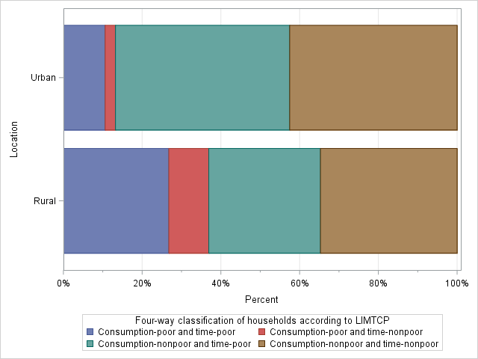

Given the equal incidence of household time poverty in urban and rural areas (55 percent), differences between the rural and urban areas noted above stem from the higher incidence of consumption poverty in the rural areas. As a result, the proportion of households that suffer from the double bind is higher in the rural areas while the proportion of households that encounter only time deficits is higher in the urban areas. The urban and rural areas are, however, very similar when it comes to the question of who is more prone to time poverty: in both cases, the incidence among the consumption-poor is much higher than among the nonpoor (Figure 5-4). This is consistent with our finding reported earlier (Table 4-3), that poor employed individuals had a higher incidence of time poverty compared to the nonpoor. As we would expect, the poor-nonpoor gap in incidence is much higher when we reckon consumption poverty by the LIMTCP (adjusted) than by the official poverty thresholds. The hidden poor households that we add to the ranks of the consumption-poor are *all* time-poor households. Thus, we increase the number of the time-poor households among the consumption-poor and decrease their number among the consumption-nonpoor, thereby leading to a widening of the gap in the time poverty rate across the consumption-poor/nonpoor divide. Time deficits emerge as a pervasive problem among the less well-off Ghanaian households, as about three-quarters of consumption-poor Ghanaian households are time-poor compared to about half of consumption-nonpoor households—a stark difference of 26 percentage points.[30]

**Figure 5‑4 Incidence of Household Time Poverty by Area of Residence and Adjusted Consumption Poverty Status, Ghana**

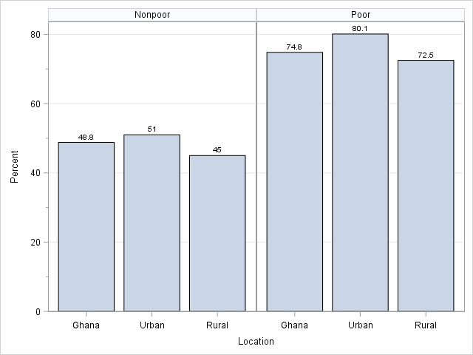

### Time Deficits and the Distribution of Household Economic “Welfare”

We discussed earlier the factors behind the higher rates of *individual* time poverty among the employed poor—their higher average hours of employment *and* higher average hours of required household production compared to the consumption-nonpoor (see the discussion around Figure 4-3 and Table 4-4). We also pointed out that the larger average size of poor households along with inadequate physical and social infrastructure[31] may account for the higher thresholds of household production. *Household* time poverty rates are lower for the nonpoor than the poor, as we just saw. But this finding does not shed light on the relationship between the time poverty rate and the extent to which the household is away from the poverty line. To gain some insight into this issue, we can operationalize the latter notion by constructing the household’s “resources-to-needs” ratio (a measure of economic “welfare”) as is often done in the analysis of poverty (e.g., Citro and Michael [1995] and Short and Smeeding [2012]). In our context, “resources” refer to consumption expenditures and “needs” to the LIMTCP consumption poverty thresholds. We abbreviate this ratio as the “RN ratio” below for convenience. The RN ratio will be below one for households below the poverty line, exactly equal to one for households at the poverty line, and greater than one for households above the poverty line.

To address our question, we can obtain a ranking of households with respect to the RN ratio (just as we could do, for example, with respect to household income) and then examine how the incidence of time poverty varies across that distribution. In order to have a reasonably large number of observations in each group, we chose to perform the ranking in terms of the deciles of RN ratio, calculated separately for urban and rural areas because of the huge gap in consumption poverty between the two areas. In the rural distribution, the bottom three deciles consisted entirely of consumption-poor households and 69 percent of the fourth decile also was consumption-poor. Reflecting the lower consumption poverty rate in the urban areas, only the bottom decile of the urban distribution was made up entirely of consumption-poor households, while those in the second decile (about 32 percent of households) were also consumption-poor. These facts are worth bearing in mind in assessing the results shown in Figure 5-5. The composition of the urban and rural deciles just described translates into a consumption poverty rate of 37 percent and 13 percent in the rural and urban areas, respectively, as we reported earlier (Table 5-1).

The time poverty rate among households falls steadily as we move further away from the LIMTCP (adjusted) poverty line. This holds true for the poor and nonpoor alike in both urban and rural areas. Although the rate of time poverty does fall as we move on to the higher deciles of the ratio, the majority of households (over 50 percent) in every decile remain time-poor until the sixth (rural) or seventh (urban) decile. Even at the very top decile, over one-fifth of households encounter time deficits.

**Figure 5‑5 Household Time Poverty Rate (percent) by Decile of the Ratio of Consumption Expenditures to LIMTCP Poverty Threshold, Ghana**

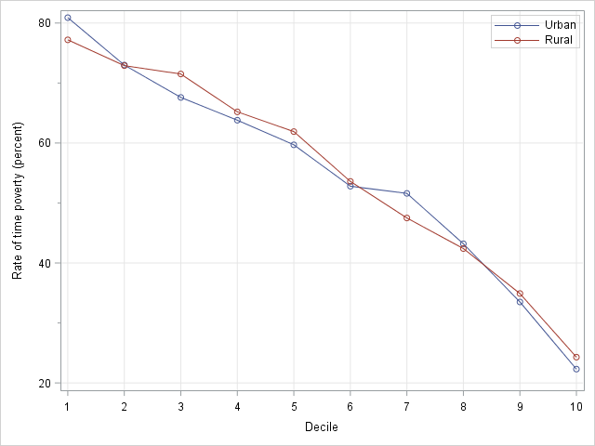

**Note:** (i) The deciles were computed separately for rural and urban areas. (ii) In the rural distribution, the bottom three deciles consisted entirely of consumption-poor households and 69 percent of the fourth decile also was consumption-poor. Only the bottom decile of the urban distribution was made up entirely of consumption-poor households, while in the second decile about 32 percent of households were also consumption-poor.

The key factor behind the inverse relationship between the household time poverty rate and decile of the RN ratio is that the household-level thresholds of household production tend to fall as we move up the deciles (Figure 5-6, left panel). As we noted earlier, the higher thresholds of household production in the lower deciles may be due to the fact that poorer large households tend to be situated in areas with poor social and physical infrastructure, which makes several tasks of household production (e.g., collecting water) more time consuming. Another reason, which we can observe directly in the data at hand, is that the households in the higher deciles tend to be smaller in size (Figure 5-6, right panel).

**Figure 5‑6 Average Weekly Hours of Required Household Production per Household (left panel) and Average Household Size (right panel) by Decile of the Ratio of Consumption Expenditures to LIMTCP Poverty Threshold, Ghana**

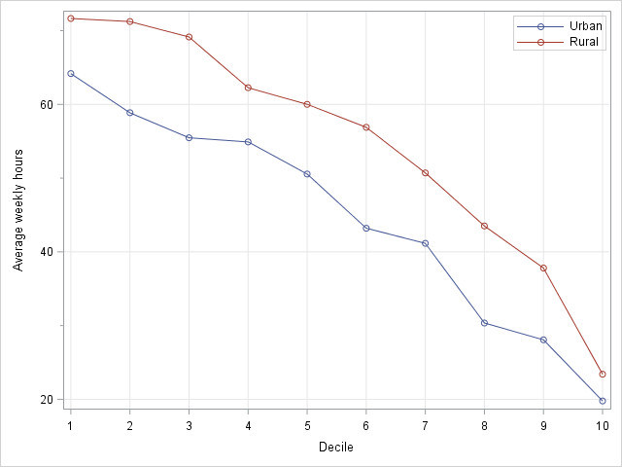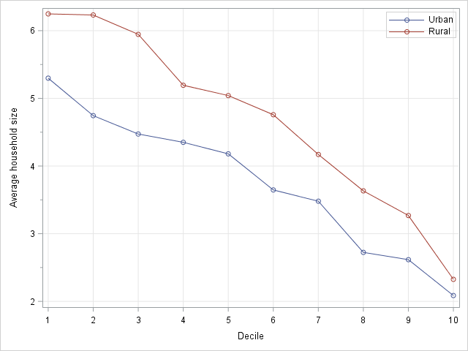

**Note:** (i) The deciles were computed separately for rural and urban areas. (ii) In the rural distribution, the bottom three deciles consisted entirely of consumption-poor households and 69 percent of the fourth decile also was consumption-poor. Only the bottom decile of the urban distribution was made up entirely of consumption-poor households, while in the second decile about 32 percent of households were also consumption-poor.

The inverse relationship between the decile of the ratio and average household size is partly mechanical since poverty thresholds are lower for smaller households. Even if two households have the same level of expenditures, the smaller of them would have a higher RN ratio and thus possibly belong to a higher decile than the larger household. However, the crucial factor behind the increase in the ratio as we move up the distribution is the increase in average consumption expenditures among households rather than the fall in the average poverty threshold. As shown in Figure 5-7, the absolute increase in consumption expenditures from one decile to another is generally far higher than the absolute decrease in the poverty threshold from one decile to another, especially as we move to the upper deciles. This is what we would expect since the distribution of household size tends to be far more equal than the distribution of consumption expenditures among households.

**Figure 5‑7 Household Consumption Expenditures and LIMTCP Poverty Line by Decile of the Ratio of Consumption Expenditures to LIMTCP Poverty Threshold (average yearly values in nominal cedi), Ghana**

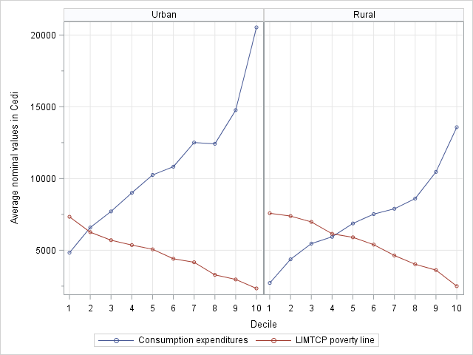

**Note:** (i) The deciles were computed separately for rural and urban areas. (ii) In the rural distribution, the bottom three deciles consisted entirely of consumption-poor households and 69 percent of the fourth decile also was consumption-poor. Only the bottom decile of the urban distribution was made up entirely of consumption-poor households, while in the second decile about 32 percent of households were also consumption-poor.

The impoverishing effects of time deficits on a time-poor household depend on the household’s position in the distribution of economic well-being. As we have seen, households that cannot afford to replace their time deficits in household production with market substitutes without falling into (or deeper into) poverty are included in our category of consumption-poor households. Nonpoor households can, in principle, “buy off” their time deficits with market substitutes. The monetized value of the household’s time deficit, when expressed as a percentage of its consumption expenditures, indicates the percentage increase in consumption expenditures that would be required to maintain the current standard of living while avoiding deficits in its household production needs.

Our estimates for time-poor households showed that the monetized value of the time deficit amounted, on average, to 41 percent of the consumption expenditures of the consumption-poor and 11 percent of the consumption expenditures of the nonpoor (Figure 5-8). To put the magnitude of the impoverishing burden imposed by time deficits in perspective, let us note that *total* nonfood expenditures were, on average, 41 percent of the budget of households that were both time- and consumption-poor. The average monetized value of time deficits was higher for the urban poor than the rural poor households not only in relative terms, as shown in Figure 5-8, but it was also higher in absolute terms by about 39 percent (2,513 cedi versus 1,804 cedi). Some of the difference in the absolute values is due to the fact the unit replacement cost of household production (after adjusting for regional price differences) is higher in the urban than the rural areas (1.14 cedi per hour versus 1.02 cedi per hour). But the bulk of the difference stemmed from the greater number of hours of time deficits: the weekly time deficit in the urban areas was 42 hours as compared to 34 hours in the rural areas (Figure 5-9). The urban poor households are therefore faced with higher vulnerability to time poverty and higher levels of time deficits than their rural counterparts.

**Figure 5‑8 Monetized Value of Household Time Deficits as a Percent of Household Consumption Expenditures of Time-Poor Households by LIMTCP Poverty Status, Ghana**

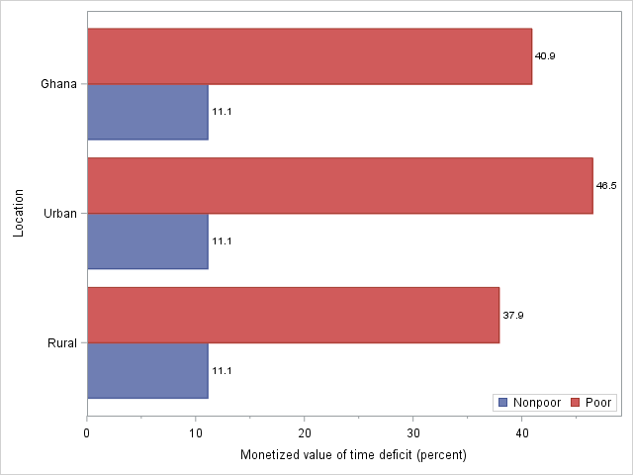

**Figure 5‑9 Household Time Deficits of Time-Poor Households by LIMTCP Poverty Status (weekly hours), Ghana**

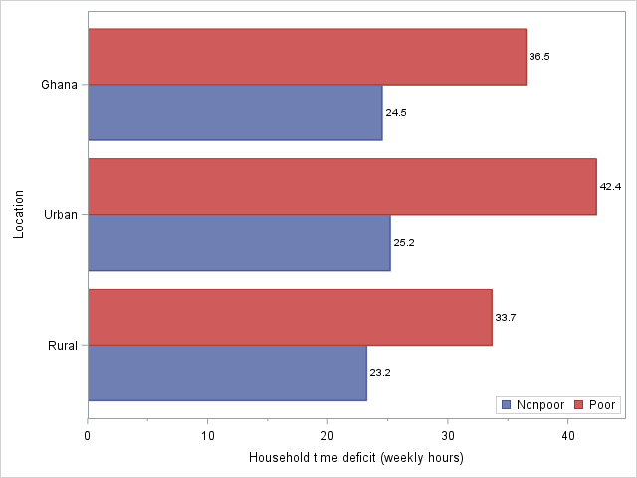

While the magnitude of the monetized value of the time deficits is much smaller for the time-poor and consumption-nonpoor households than the households in the double bind, it is still sizeable, as revealed by the fact that only the largest of the 11 major categories of nonfood expenditures[32] (i.e., education) had an equivalent budget share of 11 percent. The shares of the next-largest categories (transportation and housing) fell slightly below (10 percent and 9 percent, respectively) the proportion of the monetized value of time deficits to consumption expenditures. If we consider the distribution as a whole, we can see that the proportion of the value of the time deficits with respect to total consumption falls below 10 percent only in the seventh decile in the urban distribution and in the eighth decile in the rural distribution (Figure 5-10). In the urban seventh decile, only three budget shares—education (14 percent), housing, and transportation (10 percent each)—registered a higher proportion, while in the rural eighth decile none did, though education (8 percent) came very close. “Buying off” time deficits can thus be a relatively expensive proposition for many households that are above the adjusted poverty line. Indeed, exercising that option may be viable even for many middle-income families only by cutting back on other expenditures (e.g., clothing or healthcare) or going into debt.

**Figure 5‑10 Monetized Value of Household Time Deficits as a Percent of Household Consumption Expenditures by Decile of the Ratio of Consumption Expenditures to LIMTCP Poverty Threshold, Ghana**

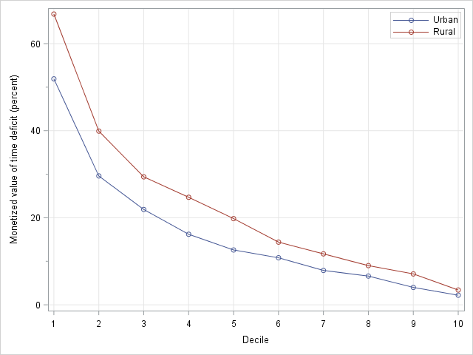

**Note:** (i) The deciles were computed separately for rural and urban areas. (ii) In the rural distribution, the bottom three deciles consisted entirely of consumption-poor households and 69 percent of the fourth decile also was consumption-poor. Only the bottom decile of the urban distribution was made up entirely of consumption-poor households, while in the second decile about 32 percent of households were also consumption-poor.

### Household Structure and Poverty

#### Typology and household-level estimates of consumption and time poverty

Living arrangements differ considerably among people in a nation, reflecting economic, social, cultural, and demographic factors. This is normally represented quantitatively by the notion of household or family structure (see Lloyd [1999] for a general discussion). While a variety of classifications are possible, the particular schema chosen here reflects our focus. Thresholds for consumption and time poverty differ systematically by the number of adults and children in the household. Resources available to households to meet consumption requirements depend primarily on their capacity to generate income or income equivalents (e.g., own-production of food grains), which depends, inter alia, on the sex, age, and number of household members. Time available for individuals to meet the requirements of household production also depends on the above factors as well as the gendered nature of the division of responsibilities of paid and unpaid work. In light of these considerations, we resorted to a classification of households according to the sex and marital status of the head, relationships between people in the household,[33] and the presence of children. While the schema is far from perfect, we believe that it is useful in understanding gender divisions and economic well-being.

The distribution of the population in employed households among the different types of households is shown in Table 5-3. In our schema, the first four categories of households have an unmarried (i.e., single) head. The four categories are based on the number of persons in the household (one versus more than one), sex of the head, and presence of children. Altogether, 27.5 percent of the population lives in households headed by a single person. The dominant subgroup here is single-female-headed households with children, which accounts for 17.4 percent of the total population. Households with a married head make up the final four categories. The categorization relies on the number of persons in the household (two versus more than two), presence of children, and presence of extended-family adults.[34] The majority of the population, 72.5 percent, lives in households headed by a married person (“married-couple” households). Married-couple households with children and no extended-family adults constitute the largest group, with 58 percent of the population. We use this rather cumbersome designation for this type of household because although most of the families (85 percent) in this group are nuclear families, the remainder is made up of extended families with at least one member (under the age of 18) who is outside the nuclear family. The next-largest group of married-couple families is married-couple households with children and extended-family adults (roughly 10 percent of the population).[35]

**Table 5‑3 Distribution of Individuals in Employed Households by Type of Household, Ghana**

|  |  |  |
| --- | --- | --- |
| **Type of household** | **Number (in thousands)** | **Percent** |
| **Head only** | 1,050 | 4.3 |
| Single-female head with children | 4,283 | 17.4 |
| Single-male head with children | 710 | 2.9 |
| Other households with a single head | 713 | 2.9 |
| **Head and spouse only** | 574 | 2.3 |
| Head and spouse with children and no extended-family adults | 14,234 | 58.0 |
| Head, spouse, children and extended-family adults | 2,432 | 9.9 |
| Other married-couple households | 552 | 2.2 |
| **All** | 24,549 | 100.0 |

Estimates of consumption poverty showed that its incidence is highest among married-couple households with children and extended-family adults (Table 5-4). They were followed by married-couple households with children and without extended-family adults. Households with children headed by a single person appear to be equally prone to poverty, irrespective of the gender of the head, when we use our LIMTCP (adjusted) poverty line; in contrast, the official poverty line deemed single-male-headed households as more prone to poverty than single female-headed households because it ignores the impoverishing effects of time deficits. Among households with children, the poverty rates of single-female-headed households are much lower than married-couple households.[36] There are two proximate reasons for this. First, the majority (60 percent) of single-female-headed households are located in the urban areas compared to fewer than half of the married-couple without extended-family adults (49 percent) and married-couple with extended-family adults (43 percent). Thus, part of the difference is due to worse economic conditions and lower earnings, which translate into the higher poverty rate in rural versus urban areas. Second, within rural areas, single-female-headed households have lower average household consumption expenditures but are also smaller in size than married-couple households. The median number of persons in single-female-headed households is four compared to five in married-couple households without extended-family adults and seven in married-couple households with extended-family adults. As smaller family size translates into a lower poverty line, the effect of the higher average consumption expenditures of married-couple households was not enough to offset the augmenting effect of the size differential on the poverty line.

**Table 5‑4 Poverty among Employed Households by Type of Household: Official versus Adjusted, Ghana**

|  |  |  |  |  |  |  |
| --- | --- | --- | --- | --- | --- | --- |
| **Type of household** | **Poverty rate of households (percent)** | | | **Number of poor individuals (thousands)** | | |
| Official | Adjusted | Hidden | Official | Adjusted | Hidden |
| **All** | 16.5 | 23.9 | 7.4 | 5,949 | 8,044 | 2,094 |
| **Head only** | 3.5 | 6.1 | 2.6 | 37 | 64 | 27 |
| Single-female head with children | 16.5 | 24.8 | 8.3 | 894 | 1,281 | 386 |
| Single-male head with children | 20 | 25.5 | 5.5 | 178 | 220 | 42 |
| Other households with a single head | 8.5 | 11.3 | 2.8 | 68 | 85 | 17 |
| **Head and spouse only** | 5.5 | 8.4 | 2.9 | 32 | 49 | 17 |
| Head and spouse with children and no extended-family adults | 21.9 | 32.2 | 10.3 | 3,796 | 5,182 | 1,386 |
| Head, spouse, children and extended-family adults | 31.8 | 41.2 | 9.4 | 880 | 1,092 | 212 |
| Other married-couple households | 11.4 | 12.8 | 1.4 | 63 | 70 | 7 |

Married-couple households with children and without extended-family adults account for the highest share of poor persons (64 percent), followed by those in a single-female-headed household with children (16 percent), and married-couple households with children and extended-family adults (14 percent). The composition of the poor by type of household does not differ much between poverty measures. In fact, the rates of hidden poverty are very similar across the three major groups of households with children. The stark difference in the poverty rate between households with and without children is indicative of the exposure of the future generation to the damaging effects of deprivation. Indeed, households with children made up nearly 90 percent of all poor households (estimate not shown in the table).

We had noted earlier the higher rate of time poverty, average hours of time deficit, and average monetized value of time deficits among consumption-poor households as compared to consumption-nonpoor households. Was that merely due to a difference in the household-type mix that made up the poor versus nonpoor households? In other words, the estimates that we just presented regarding the composition of the consumption-poor households by type of household suggest that married-couple households with children make up a disproportionate share of the consumption-poor households. Given that the thresholds of household production are higher for these types of families, the difference in the incidence of time poverty and size of time deficits among the poor and nonpoor may merely be an artifact of their compositional differences. In fact, however, we found that the rate of time poverty was notably higher among the consumption-poor *within* each type of household (Figure 5-11).[37] The poor-nonpoor gap seems to be particularly pronounced among single-female-headed and married-couple households (with no extended-family adults).

**Figure 5‑11 Rate of Time Poverty (percent) by Type of Household, Employed Households, Ghana**

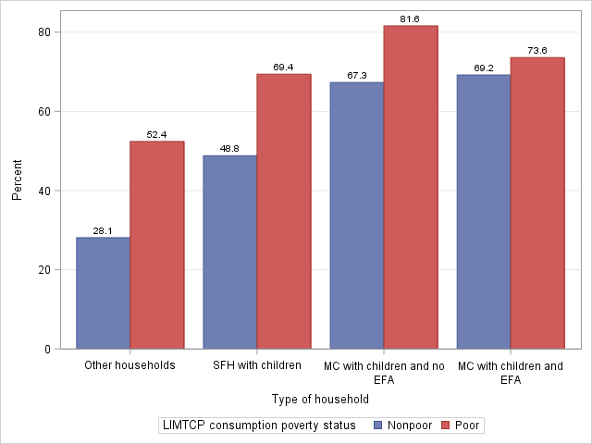

**Note:** SFH=single-female headed; MC=married couple; EFA=extended-family adult(s)

Just as with the incidence of time deficits, the size of the time deficit for consumption-poor and time-poor households was also larger than that of consumption-nonpoor and time-poor households within each household type (Figure 5-12, Panel A). The ranking of household types in terms of the amount of their time deficits puts married-couple households with extended-family adult(s) first, followed by married-couple households without extended-family adults, and single-female-headed households. Part of the reason behind the ordering is simply mechanical: the higher the number of adults, the higher the incidence of time deficits. As we mentioned above, the monetized value of the time deficits represents the expenditures that would be required for a time-poor household to maintain the minimum level of household production. Since the poor, by definition, have lower average consumption expenditures, our finding regarding the poor-nonpoor gap in time deficits imply that, as a percent of consumption expenditures, the monetized value of the time deficits would be higher for consumption-poor households than for consumption-nonpoor households (Figure 5-12, Panel B). Average household expenditures are highest for married-couple households with extended-family adult(s). Married-couple households without extended-family adult(s) and single-female-headed households follow them in succession. This explains why the relative monetized value of the time deficits is higher for single-female-headed households than that of married-couple households without extended-family adults, and also why it is higher for the latter than that of married-couple households with extended-family adult(s).

**Figure 5‑12 Average Household Time Deficits and Monetized Value of Time Deficits (as a percent of consumption expenditures) of Time-Poor Employed Households by Type of Household and Consumption Poverty Status, Ghana**

**Panel A: Average Weekly Hours of Household Time Deficits**

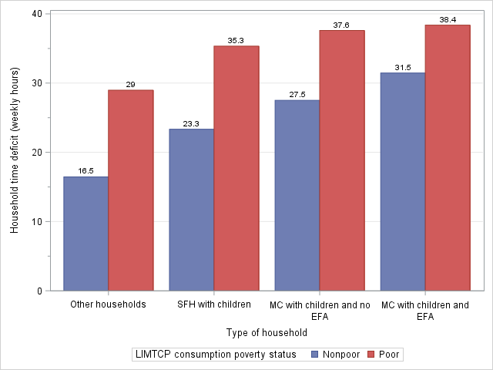

**Panel B: Average Monetized Value of Household Time Deficits as a Percent of Consumption Expenditures**

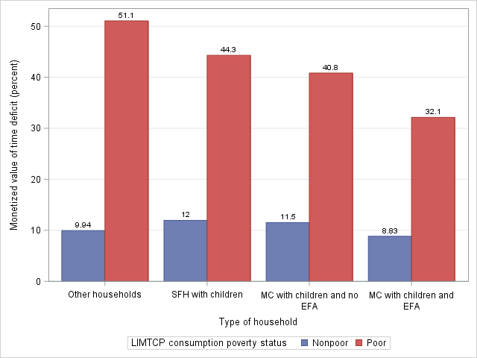

**Note:** SFH=single-female headed; MC=married couple; EFA=extended-family adult(s)

The differentials in time poverty by consumption poverty status are also reflected in the differentials between types of household in the joint incidence of consumption and time poverty (Figure 5-13). The double bind of consumption and time poverty is the highest for married-couple households with extended-family adults (30 percent), followed by married-couple households without extended-family adults (26 percent), and then single-female-headed families (17 percent). The gap between these three groups and the residual category of “Other households” is quite large since the incidence of the double bind was only 5 percent for “Other households”—a reflection of their substantially lower rate of consumption poverty. On the other hand, the share of households without time or consumption deficits is the highest among “Other households,” followed by single-female-headed households (39 percent). Married-couple families with children present a different picture, as only a much lower proportion of them (around 20 percent) falls into this category.

**Figure 5‑13 Distribution of Employed Households by Type of Household and LIMTCP (percent), Ghana**

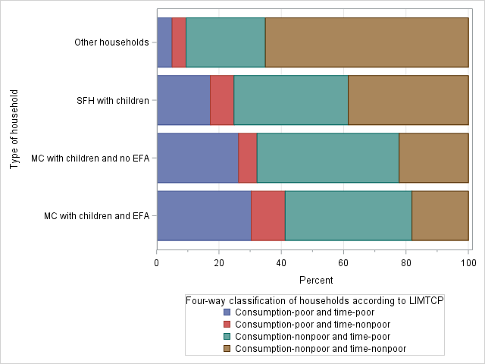

**Note:** SFH=single-female headed; MC=married couple; EFA=extended-family adult(s)

#### Household structure and gender differentials in deprivation

Patriarchy imposes higher demands on women than men with respect to household production tasks. The resulting gender inequality manifests itself within households where both sexes are present. It is also expressed in household structure by a greater preponderance of single-female-headed families than single-male-headed families. In our approach, gender inequality in household production is captured in the disparity in required hours of household production. The main effect of the inequality is on time deficits of employed people: women tend to have higher rates of time poverty than men even when both engage in similar hours of employment, and women with higher required hours of household production tend to have higher rates of time poverty than women with lower required hours.

We first investigate the nature of these inequalities in married-couple households with children. As we would expect, women are far more vulnerable to time deficits than men in these households (Figure 5-14). Within each combination of consumption poverty status and household type, women incur substantially higher rates of time poverty than men.

**Figure 5‑14 Time Poverty Rates of Employed Men and Women (15 to 70 years of age) in Married-Couple Households with Children (percent), Ghana**

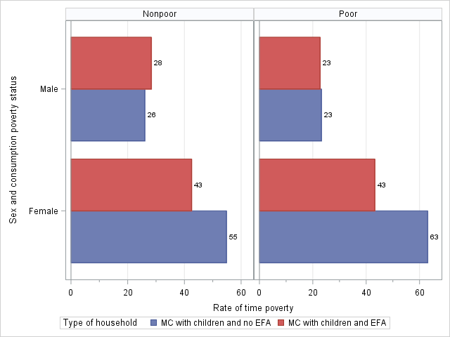

**Note:** MC=married couple; EFA=extended-family adult(s)

Once again, gender gaps in hours of employment are dwarfed by gaps in required hours of household production (Figure 5-15). The amount by which women’s average hours of employment fall short of the average hours of men is more than offset by the amount by which women’s average required hours of household production exceed the average hours of men. The estimates also indicate a gender-specific effect of household structure: specifically, the time poverty rates of women in families with extended-family adults are lower than for women in families without extended-family adults. In contrast, we found little difference in the time poverty rates of men living in these two types of families. The presence of adult members of the extended family helps to reduce the time pressure faced by women in married-couple families presumably by the sharing of household responsibilities among them.

**Figure 5‑15 Employment and Required Household Production of Employed Men and Women in Married-Couple Households with Children (weekly hours), Ghana**

**Panel A: Weekly Hours of Employment (average values)**

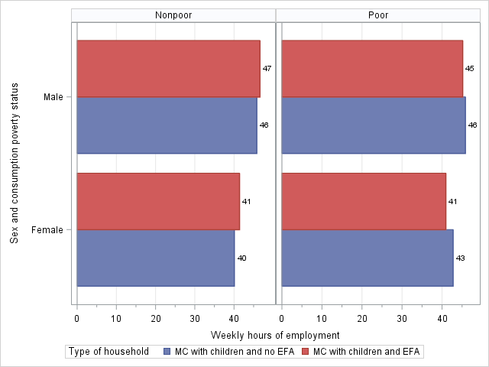

**Panel B: Required Weekly Hours of Household Production (average values)**

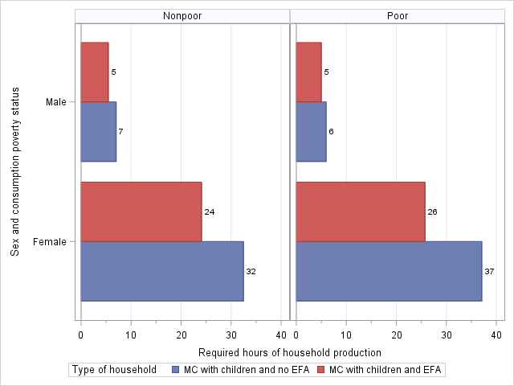

**Note:** MC=married couple; EFA=extended-family adult(s)

Unlike in the case of household-level time poverty rates, we did not find any pronounced differences between the poor and nonpoor groups, except for women in families without extended-family adults. In the latter type of families, poor women encountered much higher rates of time poverty than their nonpoor counterparts. Overall, our findings suggest that poor women in married-couple families without any extended-family adults engage in a greater number of average hours of employment than their nonpoor counterparts, face the highest average number of required hours of household production, and suffer from the highest rates of time poverty.

In married-couple households with children, the main type of gender disparity in household production is that between husbands and wives. We focus here on households where both the wife and husband are employed—referred to below as “dual-earner” households.[38] Consistent with the gender disparity in the incidence of time poverty that we observed earlier (see Figure 4-2), wives are much more prone to time deficits than husbands, even after we control for hours of employment, presence of extended-family adult(s) in the household, and LIMTCP consumption poverty status (Figure 5-16). Focusing on the interval of hours of employment that contains the largest share of employed persons (36 hours to 50 hours per week), we can see that the nonpoor husbands have roughly the same rate of time poverty—about 10 percent—irrespective of whether they live in a household with at least one extended-family adult. In contrast, the time poverty rate of wives in nonpoor households with extended-family adult(s) was *40 percentage points higher*; for wives in nonpoor households without an extended-family adult the gap was even higher at *60 percentage points*. A similar pattern of disparity in the rate of time poverty can also be observed between poor husbands and poor wives employed between 36–50 hours per week. The gender disparity in time poverty is far less notable among husbands and wives with very long (i.e., more than 61 hours per week) hours at the job, as the overwhelming bulk of individuals in this group are, in fact, time-poor.

**Figure 5‑16 Incidence of Time Poverty among Employed Husbands and Wives (15 to 70 years of age) in Households with Children (percent), Ghana**

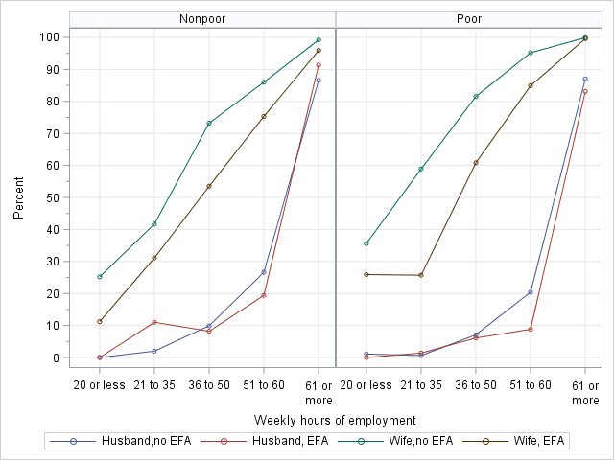

**Note:** EFA=extended-family adult(s)

As we pointed out above, the presence of extended-family adult(s) makes a sizeable difference to the incidence of time poverty among women because of the potential sharing of household responsibilities. Our estimates show that wives who had extended-family adult(s) in their household were much less prone to time poverty than wives who had no such extra potential help. This holds true for both poor and nonpoor women, irrespective of their weekly hours of employment. Adult members of the extended family are predominantly female (60 percent). Further, almost half of female extended-family members are nonemployed. Female extended-family members bear a substantial share of overall household production in poor (28 percent) and nonpoor (31 percent) households.

The direct effect of the phenomena can be seen in Figure 5-17. The average required hours of household production are notably lower for wives in households with extended-family adults as compared to wives in households without such adults. A comparison among husbands does not strongly suggest a similar pattern; in any case, the differentials are quite small here because husbands in both groups encounter rather low levels of required household production (the range is between 3 hours and 9 hours per week).

**Figure 5‑17 Weekly Hours of Required Household Production among Employed Husbands and Wives (15 to 70 years of age) in Households with Children (average values), Ghana**

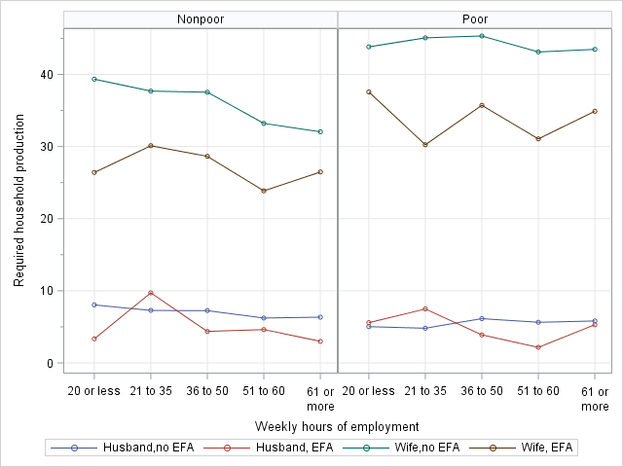

**Note:** EFA=Extended-family adult(s)

Wives in consumption-poor households with no extended-family adult(s) truly fit the description of employed women with a “second shift,” since their average required hours of household production amount to a full-time job of 40-plus hours per week. They encounter the highest level of required household production of all the groups that we have considered here. We also found that wives in consumption-poor households faced notably higher levels of required household production than those in consumption-nonpoor households in both types of married-couple households. This is a reflection of the larger average size of the household (and the attendant higher household-level thresholds of household production) among the poor in each type of household. We estimated that the average size of poor and nonpoor households with extended-family adult(s) was, respectively, 7.67 and 6.97 persons; the average household-level thresholds in the poor households was 86 hours per week, which stood 6 hours above that of the nonpoor households. The higher level of required household production for the poor wives was also due to the higher share of overall household responsibilities that fell upon them. We found that the average share of the household-level threshold of household production borne by poor and nonpoor wives was 40 percent and 36 percent, respectively. Similarly, among households without extended-family adults, the poor wives’ average share was also higher than that of nonpoor wives (64 percent and 58 percent, respectively) while the average size of the poor household was larger than the nonpoor household (5.80 persons versus 5.05 persons). Both demographic factors and intrahousehold gender equity are at work in imposing the higher number of required hours of household production on wives in poor households.

We conclude this section by considering the joint distribution of consumption poverty status and time poverty status among husbands and wives (Figure 5-18) in households with children. Roughly 25 percent of wives suffer from the double bind of consumption and time deficits compared to 17 percent of all employed women (see Table 5-5). In contrast, about 10 percent of husbands encountered the double bind, slightly higher than the incidence among all employed men (7 percent). We also found that in households without extended-family adult(s), about half (48 percent) of all husbands faced neither time nor consumption deficits, while only a quarter (24 percent) of wives were in a similar situation. The disparity between husbands and wives in this regard is smaller in households with extended-family adults: 39 percent of husbands and 28 percent of wives were subject to neither time nor consumption deficits. These findings reinforce the idea that if we were to focus only on deprivations in consumption, we would have concluded that both husbands and wives were equally prone to deprivation; taking time deficits into account clearly shows the additional vulnerabilities placed upon wives by their reproductive roles.

**Figure 5‑18 Distribution of Employed Husbands and Wives (15 to 70 years of age) by LIMTCP (percent), Ghana**

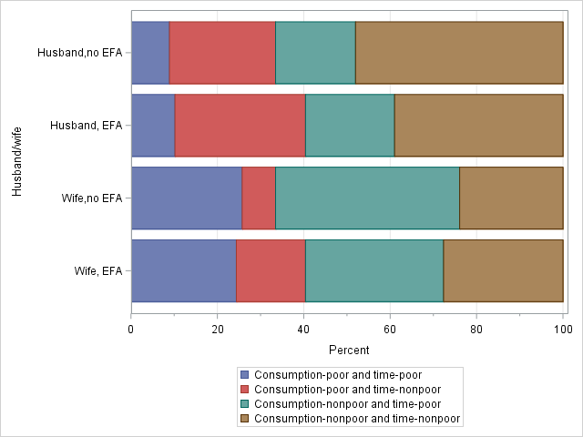

## Tanzania

### Hidden Poverty among Households

A clear majority of employed households[39] in Tanzania had at least one person with time deficits (Figure 5-19). Of the 7.85 million employed households, we found that 6.10 million (78 percent) were time-poor, i.e., they had at least one time-poor individual. As we would expect, the incidence of time poverty among households is far higher than among the employed individuals (42 percent) that we reported earlier (Table 4-5). The incidence of household time poverty was identical in rural and urban areas. However, the officially nonpoor households encountered a somewhat higher rate of time poverty than the poor (79 percent versus 74 percent) and the nonpoor-poor gap in time poverty was higher in urban areas.

**Figure 5‑19 Incidence of Household Time Poverty by Area of Residence and Official Poverty Status, Tanzania**

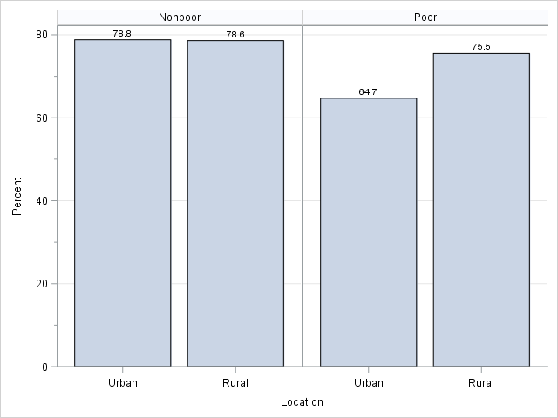

We saw earlier that accounting for time deficits added nearly two million people to the ranks of the working poor (see Table 4-6). Accordingly, the LIMTCP (adjusted) poverty rate among households was 9.5 percentage points higher than the official rate (Table 5-5). The difference amounts to roughly 740,000 hidden poor households—an increase of 44 percent in the number of consumption-poor households. We found, just as in the case of Ghana, that the jump in the number of households deemed as consumption-poor was much higher in the urban than in rural areas (91 percent versus 35 percent). As a result, the urban-rural mix of the poor became more urban (21 percent versus 16 percent) when time deficits were taken into account. The greater proportionate increase in the urban areas is a reflection of the greater presence of people who are barely above the official poverty line and sustain themselves and their families via long hours of productive and reproductive labor.

**Table 5‑5 Poverty among Employed Households: Official versus Adjusted, Tanzania**

|  |  |  |  |  |  |  |
| --- | --- | --- | --- | --- | --- | --- |
|  | **Poverty rate (percent)** | | | **Number of poor households (millions)** | | |
|  | Official | Adjusted | Hidden | Official | Adjusted | Hidden |
| **Tanzania** | 21.5 | 31.0 | 9.5 | 1.69 | 2.43 | 0.74 |
| Urban | 10.3 | 19.7 | 9.4 | 0.26 | 0.50 | 0.24 |
| Rural | 26.9 | 36.3 | 9.4 | 1.43 | 1.93 | 0.50 |

**Note:** The numbers in the column “Hidden” are obtained by subtracting the numbers in the column “Official” from those in the column “Adjusted.”

As we discussed in the context of Ghana (see the discussion surrounding Table 4-1), the hidden poverty rate for the entire population is determined by two factors: the incidence of time poverty among the officially nonpoor and the percentage of hidden poor households in the number of officially nonpoor, but time-poor, households. While the hidden poverty rate is identical in rural and urban Tanzania, the relative weights of the two factors are somewhat different. The incidence of time poverty among the officially nonpoor was higher in the urban than in the rural areas (71 percent versus 57 percent), while the incidence of hidden poverty among the officially nonpoor and time-poor was lower in the urban than the rural areas (13 percent versus 17 percent). The net effect of these opposing differences was to make the hidden poverty rate identical in both areas.[40]

Taking time deficits into account implies that the size of the unmet consumption needs of the consumption-poor households has to be revised. The official measure understates the deficits of the time-poor households that are officially poor, as well as those of the hidden poor households. We estimated that the aggregate value of the official poverty gap was US$50 million (Table 5-6). Monetizing time deficits and incorporating them into the poverty measure increases the size of the poverty gap to US$86 million, an increase of 72 percent. Relative to the size of the economy (i.e., GDP) and government expenditures, the aggregate value of the official and adjusted poverty gaps were fairly small, 1.5 percent and 2.6 percent, respectively. As we pointed out in the context of Ghana, the actual requirements for poverty alleviation are likely to be smaller with an appropriate development strategy because such a strategy is likely to have substantial positive multiplier effects on GDP and government revenues.

**Table 5‑6 Aggregate Annual Consumption Poverty Gap by Measure of Poverty, Tanzania (in millions of US$)**

|  |  |
| --- | --- |
| Official | 595 |
| Adjusted | 1,027 |
| **Percent of government expenditure** | |
| Official | 10.4 |
| Adjusted | 18.0 |
| **Percent of GDP** |  |
| Official | 1.5 |
| Adjusted | 2.6 |

**Note:** Government expenditure is measured as government final consumption expenditure. Source for market exchange rate, GDP, and government expenditure is the World Bank’s “World Development Indicators” database. Available at: databank.worldbank.org. Accessed on August 23, 2016.

We saw earlier that nearly three-fourths of all officially-poor households in Tanzania encountered time deficits (Figure 5-19). Once we took their time deficits into account, we found that their average adjusted poverty gap was Tanzanian shillings (TSh) 74,079 (Figure 5-20). This is 62 percent higher than the official poverty gap of TSh 45,670. The average poverty gap of the hidden poor was substantially smaller than that of the officially poor (TSh 29,073). Interestingly, while the incidence of time poverty among the officially poor was higher in the rural than in urban areas by about 11 percentage points (Figure 5-19), the average poverty gap was higher in the urban areas by 8 percent. Taking the time-poor and time-nonpoor together, the average adjusted poverty gap was TSh 55,749, or about 20 percent higher than the average official poverty gap. The proportionate difference between the adjusted and official estimate was somewhat higher in urban (24 percent) than in rural areas (18 percent). Our estimates of the number of the hidden poor along with that of the hidden consumption deficits point to a serious deficiency in the official picture of poverty. It also suggests that analyses and policies based on the official poverty yardstick may be misleading in several important ways and fail to address the deprivations faced by large numbers of working people in Tanzania.

**Figure 5‑20 Average Consumption Deficit (nominal yearly values) of Employed Consumption-Poor Households by Subgroup, Tanzania**

### Single and Double Binds of Deprivation

A clear majority of households in Tanzania (83 percent) faced either time deficits or consumption poverty (Figure 5-21). This holds for both urban and rural areas. The urban-rural divide, however, is clearly visible in the incidence of the double bind of consumption and time poverty: the rural households are much more vulnerable than the urban households to the double bind in this regard (30 percent versus 16 percent, respectively). Evidently, this reflects the higher rate of consumption poverty in the rural areas. On the other hand, the percentage of households that encountered only time deficits was higher in the urban areas than the rural areas (61 percent versus 48 percent, respectively).

**Figure 5‑21 Distribution of Employed Households by LIMTCP (percent), Tanzania**

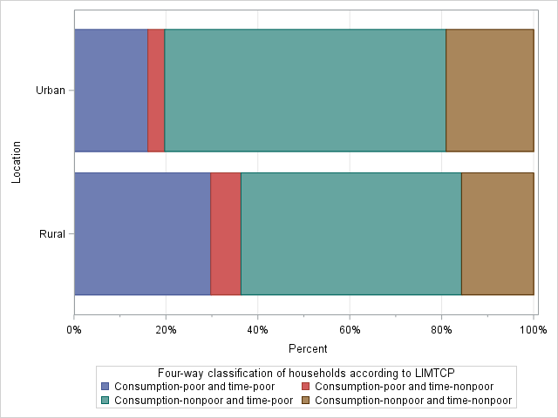

We reported earlier (see Table 4-7) that there was hardly any difference in the incidence of time deficits between poor and nonpoor employed persons when the yardstick used for consumption poverty was the LIMTCP (adjusted) poverty lines rather than the official poverty lines. However, when we choose the household as the unit of analysis, we find that the incidence of time deficits among the consumption-poor is slightly higher than among the nonpoor (Figure 5-22). This stands in contrast to our earlier finding (Figure 5-17) that when the official thresholds are employed, time poverty among the nonpoor is actually higher than among the poor. We can explain this finding by the fact that the official poverty categorization puts hidden poor households—all of whom are time-poor—in the consumption-nonpoor category, while we designate them as consumption-poor. It appears that time deficits are ubiquitous among Tanzanian households, as about 76 percent of all nonpoor households and 82 percent of all poor households contain at least one time-poor person.

**Figure 5‑22 Incidence of Household Time Poverty by Area of Residence and Adjusted Consumption Poverty Status, Tanzania**

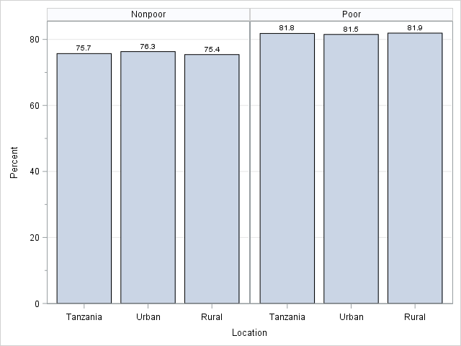

### Time Deficits and the Distribution of Household Economic “Welfare”

The poor-nonpoor distinction between households based on their consumption expenditures fails to convey information regarding the relationship between how far a household is from the poverty line and how prone it is to experiencing time deficits. As before (see Section 5.1.3), we seek to shed light on this relationship by examining the relationship between household economic “welfare” and the household time poverty rate. We define household economic welfare as the ratio of consumption expenditures to LIMTCP consumption poverty thresholds, with the former serving as a proxy for resources and the latter for needs. As noted before, the resources-to-needs ratio (RN ratio) will be below one for households below the poverty line, exactly equal to one for households at the poverty line, and greater than one for households above the poverty line.

Unlike in Ghana, there is no smooth relationship in Tanzania between the household time poverty rate and the distance from the LIMTCP (adjusted) poverty line, especially in the lower deciles (Figure 5-23). The rate of time poverty falls markedly between the bottom and next decile in both the urban and rural areas. However, in the rural areas, the rate remains in a narrow band between the second and sixth deciles before declining when it goes over the top 40 percent of households. The urban areas also show a marked decline from the sixth decile onwards, while in the lower deciles we observe a zigzag pattern (rising sharply from the second to third, then falling between the third and fifth, before rising again between the fifth and sixth). Given the high incidence of time poverty, it should not come as a surprise that over two-thirds of households are found to be time-poor in every decile except the top one; even there, the majority of households are indeed saddled with time deficits.

**Figure 5‑23 Household Time Poverty Rate (percent) by Decile of the Ratio of Consumption Expenditures to LIMTCP Poverty Threshold, Tanzania**

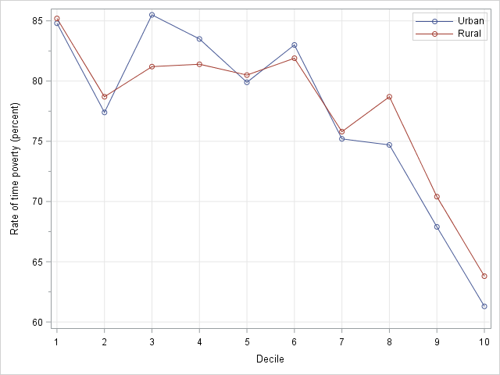

**Note:** (i) The deciles were computed separately for rural and urban areas. (ii) In the rural distribution, the bottom three deciles consisted entirely of consumption-poor households and 63 percent of the fourth decile also was consumption-poor. The bottom decile of the urban distribution was made up entirely of consumption-poor households, while in the second decile nearly all (97 percent) households were also consumption-poor.

Other things being equal, the degree to which a household is prone to time deficits would depend on the thresholds of household production. As we have seen, the thresholds are higher in Tanzania than in Ghana. Just as we saw in the case of Ghana, the thresholds tend to decline as we move up in the decile ranking, reflecting the lower average size of the households in higher deciles (Figure 5-24). One reason why the household time poverty rate does not fall steadily with the rise of the decile of the RN ratio in the lower deciles may be the higher levels of household production thresholds in Tanzania compared to Ghana. The extent of the decline that occurs in this portion of the distribution is not large enough to make a sufficient difference to the time available to the individuals. In such circumstances, variation in other factors across deciles, such as hours of employment and intrahousehold sharing of household responsibilities, can drive the differences (or lack thereof) in household time poverty rates across the deciles. However, it is noteworthy that the steepest declines in household time poverty rates and thresholds of household production occur in the top three to four deciles.

**Figure 5‑24 Average Weekly Hours of Required Household Production per Household (left panel) and Average Household Size (right panel) by Decile of the Ratio of Consumption Expenditures to LIMTCP Poverty Threshold, Tanzania**

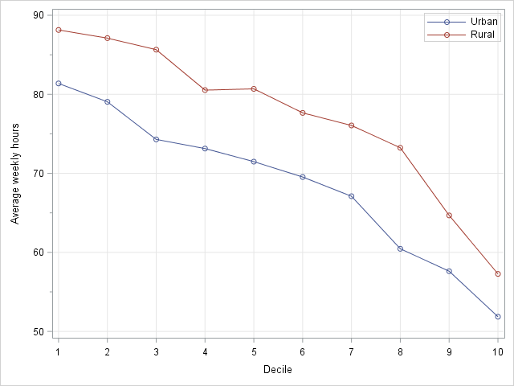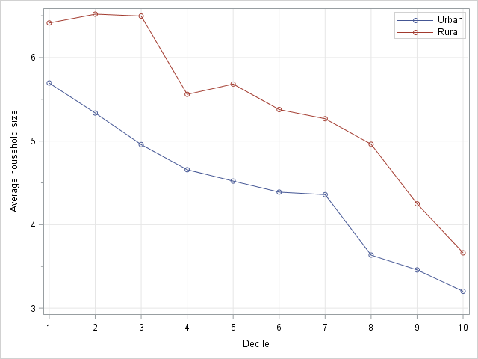

**Note:** (i) The deciles were computed separately for rural and urban areas. (ii) In the rural distribution, the bottom three deciles consisted entirely of consumption-poor households and 63 percent of the fourth decile also was consumption-poor. The bottom decile of the urban distribution was made up entirely of consumption-poor households, while in the second decile nearly all (97 percent) households were also consumption-poor.

As discussed before, a mechanical reason behind the inverse relationship between the decile of the ratio and average household size is the lower poverty thresholds for smaller households. But, just as we saw with Ghana, the key factor behind the inverse relationship is the sharp increase in average consumption expenditures as we move to the higher deciles (Figure 5-25). The decline in poverty thresholds is far less steep.

**Figure 5‑25 Household Consumption Expenditures and LIMTCP Poverty Line by Decile of the Ratio of Consumption Expenditures to LIMTCP Poverty Threshold (average monthly values in nominal Tanzanian Shillings [TSh]), Tanzania**

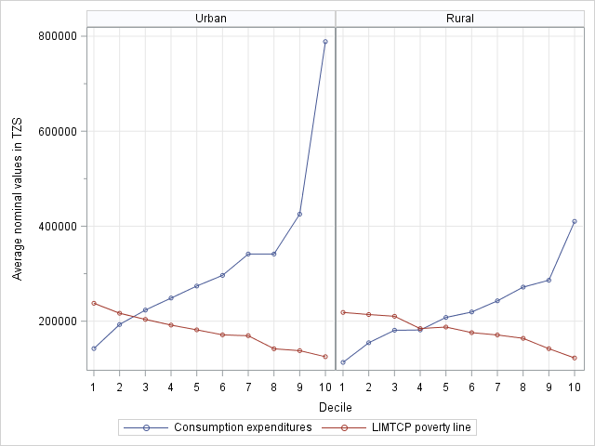

**Note:** (i) The deciles were computed separately for rural and urban areas. (ii) In the rural distribution, the bottom three deciles consisted entirely of consumption-poor households and 63 percent of the fourth decile also was consumption-poor. The bottom decile of the urban distribution was made up entirely of consumption-poor households, while in the second decile nearly all (97 percent) households were also consumption-poor.

When the household encounters a potential time deficit it has two options. First, it may purchase market substitutes to compensate for the loss in self-provisioning of household services. Alternatively, it may endure the loss in self-provisioning, captured by our measure of time deficits, because the market substitutes are simply unaffordable. Attempting to use market substitutes will push them below the LIMTCP poverty line or, if they’re already below it, enlarge their poverty gap. We argued in our discussion of Ghana (see Section 5.1.3) that the monetized value of time deficits can be considered as the amount of expenditure that is required to sustain the current standard of living while avoiding deficits in household production needs.

We found that the average monetized value of the time deficit for consumption-poor households was higher than nonpoor households in Tanzania by about 19 percent (TSh 41,571 versus TSh 34,970). Since by definition the poor have a lower average level of consumption expenditures than the nonpoor, the discrepancy in the potential burden imposed by time deficits on household budgets appears to be larger between the two groups when the monetized value of time deficits is reckoned relative to consumption expenditures (Figure 5-26). The value of time deficits amounted to 29 percent of consumption expenditures for the poor households, more than double that of the 13 percent that we found for nonpoor households. Reckoned in relation to the budget shares of major items in the average time- and consumption-poor household’s consumption basket, we found it striking that the share of the monetized value of the time deficits is quite close to that of total nonfood expenditures (32 percent). For the average time-poor and consumption-nonpoor household, the budget share of the value of time deficits was much smaller than total nonfood expenditures (48 percent). However, for them, too, the potential burden is far from trivial because the budget share was larger than the major categories of nonfood expenditures such as “housing (excluding rent), water, electricity, gas, and other fuels” (12 percent) and “transport” (10 percent).

**Figure 5‑26 Monetized Value of Household Time Deficits as a Percent of Household Consumption Expenditures of Time-Poor Households by LIMTCP Poverty Status, Tanzania**

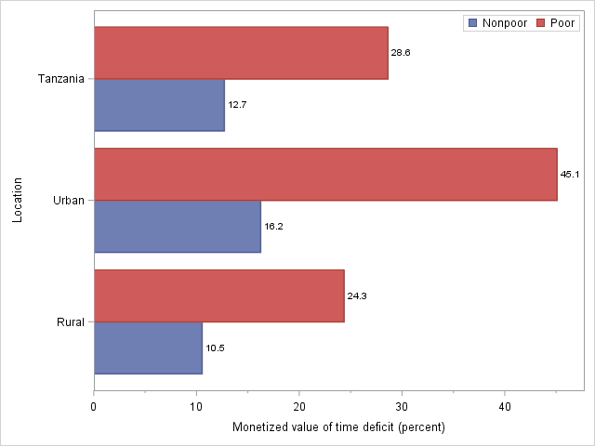

Just as in Ghana, we found that the average monetized value of the time deficits was higher for the urban time-poor households in relative terms (as shown in Figure 5-26), as well as in absolute terms (not shown). Urban households in the double bind of consumption and time poverty fared much worse than their rural counterparts (TSh 74,323 versus TSh 33,083). Consumption-nonpoor urban households also encountered a substantially larger average monetized value of time deficits than consumption-nonpoor rural households (TSh 50,236 versus TSh 25,625). The main driving force behind the higher urban values is our assumption that the hourly replacement cost in the urban areas (after adjusting for regional price differences) is about twice as much as in rural areas (TSh 357 versus TSh 175). However, the higher number of average weekly hours of time deficit also contributed to making the average monetized value of the time deficit higher among the urban time-poor (Figure 5-27). Interestingly, the urban-rural difference was far more notable among the consumption-poor than the consumption-nonpoor.

**Figure 5‑27 Household Time Deficit of Time-Poor Households by LIMTCP Poverty Status (weekly hours), Tanzania**

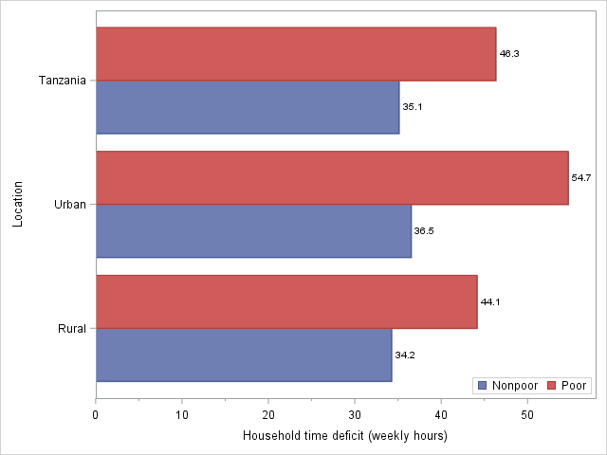

Time deficits can potentially affect the standard of living of not only those around or below the poverty line. As we can see from the estimates shown in Figure 5-28, the monetized value of the time deficits was as high as 20 percent of the consumption expenditures for the urban time-poor households in the middle (fifth) decile of the distribution of economic welfare. This is substantially higher than the shares of other categories of nonfood expenditures of households in that decile: i.e., “housing (excluding rent), water, electricity, gas, and other fuels” (13 percent); “communication” (8 percent); and “transport” (7 percent).The share of the monetized value of the time deficits falls below 10 percent only in the ninth decile of the urban distribution. This is slightly below the share of the total budget that households in that decile spend, on average, on “housing (excluding rent), water, electricity, gas, and other fuels” (11 percent). The rural time-poor households face fewer potential deleterious effects than their urban counterparts. The share of the monetized value of the time deficits was 14 percent in the fifth decile, making it the largest item among all major items of nonfood consumption above “housing (excluding rent), water, electricity, gas, and other fuels” (12 percent). At the ninth decile, the ranking reverses between the two categories with “housing (excluding rent), water, electricity, gas, and other fuels” climbing to 13 percent and the monetized value of the time deficits falling to 9 percent. These findings point to the fact that substituting market provisioning for the shortfalls in household production can involve curtailing other expenditures substantially or taking on additional debt.

**Figure 5‑28 Monetized Value of Household Time Deficits as a Percent of Household Consumption Expenditures of Time-Poor Households by Decile of the Ratio of Consumption Expenditures to LIMTCP Poverty Threshold, Tanzania**

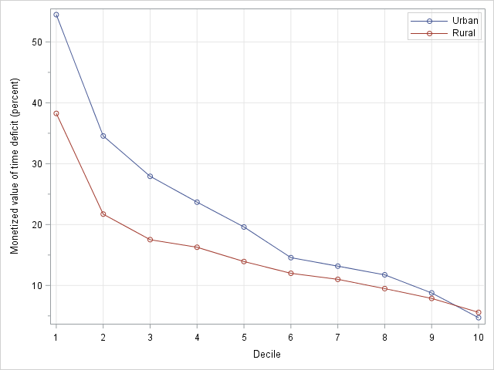

**Note:** (i) The deciles were computed separately for rural and urban areas for *all* (not just time-poor) employed households. (ii) In the rural distribution, the bottom three deciles consisted entirely of consumption-poor households and 65 percent of the fourth decile also was consumption-poor. The bottom decile of the urban distribution was made up entirely of consumption-poor households, while in the second decile nearly all (98 percent) households were also consumption-poor.

### Household Structure and Poverty

#### Typology and household-level estimates of consumption and time poverty

For Tanzania we employ the same typology of households that we used for Ghana, based on the sex and marital status of the head, relationships between people in the household, and the presence of children. As may be recalled from our earlier discussion, the chosen typology is meant to reflect the differences in needs and resources among households that are relevant to the understanding of gender divisions and economic well-being. It is also shaped by the limited type of information contained in the household survey regarding, for example, relationship among the individuals in the household.

The estimated distribution of the population in employed households among the different types of household in Tanzania is shown in Table 5-7. A little less than a fifth of individuals (19.4 percent) live in households headed by a single person (the first four categories in the table). The largest subgroup here is single-female-headed households with children, which accounts for 14.1 percent of the total population. Households headed by a married person and his spouse (“married-couple” households) are the predominant type of household in which the population (81 percent) resides. In fact, nearly two-thirds of the population lives in married-couple households that are nuclear, i.e., they have no adults from the extended family.[41] A sizeable proportion of the population (12.1 percent) lives in “extended families,” i.e., married-couple households with at least one adult from the extended family.[42]

**Table 5‑7 Distribution of Individuals in Employed Households by Type of Household, Tanzania**

|  |  |  |
| --- | --- | --- |
| **Type of household** | **Number (in thousands)** | **Percent** |
| **Head only** | 638 | 1.6 |
| Single-female head with children | 5,663 | 14.1 |
| Single-male head with children | 961 | 2.4 |
| Other households with a single head | 511 | 1.3 |
| **Head and spouse only** | 776 | 1.9 |
| Head and spouse with children and no extended-family adults | 26,000 | 65.0 |
| Head, spouse, children and extended-family adults | 4,849 | 12.1 |
| Other married-couple households | 623 | 1.6 |
| **All** | 40,021 | 100.0 |

Similar to our finding for Ghana, married-couple households with children and extended-family adults experience the highest rates of consumption poverty (Table 5-8). The next highest incidence was found in households with children headed by single males. However, it should be noted that this is a rather small subgroup with fewer than a million people, or 2.4 percent of the population, that live in employed households. They were followed by nuclear married-couple households and households with children headed by single females—both displaying roughly similar rates of consumption poverty. The ranking of the subgroups with respect to the poverty rate does not appear to be sensitive to the yardstick (official or LIMTCP). But, it is noteworthy that the gap in the incidence of poverty between the single-male-headed households with children and single-female-headed households with children narrows considerably when time deficits are accounted for. The same observation can also be made for the differential in the poverty rate between the single-male-headed households with children and nuclear married-couple households. Of course, the higher hidden poverty rates of nuclear married-couple and single-female-headed households compared to single-male-headed households reflects this phenomenon. In terms of the distribution of the poor population, two-thirds of such persons are in nuclear married-couple households. A little under 30 percent of the poor are split approximately between extended-family married-couple households and single-female-headed households. Thus, these three subgroups of households that account for nearly 91 percent of all employed households encompass virtually all—95 percent—of the poor population by either definition of poverty. Similar to Ghana, poverty rates for households with children are higher than other households and indicate the intergenerational negative effects that might be imposed by deprivation.

**Table 5‑8 Poverty among Employed Households by Type of Household: Official versus Adjusted, Tanzania**

|  |  |  |  |  |  |  |
| --- | --- | --- | --- | --- | --- | --- |
| **Type of household** | **Poverty rate of households (percent)** | | | **Number of poor people (thousands)** | | |
| Official | Adjusted | Hidden | Official | Adjusted | Hidden |
| **All** | 21.5 | 31.0 | 9.5 | 11,292 | 14,993 | 3,702 |
| **Head only** | 1.8 | 7.4 | 5.6 | 12 | 47 | 36 |
| Single-female head with children | 23.4 | 33.3 | 9.9 | 1,614 | 2,151 | 537 |
| Single-male head with children | 28.4 | 35.9 | 7.5 | 316 | 377 | 62 |
| Other households with a single head | 14.9 | 21.4 | 6.5 | 81 | 115 | 34 |
| **Head and spouse only** | 7.7 | 14.7 | 7.0 | 62 | 116 | 54 |
| Head and spouse with children and no extended-family adults | 24.0 | 34.5 | 10.5 | 7,436 | 10,023 | 2,588 |
| Head, spouse, children and extended-family adults | 29.4 | 37.9 | 8.5 | 1,659 | 2,002 | 343 |
| Other married-couple households | 19.8 | 28.9 | 9.1 | 114 | 162 | 49 |

It may be recalled that we reported that the incidence of time poverty, average weekly hours of time deficits, and average monetized value of time deficits (as a percent of consumption expenditures) among consumption-poor was higher than consumption-nonpoor households (Figures 5-20 and 5-24). We now turn to examine if this pattern persists within each subgroup of households. We concentrate on the three subgroups that contain most of the population, especially the poor among them: nuclear married-couple, extended-family married-couple, and single-female-headed households with children. All other households are lumped together in the residual category of “Other households.”[43]

Our estimates showed that the poor households were notably more prone to time poverty than the nonpoor only for the single-female-headed households (Figure 5-29). Poor households had roughly the same incidence as the nonpoor among nuclear married-couple households and, in fact, a lower incidence than the nonpoor among extended-family married-couple households. On average, the number of children and adults was higher among the poor than nonpoor within each household type; hence, the household-level thresholds of household production are also, on average, higher for the poor than the nonpoor. Other things being equal, we would expect a direct (though not linear) relationship between a person’s likelihood of facing time deficits and their thresholds. At the same time, a greater number of persons in the household (especially if there are older girls and/or extended-family adults, such as a mother or mother-in-law of the head, among them) may lead to a lower share of household production accruing to the person who is most likely to be time-poor in the household, i.e., the employed spouse. This may explain why the rate of time poverty among poor extended-family married-couple households is lower than that of their nonpoor counterparts, as well as that of poor and nonpoor nuclear married-couple households. We will address this issue in the next subsection when we examine gender differentials.

**Figure 5‑29 Rate of Household Time Poverty (percent) by Type of Household and LIMTCP Consumption Poverty Status, Employed Households, Tanzania**

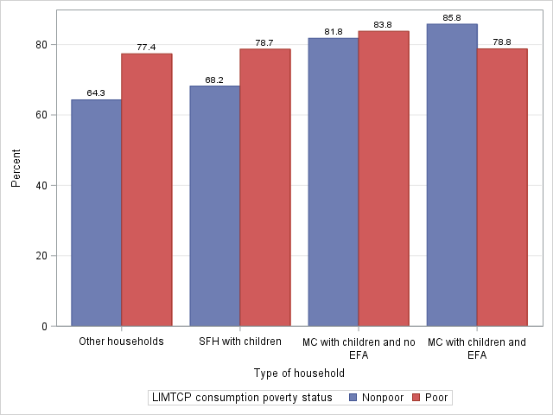

**Note:** SFH=single-female headed; MC=married couple; EFA=extended-family adult(s)

Turning to the depth of time poverty, we found that the average weekly time deficits of consumption-poor and time-poor households were considerably higher than that of consumption-nonpoor and time-poor households within each household type (Figure 5-30, Panel A). Comparing across household types, it appears that the average time deficits turn out to be lower for single-female-headed households than that of nuclear married-couple households, which, in turn, are lower than that of extended-family married-couple households. The potential impact of time deficits on the standard of living is captured by the monetized value of the time deficits. Our estimates show that as a percent of consumption expenditures, the monetized value of the time deficits was considerably higher, on average, for consumption-poor households than consumption-nonpoor households (Figure 5-30, Panel B). It must be noted that the absolute level of the monetized value of the time deficits was also higher for consumption-poor than consumption-nonpoor households within each household type, with the exception of extended-family married-couple households. A comparison across household types shows that the relative monetized value of the time deficits is higher for single-female-headed households than that of nuclear married-couple households, which, in turn, is higher than that of extended-family married-couple households. The ranking of the three household types with respect to the relative monetized value of the time deficits is thus opposite to the ranking with respect to weekly time deficits. Naturally, this is a reflection of the fact that average consumption expenditures follow the same pattern as weekly hours of time deficits: lowest for single-female-headed households, followed by nuclear married-couple, and then extended-family married-couple households.

**Figure 5‑30 Average Household Time Deficits and Monetized Value of Time Deficits (as a percent of consumption expenditures) of Time-Poor Employed Households by Type of Household and Consumption Poverty Status, Tanzania**

**Panel A: Average Weekly Hours of Household Time Deficit**

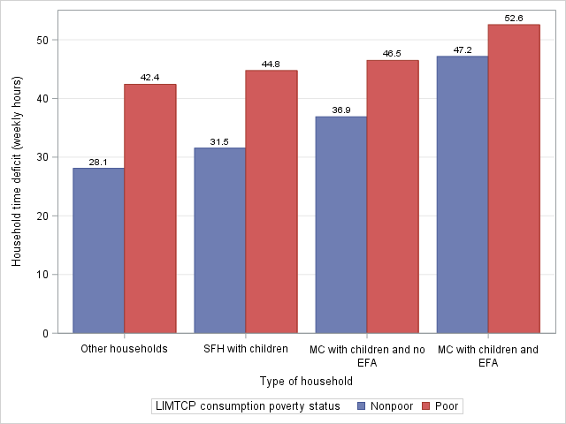

**Panel B: Average Monetized Value of Household Time Deficits as a Percent of Consumption Expenditures**

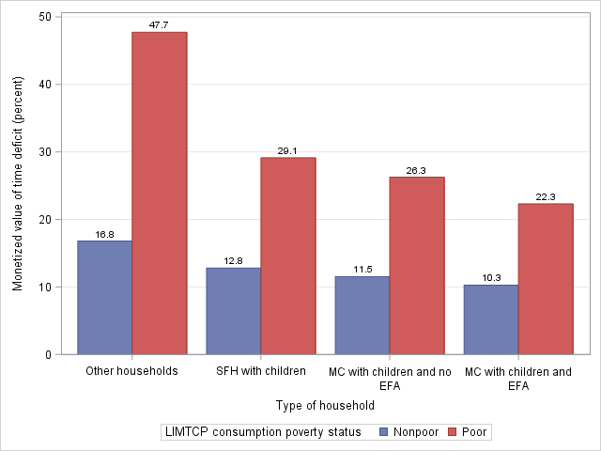

**Note:** SFH=single-female headed; MC=married couple; EFA=extended-family adult(s)

As we would expect, the joint distribution of households across the four LIMTCP categories follow the patterns discussed so far (Figure 5-31). Married-couple households are the most prone to the double bind of consumption and time poverty (around 30 percent), followed by single-female-headed families (26 percent). The residual category of “Other households” registered a much lower incidence of the double bind (13 percent) as a result of the lower level of consumption poverty and time poverty among the consumption-poor. In terms of being free from both consumption and time deficits, single-female-headed households fare substantially better than both types of married-couple households (21 percent versus 12 percent of nuclear and 9 percent of extended-family married-couple households). This is a reflection of the lower extent of time poverty of the consumption-nonpoor, single-female-headed households compared to their counterparts in married-couple families. These findings are broadly similar to our findings for Ghana.

**Figure 5‑31 Distribution of Employed Households by Type of Household and LIMTCP (percent), Tanzania**

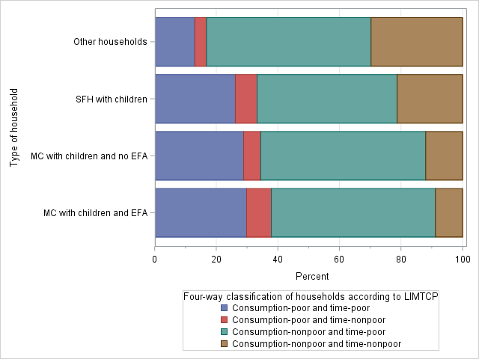

#### Household structure and gender differentials in deprivation

Consistent with our results regarding the gender disparity in time poverty rates, we also found that women in married-couple households had higher rates of poverty than men in married-couple households (Figure 5-32). The salience of the gender disparity is robust to controlling for consumption poverty status and presence of extended-family adults in the household. The poor-nonpoor differentials in the time poverty rates of men and women within each household type mirror the differentials that we observed in the case of household time poverty rates.

**Figure 5‑32 Time Poverty Rates of Employed Men and Women (15 to 70 years of age) in Married-Couple Households with Children (percent), Tanzania**

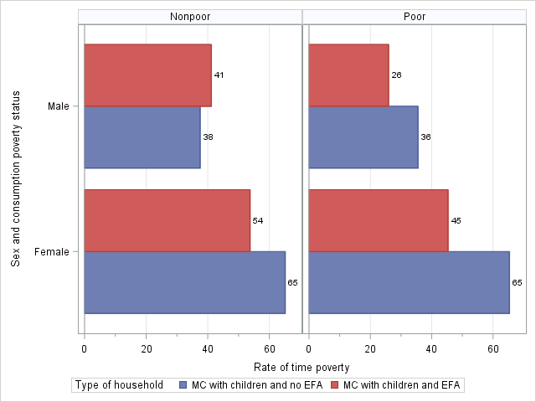

**Note:** MC=married-couple; EFA=extended-family adult(s)

As we saw with respect to the gender disparity between all employed men and women in Tanzania, the main factor here, too, is the greater time demands on women than men for household production. While it is true that men in married-couple households do have longer hours at the job than women, the latter encounter longer hours of required household production (Figure 5-33 below). And, the gap in household production overwhelms the gap in employment, resulting in less available time for women than men, and rendering them more prone to time deficits.

Similar to our finding for Ghana, women in families with extended-family adult(s) experience a lower incidence of time poverty than women in families without extended-family adult(s). For men, such an effect of family structure is only visible in consumption-poor households. As we discussed before, having adult members of the extended family as well as older children may go toward reducing the share of household responsibilities that fall upon each individual in the household because the tasks now get distributed over a larger number of individuals. Estimates shown in Figure 5-33, Panel B clearly indicate that the average weekly hours of required household production are lower for women in extended-family married-couple households than nuclear married-couple households.

**Figure 5‑33 Employment and Required Household Production of Employed Men and Women in Married-Couple Households with Children (weekly hours), Tanzania**

**Panel A: Weekly Hours of Employment (average values)**

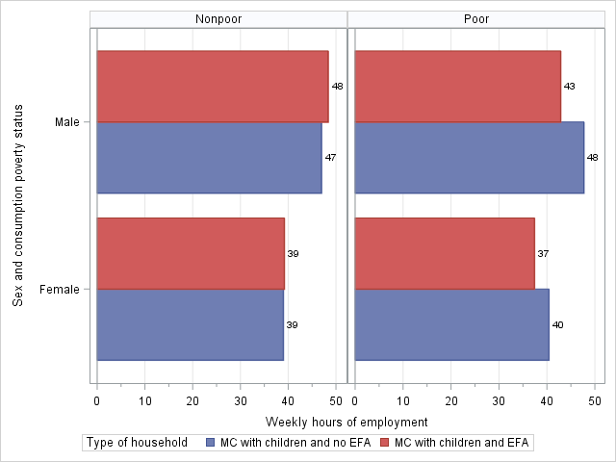

**Note:** MC=married couple; EFA=extended-family adult(s)

**Panel B: Required Weekly Hours of Household Production (average values)**

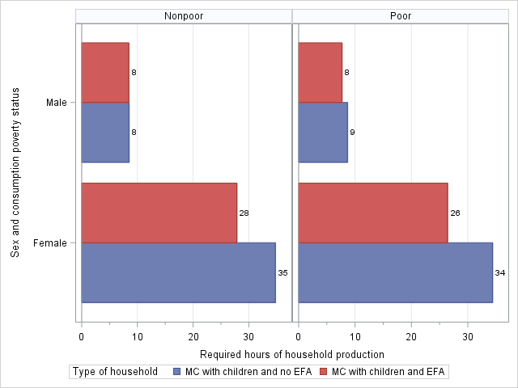

**Note:** MC=married couple; EFA=extended-family adult(s)

In married-couple households with children, the locus of the gender disparity imposed by the institution of the patriarchy lies between husbands and wives. Patriarchy also imposes differentiated roles for boys and girls, as well as between members of the extended family according to sex. Due to limitations of space and data, we do not explore these aspects of the issue here. Instead, we analyze households where both the husband and wife are employed— “dual-earner” households.[44]

In line with our earlier findings, we found that wives experience a higher rate of time poverty than husbands. This finding holds after we control for hours of employment, presence of extended-family adult(s) in the household, and LIMTCP consumption poverty status (Figure 5-34). Time poverty rates of husbands are equal at the highest hours interval (61 hours or more per week) where time deficits are universal; about 28 percent of husbands and 15 percent of wives do put in such long hours at the job. At every other hours interval, the gap between husbands and wives in the incidence of time poverty is huge. For example, in the 36 hours to 50 hours interval (the interval with the largest concentration of husbands and wives), husbands in nonpoor, nuclear married-couple households had a time poverty rate of 17 percent, while for wives it was *70 percentage points higher*; for their consumption-poor counterparts, too, the gap was slightly larger at 73 percentage points—13 percent for husbands versus 86 percent for wives. Similar gaps can also be observed for the consumption-poor households. The presence of extended-family adults seems to have a slightly asymmetric effect on husbands and wives in nonpoor households: wives in extended-family married-couple households had somewhat lower and husbands slightly higher rates of time poverty than their counterparts in nuclear married-couple households. Wives in poor households can also be seen to experience a similar effect, though the effect is not unequivocal for husbands.

**Figure 5‑34 Incidence of Time Poverty among Employed Husbands and Wives (15 to 70 years of age) in Households with Children (percent), Tanzania**

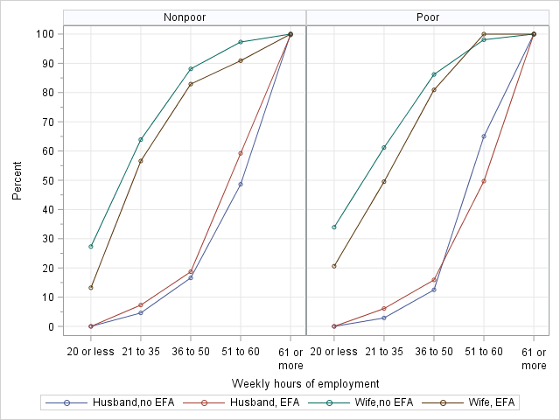

**Note:** EFA=Extended-family adult(s)

We had indicated earlier the mechanism that may be at work here. The presence of extended-family adult(s) may lead to sharing of household responsibilities, thereby lowering the vulnerability of wives to time deficits. Similar to Ghana, the majority (57 percent) of adult members of the extended family are women. However, unlike Ghana, the majority (63 percent) of female adult members of the extended family are employed, though they devote relatively less time toward employment (54 percent work for 20 or fewer hours per week). Female extended-family members contribute to one-fifth of overall household production in poor and nonpoor households. This is most likely the reason why the average of required hours for household production are notably lower for wives in households with extended-family adults as compared to wives in households without such adults (Figure 5-35). Estimates of the average hours of household production also provide a clue to the asymmetric effect of extended family on the time poverty rate: husbands generally incur more average hours in extended than nuclear families while the opposite holds true for wives.

**Figure 5‑35 Weekly Hours of Required Household Production of Employed Husbands and Wives (15 to 70 years of age) in Households with Children (average values), Tanzania**

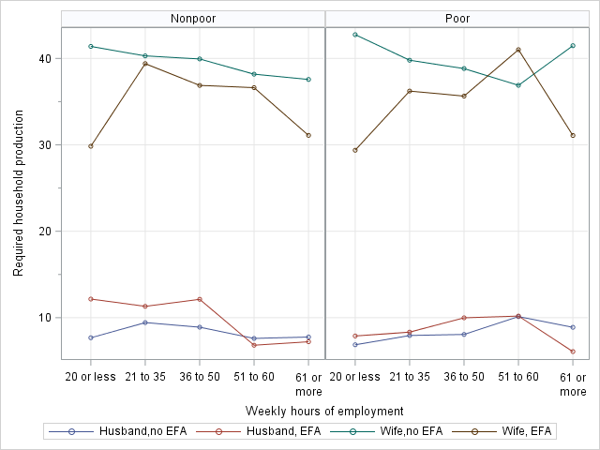

**Note:** EFA=extended-family adult(s)

The demand on time for household production faced by wives in households with no extended-family adult(s) amounts to a full-time job that involves roughly 40 hours per week. Wives in extended-family households generally encounter somewhat fewer required hours of household production, especially when their weekly hours of employment fall in the lowest and highest intervals.[45] The lower demands placed on the time of wives in extended families is in spite of their higher average household-level thresholds of household production relative to nuclear families (109 hours versus 83 hours per week). Of course, the thresholds are higher for extended families because they have, on average, more adults and children than nuclear families (4.18 versus 2.56 adults and 4.04 versus 3.26 children). The difference in the number of adults is a reflection of the presence of adult relatives in the extended families who share in the household responsibilities. As a result, the share of wives in household-level thresholds of household production turned out to be much smaller than in nuclear families (33 percent versus 52 percent), leading to fewer average total hours of required household production. Notably, husbands’ share in household-level thresholds of household production showed little difference between extended families (9 percent) and nuclear families (11 percent).

Finally, we examine the joint distribution of consumption poverty and time poverty status among husbands and wives (Figure 5-36) in households with children. Almost 40 percent of husbands and wives in extended families are consumption-poor. However, 27 percent of wives are both consumption- and time-poor, as against 15 percent of husbands in extended families. This is, indeed, a reflection of the gender disparity in time poverty. Such disparity also exists for the consumption-nonpoor. Hence, 29 percent of husbands are neither time- nor consumption-poor, while only 18 percent of wives in extended families fall into that category. Similar differentials can be observed for nuclear families, too. Their poverty rate is slightly lower than that of extended families, as 37 percent of husbands and wives are consumption-poor. But, the share of wives in nuclear families who face the double bind of consumption and time poverty is 28 percent compared to 15 percent of husbands. The proportion of husbands in nuclear families who face neither consumption nor time deficits was 38 percent as compared to only 16 percent of wives. As we pointed out before, neglect of time deficits is tantamount to ignoring an additional form of deprivation, borne disproportionately by employed women, and turning a blind eye to the importance of reproductive care work for the maintenance of living standards.

**Figure 5‑36 Distribution of Employed Husbands and Wives (15 to 70 years of age) by LIMTCP (percent), Tanzania**

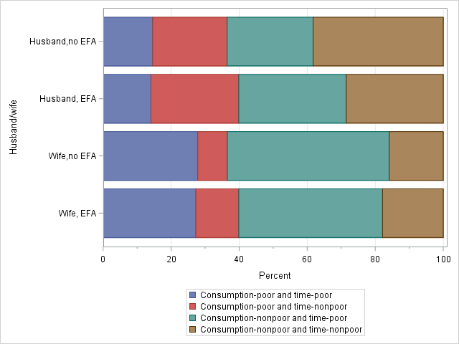

**Note:** EFA=extended-family adult(s)

# THE IMPACT OF EMPLOYMENT ON TIME AND CONSUMPTION POVERTY: SIMULATION RESULTS

Consumption poverty in Ghana and Tanzania is certainly not the result of individuals’ lack of economic activity. Economic development literature has put some emphasis on the relative efficiency of the uses to which households’ labor power is put. Can a switch from agricultural production for own consumption to paid employment provide a way out of poverty for consumption-poor households? We attempt to answer this question with a microsimulation exercise, based on similar exercises we have done for other countries (Zacharias, Masterson, and Kim 2009; Zacharias, Antonopoulos, and Masterson 2012).

It must be stressed that *this simulation is not an attempt to model a full-employment situation*, in which all of the job recipients are moved into paid labor as a result of some job-creating policy intervention or process of economic growth. Rather it is an estimation for each consumption-poor household of the impact *on that household* of all able-bodied and available adults in that household not currently working more than 10 hours per week for pay moving into paid employment. The results we present below are aggregate impacts for regions and types of households and individuals. Before we get to the results, we outline the method used.

## Simulation Methodology

The purpose of this simulation exercise is to estimate the impact on time and consumption poverty of a shift in the employment of adults in poor households to *paid employment*. Any such shift entails changes in household earnings, the distribution of time allocated to household production, and time allocated to other production activities. Earnings in the household would change as some household member(s) transition from nonemployment and marginal (probably low-paid) activities into paid employment. As some household members move into a paid job, it is possible that a smaller share of their time would be allocated to required household production activities, which would have to be compensated for by the other members in the household. In addition, as some household members would move from marginal jobs or unpaid jobs, less time would be spent on productive activities—such as working on the family farm or business—that were already being carried out by these members of consumption-poor households. In previous simulations (see, for example, Masterson [2012]) we rejected job assignments if the resulting changes in individuals’ earnings were negative (if the individual was already doing paid work, but we attempted to assign full-time employment, for example), since we were attempting to estimate the effect of voluntary, not mandatory, paid employment. In this simulation we compare the new earnings from the simulation not only to actual earnings but also to the contribution these individuals make to their household’s farm and/or nonfarm business income.

Many microsimulation models use a standard labor supply model to estimate hours and earnings for those that enter into employment (Rohaly, Carasso, and Saleem [2005], for example). The earnings and hours are imputed directly using observed patterns to make predictions parametrically in a neoclassical behavioral framework. Other models use a nonparametric approach that assigns individuals into employment randomly using a Monte Carlo procedure (Orcutt 1957). Ours is a hybrid approach, originally developed at the Levy Economics Institute for the purpose of estimating the impact of the American Recovery and Reinvestment Act in 2009 (Zacharias, Masterson, and Kim 2009). In our approach, we use a labor supply model to impute likely wages and hours for individuals that are not in paid employment, but we use the results in a statistical matching framework to select existing jobs from the pool of employed persons in the base dataset.

Such an employment simulation always requires a series of several intermediate steps to complete. For this project, we incorporated a new step into our employment simulation model: estimating the contribution of each individual in the simulation to household farm income and nonfarm business income. This estimate is used to compare the gain in earnings from a possible switch to paid employment in order to assess whether it would be worthwhile for each individual to make the switch. We now specify in detail the steps we took to produce the simulation estimates.

The first step is to identify the donor and recipient pools for job assignments. We first determine which of the individuals in the base dataset is eligible for the analysis. An eligible individual is defined as a person between the ages of 18 and 70, who is not in school, retired, or disabled. In the Ghanaian simulation, this step reduces the number of records to 36,146 (representing 13,624,024 people) from the total of 71,717. In the Tanzanian simulation, 21,991 of 46,535 records (representing 18,933,118 people) were categorized as eligible. We next separate the eligible individual records into potential donors and recipients. The recipients are those who may be assigned a paid job in the simulation. These are individuals in LIMTCP poor households who are: not employed in any capacity, working for pay for fewer than 10 hours per week, or working in an actual primary activity other than as a paid employee or apprentice. The latter categories included “nonagricultural contributing family worker,” “agricultural self-employed without employees,” or “agricultural contributing family worker” in the case of Ghana,[46] and “working on the household farm” or “helping without pay in household business” in the case of Tanzania.[47] The majority of the potential recipients were those who were engaged in unpaid work (95 percent in Ghana and 98 percent in Tanzania). The donor pool consists of those individuals who are currently working for pay for 10 hours per week or more as their primary activity.

Next, we estimate separate production functions for farm and nonfarm family business income for each household engaging in these activities. The results of these models will be used to estimate the reduction in output due to each individual potential recipient’s leaving the family farm or business to take up paid employment. We estimate a *log-linear* production function defined as:

(4)

where is the natural log of the value of total output; is a vector of the natural log of the amount of family labor used by age categories[48] and sex; is the natural log of the amount of hired labor; is the natural log of the amount of land operated (in the case of farm businesses); is the natural log of the value of fixed assets employed in production; is the natural log of the value of other inputs into production; and ***Z*** is a vector of household characteristics, including dummies for agroclimatic zone (in the case of farms), region, rural/urban status, age, sex, and education level of the household head.

We then estimate each individual’s contribution to production. First, we predict the level of output for each farm/business using the results of the regression. Next, we calculate the level of operating expenses per weekly hour of family labor employed. Then, for each individual in the household that works on the farm or in the business, we subtract their weekly hours worked from the household total for their age-sex category and we subtract the amount of inputs (operating expenses) for their hours of work. Then we predict the output for each individual in that household using the same regression results with adjusted household totals. Subtracting this result from the overall household prediction produces an estimate of the gross contribution of each individual family worker to gross output. We scale the sum of all the individual contributions in the household to equal the actual gross output for the household and then subtract (for each individual) the cost of the operating expenses that would not be used due to their not working on the farm/business.[49] The result is an estimate for each individual of their net contribution to the family farm or nonfarm business enterprise.

The next step in assigning jobs to recipients is to determine what are the likeliest industry and occupation for each of the potential job recipients. This is done using a multinomial logit procedure. Industry and occupation are regressed on age, age squared, sex, rural/urban status, education, and geographic region in the donor pool. The likelihood for each industry and occupation is then predicted in the recipient pool, using the results of the multinomial logit. Then each recipient is assigned the industry and occupation corresponding to the largest predicted likelihoods.

We then impute the earnings and usual weekly hours of paid work using a three-stage Heckit procedure (Berndt 1996, 627) separately for each combination of four age categories[50] and sex. The first stage is a probit estimation of labor force participation:

(5)

where is the cumulative density function of a normal distribution. The vector of explanatory variables, , comprises the number of children under the age of 5 years and the number of children aged 6 to 17 years in the household, the individual’s education, and the individual’s spouse’s age, education, and labor force status. The regression is run on the universe of all eligible adults. The Mills ratio,, is calculated for all individuals using the results of the first stage regression:

(6)

where and are, respectively, the probability and cumulative density function of a normal distribution, and is the vector of estimated coefficients from the probit model.

The second stage is an ordinary least squares (OLS) estimate of the log of hourly wage:

(7)

This regression is run only on those that are actually employed for pay. The vector of explanatory variables, , includes the individual’s education, age, industry, occupation, geographic region, rural/urban location, spouse’s labor force status, and, finally, *λ*, the Mills ratio calculated in the first stage. Inclusion of the Mills ratio corrects for the selection bias induced by limiting the regression to those in paid employment. The imputed log of wage is predicted for donors and recipients from the results of the regression, with industry and occupation replaced for the latter by the industries and occupations assigned in the previous step.

The third stage is a regression of usual hours of paid work per week:

The regression is once again run only on those in paid employment. The vector of explanatory variables, , in this stage is the same as the previous stage, , with the addition of the number of children under the age of 5 years and the number of children aged 6 to 17 years in the household. Finally, the predicted in the second stage and the Mills ratio, , calculated in the first stage are included. Imputed hours per week are predicted for donors and recipients using the results of the regression, replacing the industry and occupation of the latter with their assigned values. The results of the last two stages give us the remaining variables with which we perform the hot-decking procedure to assign actual earnings, hours, industry, and occupation to recipients.

We can now assign earnings, usual hours of work, industry, and occupation to those individuals in the recipient pool. The assignment method is statistical matching with hot-decking (Andridge and Little 2010). The matches are performed within cells formed from combinations of age, sex, and educational attainment. The variables used to assess nearness of match are family type, spouse’s labor force status and educational attainment, assigned industry and occupation, the number of children under the age of five years and the number of children aged 6 to 17 years in the household, and the two imputed variables, log of wage and hours worked. We use affinity score matching, which allows us to weight the matches of each of the matching variables by importance. Industry and occupation are the most heavily weighted variables, followed by imputed hours and wage. After these, we weight family type and spouse’s full-time/part-time status, then marital status and spouse’s education and labor force status, and then the variables detailing the number of children in the household. Matches are drawn randomly from all those donor records with the highest affinity score for an individual recipient. Industry, occupation, earnings, and hours from both the donor’s primary and secondary activity are transferred to the recipient.

Once the hot-decking is finished, we compare the earnings each recipient receives with the net value of lost production, calculated as described above, and earnings in their current job if they are working for 10 hours a week or less. We cancel any assignments with a large enough negative impact, and for the rest we adjust the income from household farm/business. We define the cutoff for a “large enough” negative impact using the ratio of the simulated earnings to the recipient’s estimated net contribution to family farm/business output plus reported individual earnings. For those individuals for whom this ratio is less than 75 percent, we reverse the results of the simulation. The rest of the recipients remain in the “adjusted” recipient pool.

Finally, we need to reallocate the shares of required household production in order to recalculate each individual’s time deficits/surpluses as a result of the simulation. Since an individual’s paid/unpaid work hours may have changed as a result of the simulation, we need to adjust the shares of household production for all the adult members of all the households that included an individual who received a job assignment in the simulation. We use a second round of hot-decking to assign new weekly hours of household production and new commuting hours to each of the adults, based on the updated labor force participation variables for the recipients of jobs in the first stage. The method is the same as the first stage, with the exception of the matching variables used and their relative weighting in the procedure. In this stage, the variables used to assess nearness of match are family type, spouse’s labor force status, number of adults, number of children, and the number of children under 5 years of age and 6 to 17 years of age in the household, simulated net household income, the income share of each individual,[51] simulated usual weekly hours of employment, and household total simulated hours of employment. All income and labor force variables are updated to reflect the new job assignments received in the previous stage. In this round of hot-decking, the number of children and number of adults in the household are weighted most heavily of all the variables. The next most heavily weighted are family type and income share. Then, the variables detailing the number of young children in the household, followed by net household income, hours of employment, and household hours of employment, and finally spouse’s labor force status. For each match, the weekly hours of household production are transferred for every individual in the affected household.

A final step is to allow for consumption expenditures to change as a result of the change in earnings. We make the most conservative assumption, in terms of poverty impact, that households that receive altered incomes as a result of the assignment pass through all of the change in income to an equivalent change in consumption expenditures. We now have the consumption and time use variables necessary to recalculate time and consumption poverty for recipient individuals and households.[52]

## Ghana

Turning to the results for Ghana first, we first remind ourselves that though we speak of simulated poverty rates, etc., we really mean the percentage of people (households, etc.) who we estimate would remain poor even if all the adults in their household received the paid job they were most likely to get. We will first look at the estimated impact of employment on the time and consumption poverty of individuals, then move on to look at the household-level impacts.

### The Impact of Simulated Paid Employment on the Time and Consumption Poverty of Individuals

We first look at the aggregated results of the simulation for the consumption poverty of all individuals (Figure 6-1). In terms of reduction in consumption poverty, the transition to paid employment seems to be a success. Both official and time-adjusted poverty rates fall drastically in the simulation. Overall official consumption poverty drops to 10.2 percent from 24.2 percent, while time-adjusted poverty falls from 32.3 to 18.2 percent. The percentage of individuals that would remain time-adjusted poor is still quite high. Note that in urban areas, the impact of the simulated transition to paid employment is smaller than in rural areas. In urban areas the reductions in poverty rates are 5.4 and 6.3 percentage points for official poverty and time-adjusted poverty, respectively, while in rural areas the corresponding reductions are 22.5 and 22.0 percentage points, respectively. This is owed in no small part to the much lower poverty rate in urban areas to begin with, as well as the smaller relative reduction in urban areas: 51.5 percent and 35.4 percent, respectively, for official and time-adjusted poverty in urban areas, compared to 59.6 percent and 46.7 percent in rural areas. It is important to note that despite the large percentage of individuals that would be lifted out of poverty according to the simulation, the phenomenon of hidden poverty remains very important. In Ghana as a whole, hidden poverty decreased slightly to 8.0 percent from 8.1 percent in the actual situation. In urban areas, the hidden poverty rate fell from 7.2 to 6.3 percent, while in rural areas the rate rises modestly from 9.2 to 9.7 percent. So, despite the overall unchanged rate of hidden poverty, there is a shift in hidden poverty from urban to rural households as a result of the simulation. Breaking these numbers down further will help to illuminate what is driving these patterns.

**Figure 6‑1 Actual and Simulated Official and LIMTCP Poverty Rates for Individuals by Region, Ghana**

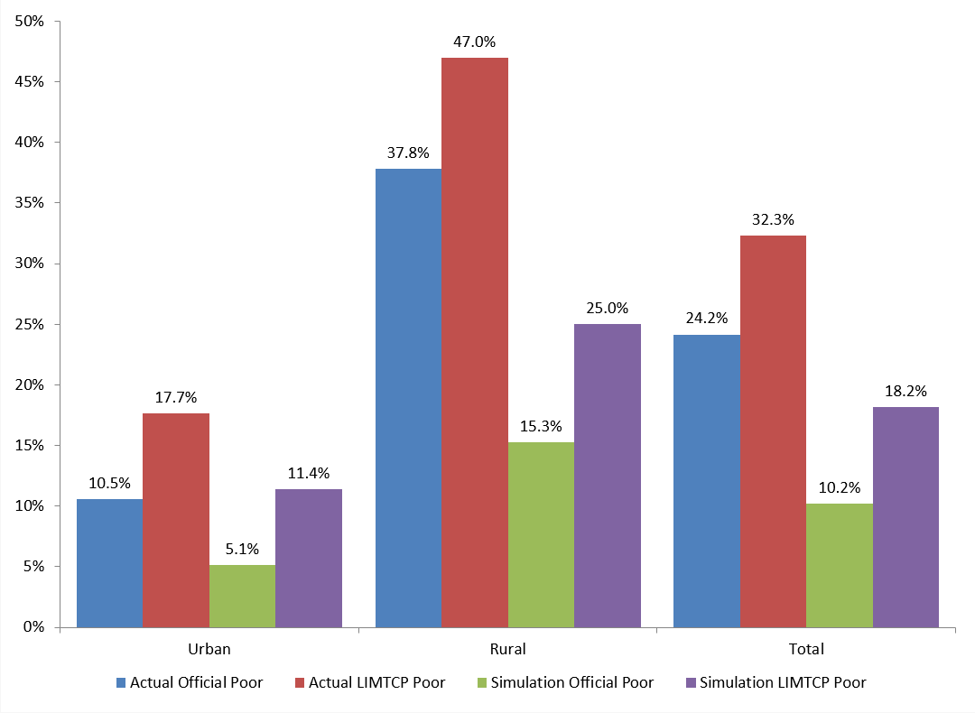

Of course, we are also interested in the impact of transitioning to paid employment on time poverty. Table 6-1 breaks down this impact for consumption-poor employed adults for all of Ghana, which can be compared to the results before the simulation (the total is included below; for full results, see Table 4-3). Most employed adults (55.3 percent) that were consumption-poor remained so despite the transition to paid employment.[53] In addition, there was an increase in the time poverty rates of these individuals from 41.1 percent to 46.5 percent (Figure 6-2). A majority (64 percent) of the individuals who were both time- and consumption-poor remained consumption-poor and of those that escaped consumption poverty, only 28.9 percent also escaped time poverty. Slightly over half of those who were consumption-poor and time-nonpoor escaped consumption poverty, but about one-quarter of those who did fell into time poverty, and 15.1 percent of those who did not escape consumption poverty also became time-poor in the simulation.

**Table 6‑1 Simulated Consumption and Time Poverty Status of Consumption-Poor Employed Adults, Ghana**

|  |  |  |  |  |  |
| --- | --- | --- | --- | --- | --- |
|  | **Consumption- and time-poor** | **Consumption-poor and time-nonpoor** | **Consumption-nonpoor and time-poor** | **Consumption- and time-nonpoor** | **Total** |
| **Time-poor** | 58.6 | 5.5 | 25.6 | 10.4 | 100.0 |
| **Time-nonpoor** | 7.4 | 41.7 | 12.7 | 38.2 | 100.0 |
| **Simulation Total** | 28.5 | 26.8 | 18.0 | 26.8 | 100.0 |
| **Actual Total** | 41.1 | 58.9 | 0.0 | 0.0 | 100.0 |

Figure 6-2 shows the time poverty rates of consumption-poor employed individuals by sex, before and after the simulation. As we saw above, the time poverty rates of females is much higher than males, and the transition to paid employment does nothing to remedy the high rates of time poverty for women: almost two of every three employed women are time-poor in the simulation. While the increase is slightly greater for men than for women (11.2 versus 6.9 percentage points, respectively), the female-male gap in time poverty rates shrinks only a little from 33.1 to 28.8 percentage points. So the increase in time poverty in the simulation is due more to men than to women, but the overall picture of much greater time poverty rates for women remains unchanged, indicating that women are much more prone than men to the double bind of time and consumption poverty. This result undermines the argument for paid employment as a road to women’s empowerment, at least insofar as having free time is considered an important component of empowerment.

**Figure 6‑2 Actual and Simulated Time Poverty Rates of Consumption-Poor Employed Individuals, by Sex, Ghana**

In Table 6-2 we present the distribution of simulation job recipients by their actual time poverty, sex, and job status. The overwhelming majority of our job recipients are underemployed farm workers and nonemployed individuals. Of the individuals who received jobs in the simulation that were working, most of them worked on the household farm, whether as unpaid family workers or self-employed farm workers. The clear majority of working males that received jobs (71 percent) were in the latter category, while females were more evenly split between the two, with a slightly greater share of family workers (58 percent). About 29 percent of all job recipients were not already working, but the proportion of those not working was higher among female job recipients than male (33 percent versus 25 percent). The majority of both male and female simulated job recipients were time-nonpoor, but the incidence of time poverty was much higher among female than male recipients (33 percent versus 11 percent). Almost all of the actual *time-poor* job recipients were farm workers, while among the time-nonpoor job recipients a greater proportion of those who were working were also self-employed farm workers. Most of those job recipients who were not working in the actual situation in Ghana were time-nonpoor. It is noteworthy that most of the adults (86.5 percent) in consumption-poor households were employed in some capacity (those not receiving jobs were already in paid employment, or would not have received a job that covered enough of their current contribution to the household). A smaller proportion of the time-poor potential recipients than their time-nonpoor counterparts were assigned jobs in the simulation. The gap was higher for women (by 22 percentage points), though smaller shares of potential female recipients were assigned jobs than their male counterparts. As proportions of the employed, the gender gaps were much smaller and indeed more time-poor employed women than men received jobs. The differences in shares of the employed between time-poor and nonpoor were also smaller.

**Table 6‑2 Simulation Job Recipients by Actual Time Poverty, by Sex and Job Status, Ghana**

|  |  |  |  |  |  |
| --- | --- | --- | --- | --- | --- |
|  | **Male** | | **Female** | |  |
|  | **Time-poor** | **Time-nonpoor** | **Time-poor** | **Time-nonpoor** | **Total** |
| **Not working** | 196 | 244,806 | 3,628 | 301,478 | 550,108 |
| **Paid employee** | - | 2,247 | - | 637 | 2,885 |
| **Nonfarm self-employed** | - | 998 | 348 | 4,989 | 6,334 |
| **Nonfarm family worker** | 3,177 | 7,264 | 9,297 | 5,627 | 25,365 |
| **Farm self-employed** | 91,025 | 430,334 | 122,101 | 116,933 | 760,393 |
| **Farm family worker** | 21,306 | 179,143 | 179,222 | 183,177 | 562,848 |
| **Total** | 115,704 | 864,793 | 314,595 | 612,841 | 1,907,934 |
| **Total as % of potential recipients** | 67.2 | 81.7 | 53.3 | 75.3 | 72.4 |
| **Total as % of employed** | 8.9 | 20.2 | 10.9 | 19.1 | 16.3 |

Turning to the outcomes of the simulation for the job recipients, our key finding is that the majority (68 percent) of the recipients would be able to escape consumption poverty if adequate paid employment were available to them (Figure 6-3). This shows the importance of job creation as a pathway out of consumption poverty. At the same time, we should note that a significant proportion (32 percent) of the consumption-poor individuals that may be suited to making the transition to paid employment may still be mired in consumption poverty even if jobs are made available to them. This shows that job creation alone is not enough for all to escape poverty: jobs that offer a living wage are crucial for a large segment of the nonemployed and underemployed poor. A clear gender disparity is evident in the relative size of this segment: 37 percent of recipient women compared to 28 percent of recipient men would not overcome consumption poverty via paid employment. Gender disparity in earnings and gendered job segregation are likely factors behind this disparity, though there are also large education gaps between male and female recipients: almost half of the female recipients never attended school, compared to a third of the male recipients, while only 30 percent of female recipients have middle school or higher levels of education compared to 47.5 percent of male recipients. Another type of gender disparity that we have noted in several instances is also apparent among the recipients: the incidence of the double bind of time and consumption poverty is almost *three times* higher among female than male recipients (25 percent versus 9 percent). Apart from the gender disparity in the intrahousehold division of household responsibilities, the greater incidence of time deficits among recipient females than males that we noted above also contributed to this outcome.

**Figure 6‑3 Distribution of Job Recipients by Sex and Simulation LIMTCP (percent), Ghana**

To explore the gender difference in initial time poverty status and its impact on the simulation outcome, we now break down the results by the sex of the individual receiving a job and initial time poverty status (Figure 6-4). The overall results obscure a large difference between male and female job recipients. As shown, 30 percent of time-poor job recipients remained time- and consumption-poor. However, 34 percent of women and only 20 percent of men remained both time- and consumption-poor. We also found that about 40 percent of job recipients who were initially time-poor failed to help their households out of consumption poverty compared to only 30 percent of job recipients who were initially time-nonpoor. This percentage does not differ by gender among the time-poor, suggesting that the effect of starting out from a position of time deficits on the probability of transitioning out of consumption poverty is similar for both men and women. However, the chances of escaping consumption poverty for those starting out from a position of no time deficits appears to be worse for women than men: 35 percent of female job recipients who were initially time-nonpoor could not help their households out of consumption poverty as compared to 27 percent of male recipients who were initially time-nonpoor. Furthermore, starting out from a positon of time poverty implies a much greater likelihood of staying in time poverty even after transitioning to paid employment for women (76 percent) than for men (43 percent). On the other hand, even among those starting in a position of no time deficits, just under half of females (47 percent) became time-poor as a result of the simulation while only 27 percent of males did. So, although a transition to paid employment helps move a significant share of recipients out of consumption poverty, females are much more likely to either remain or become time-poor as a result of a shift to paid employment.

**Figure 6‑4 Distribution of Job Recipients by Sex, Initial Time Poverty Status, and Simulation LIMTCP (percent), Ghana**

Next we break down the simulated changes in consumption and time poverty status for individuals that received jobs in the simulation by actual time poverty status and job status. We focus here on the changes in the largest groups in the simulation: farm workers and the nonemployed (Figure 6-5). It may be recalled (Table 6-2) that the farm self-employed group consists mainly of men (69 percent), while women constitute the majority of farm unpaid family workers (63 percent) and the nonemployed (55 percent). We begin by discussing the results for those who were initially time-poor, the majority of whom (73 percent) are women. Over a third of the family farm workers remained both time- and consumption-poor after the simulation. In fact, roughly 40 percent each of the time-poor unpaid family farm workers and self-employed farm workers were not able to escape consumption poverty via paid employment. Among those who escaped consumption poverty in the simulation, the majority of those who worked initially on the farm continued to incur time deficits in their simulated paid employment. Paid employment appears to offer no pathway out of consumption poverty for large proportions of time-poor individuals on the farm.

We now turn to those who started out with no time deficits. Over half of the farm family workers remained time-nonpoor, while the majority (73 percent) helped their households escape consumption poverty. About 11 percent remained consumption-poor and also fell into time poverty. Among the nonworking job recipients, the largest share (49 percent) were in households that left consumption poverty as they themselves remained time-nonpoor, while another 20 percent became time-poor while escaping consumption poverty. Nearly a third remained in consumption poverty, with 13 percent also falling into time poverty. Of time-nonpoor self-employed farm workers, 62 percent helped their households escape consumption poverty in the simulation. About one-third of these individuals became time-poor in the process. Among those in households that would not escape consumption poverty, a slightly greater share (13 percent of a total 30 percent) of the self-employed farm workers became time-poor. So it appears that among those who start out with no time deficits, the probability of a transition to paid employment lifting their household out of consumption poverty is highest for unpaid farm family workers, while the probability of a transition to the double bind of time and consumption poverty is the highest for nonemployed individuals.

Among the initially time-poor, the results are even less encouraging. Just 59 percent of farm family workers’ households escape consumption poverty, while nearly three-quarters of these individuals remain time-poor. Farm family workers had a higher rate of the double bind of time and consumption poverty than any other group of job recipients (34 percent). A slightly larger share of households with time-poor job recipients who were self-employed on farms (60 percent) escaped consumption poverty, and only 60 percent of these workers remained time-poor.

**Figure 6‑5 Distribution of Job Recipients by Initial Time Poverty Status, Initial Job Status, and Simulation LIMTCP (percent), Ghana**

As we have seen so far, the effectiveness of paid employment in alleviating poverty is limited, especially for those individuals that are time- and consumption-poor, and especially for women. We move on now to examine the impact of paid employment on consumption-poor households.

### The Impact of Simulated Paid Employment on the Time and Consumption Poverty of Households

The most striking result of the simulation at the household level is the fact that the majority of consumption-poor employed households (62 percent) would not escape time-adjusted consumption poverty after a transition to paid employment. Figure 6-6 compares the actual incidence of poverty among employed households with the post-simulation incidence of poverty, i.e., the share of these households that are not lifted out of consumption poverty in the simulation.[54] In both urban and rural areas, as well as Ghana as a whole, we see that official poverty among employed households falls by about the same absolute amount (i.e., the number of percentage points) as time-adjusted consumption poverty. In fact, the percentage-point decline in the time-adjusted rate is slightly larger than that in the official rate. However this naturally implies that the relative change in poverty rates is much smaller for the official rather than the time-adjusted measure. About 53 percent fewer employed households are in consumption poverty by the official measure, but that reduction is only 38 percent by our measure. In urban areas, however, the difference is much greater: there are 45 percent fewer urban poor by the official measure, while there are only 28 percent fewer by the time-adjusted measure. In rural areas the poor escaped poverty at greater rates and the gap between the improvements in the two measures is smaller: 56 percent and 43 percent of poor households in rural areas escape poverty in the simulation according to the official and the time-adjusted consumption poverty lines, respectively. Note also that this difference implies a slightly greater decrease in hidden poverty (0.6 percentage points) in urban areas than in rural areas, where hidden poverty is effectively unchanged. Overall the hidden poverty rate of employed households in the simulation is just 0.4 percentage points lower than in the actual scenario.

**Figure 6‑6 Official and LIMTCP Consumption Poverty of Employed Households, Actual and Simulated, Ghana**

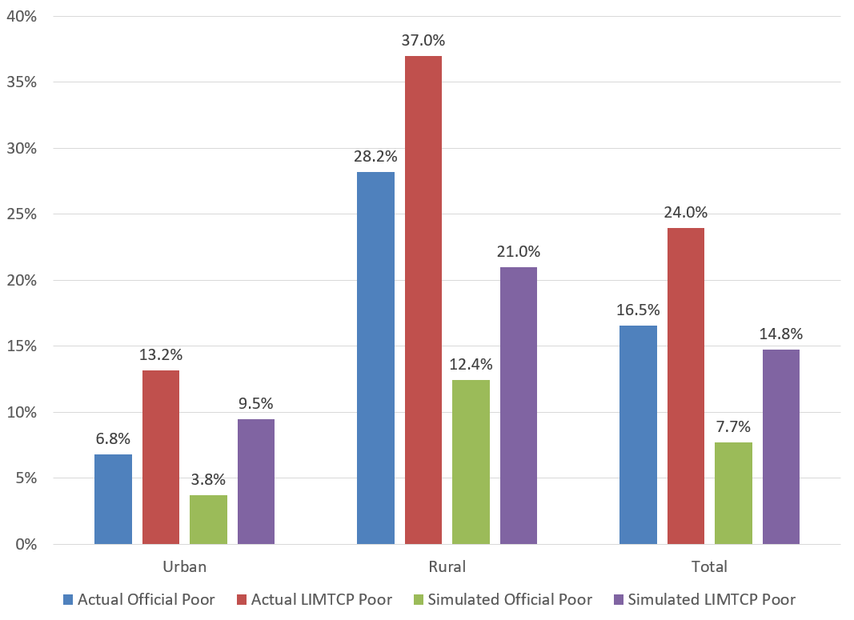

We call the nearly 891,000 households that do not exit consumption poverty as a result of the simulation *hard-core poor* households. In order to see why they are hard-core poor, we first look at the labor force engagement of the eligible adults in these households in Table 6-5. Since the simulation models a transition from whatever job status that eligible adults are currently in (e.g., unpaid family worker) to paid work, we first notice that in 6 percent of hard-core poor households all eligible adults are already working for pay. For these households, a transition to paid employment is not possible and cannot help. In 84 percent of hard-core poor households, all eligible adults are already employed (whether for pay, on the family farm, or in a family business) and would not, according to our model, find it worthwhile to switch to a job that they could potentially get: the lack of jobs with living wages is the decisive factor that locks them into hard-core poverty.

**Table 6‑3 Hard-Core Poor Households, by the Composition of Eligible Adult Labor Force Engagement, Ghana**

|  |  |  |
| --- | --- | --- |
|  | **Number** | **Percentage** |
| **None eligible** | 7,108 | 0.8 |
| **All paid employees** | 54,335 | 6.1 |
| **All employed** | 747,945 | 84.0 |
| **All hard-core poor** | 890,676 |  |

This persistence of consumption poverty in the simulated results can be partly explained by the increase in time poverty among recipient households. Just under three-quarters of all poor employed households are time-poor and in Figure 6-7 we see that 64.9 percent of them would not escape consumption poverty if all eligible adults moved into paid work. Still, just over half (50.5 percent) of time-nonpoor employed households would remain consumption-poor as well. Of those that would escape consumption poverty, roughly one-third of the time-poor remain so and 35 percent of the time-nonpoor become time-poor. Thus, just over 95 percent of the time-poor households remain time-poor in the simulation and 48.5 percent of the time-nonpoor become time-poor. The time poverty rate among households that do not escape consumption poverty in the simulation is 85 percent. Clearly paid work comes with increased time deficits and not enough pay for most people in consumption-poor employed households.

**Figure 6‑7 Simulated Time and Consumption Poverty of Consumption-Poor Employed Households by Actual Time Poverty Status (percent), Ghana**

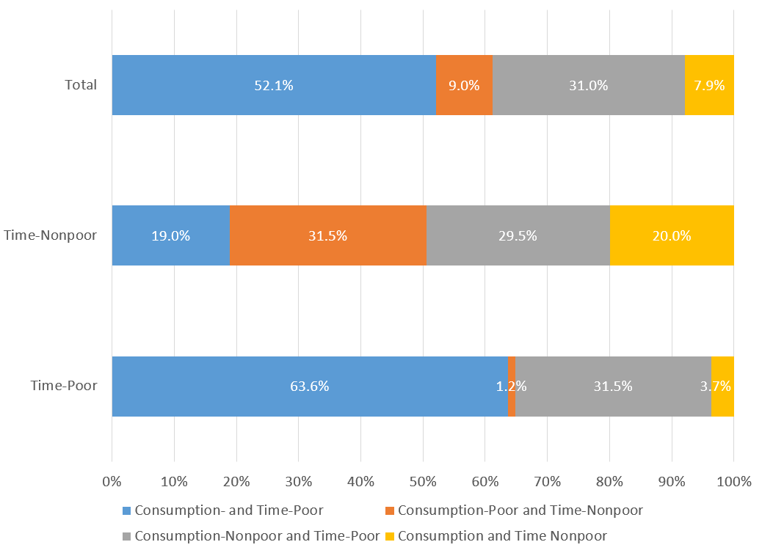

This point is driven home even more when we look at the change in the household time deficits. Table 6-4 shows the average household time deficits and the average value of time deficits for time-poor and all households by time-adjusted poverty status, both in the actual situation and as a result of the simulation. Notice that for households that are poor and time-poor, the value of the time deficit is, on average, nearly half of their current consumption expenditures. This indicates that it would take a substantial increase in their income (and therefore their consumption expenditures) for those households to escape both consumption and time poverty. The impact of the shift to paid work in the simulation is small in these terms. Time deficits increase (by over 4 hours per week), as does the monetary value of time deficits. However, due to the increase in income and consumption as a result of the shift, the value of time deficits is a smaller (though still large) share of household consumption expenditures (39.3 percent). For all poor households, there is an increase in time deficits (6.7 hours per week) and their value was greater, but the value of time deficits as a share of consumption expenditure fell by fewer than 3 percentage points.

**Table 6‑4 Household Time Deficits for Time-Poor and Time-Nonpoor Households, Actual and Simulation, Ghana**

|  |  |  |  |  |  |  |  |
| --- | --- | --- | --- | --- | --- | --- | --- |
|  | | **Actual** | | | **After simulation** | | |
| **Time deficit (average weekly hours)** | **Value of time deficit (annual, cedis)** | **As share of consumption expenditures (percent)** | **Time deficit (average weekly hours)** | **Value of time deficit (annual, cedis)** | **As share of consumption expenditures (percent)** |
| **Time-poor households** | **Nonpoor** | 24.4 | 1,396 | 13.4 | 24.4 | 1,396 | 13.4 |
| **Poor** | 36.4 | 2,029 | 46.8 | 40.5 | 2,253 | 39.3 |
| **All** | 28.3 | 1,603 | 24.3 | 29.7 | 1,676 | 21.8 |
| **All households** | **Nonpoor** | 11.0 | 630 | 6.0 | 11.0 | 630 | 6.0 |
| **Poor** | 26.0 | 1,453 | 33.5 | 32.7 | 1,816 | 30.9 |
| **All** | 14.5 | 822 | 12.4 | 16.1 | 907 | 11.8 |

Finally, we turn to examine the impact of the simulation on recipient households only (see Figure 6-8). A majority of recipient households (61 percent) are estimated to escape consumption poverty. However the time poverty rate among recipient households is considerably higher than before the simulation (82 percent versus 67 percent) and over one-third are both time- and consumption-poor after the simulation. Two-thirds of recipient households that were time-nonpoor were able to escape consumption poverty in the simulation. But almost as many (63 percent) fell into time poverty as a result. Of those that remained consumption-poor, most fell into time poverty (24 percent of the total 33 percent). For previously time-poor recipient households, the simulation was even less helpful. Only 58 percent left consumption poverty and 92 percent remained time-poor. A large proportion of those households that were time- and consumption-poor remained so despite transitioning to paid employment in the simulation (40 percent).

**Figure 6‑8 Simulated Time and Consumption Poverty of Recipient Households by Time Poverty Status (percent), Ghana**

As a whole, these simulations point to a major flaw in the argument for inclusive growth as a poverty-reducing strategy in Ghana that is only revealed when we take time deficits into account. A shift to the kind of paid work that the poor in Ghana are likely to be able to secure would mean greater time deficits and a greatly attenuated impact on poverty due to the need to purchase market substitutes for the additional time deficits. Given the current labor market conditions, there is a major tradeoff between time and income.

## Tanzania

Turning now to the results of the simulation for Tanzania, we again first assess the impact on employed individuals and then on employed households.

### The Impact of Simulated Paid Employment on the Time and Consumption Poverty of Individuals

We first look at the aggregated results for the consumption poverty of all individuals (Figure 6-9). Here we see evidence that large numbers of individuals could move out of consumption poverty via a shift to paid market work: both official and time-adjusted poverty rates fall drastically in the simulation. Note that in Dar-es-Salaam the impact is much smaller than in other urban areas, whereas the impact in rural areas is the largest, in both absolute and relative terms. For Tanzania as a whole, the reduction in poverty rates is heavily influenced by the rural areas, where a large share of the poor population live. It is important to note that despite substantial reductions in poverty (21 and 24 percentage points for official and time-adjusted poverty, respectively), the phenomenon of hidden poverty remains very important, though the rate of hidden poverty has fallen to less than 5.4 percent from 9.1 percent in the actual situation. In rural areas, the drop in poverty rates was 25 percentage points for official and 29 percentage points for time-adjusted consumption poverty. In urban areas, the drop is not as dramatic: 16 and 18 percentage points for official and time-adjusted poverty rates, respectively. In addition, the transition to paid employment seems to have equalized rates of time-adjusted consumption poverty across regions in Tanzania. There is a steep gradient in terms of both official and time-adjusted actual poverty rates when moving from Dar-es-Salaam to urban to rural areas. But the transition to paid employment seems to have done the most to alleviate poverty where it was needed most, at least in terms of time-adjusted consumption poverty. While the LIMTCP poverty rate varies from 16 percent to 42 percent in the actual situation, in the simulation, 10.8 percent of individuals in Dar-es-Salaam remain in time-adjusted consumption poverty but just 13.3 percent remain poor in rural areas.

**Figure 6‑9 Actual and Simulated Official and LIMTCP Poverty Rates for Individuals by Region, Tanzania**

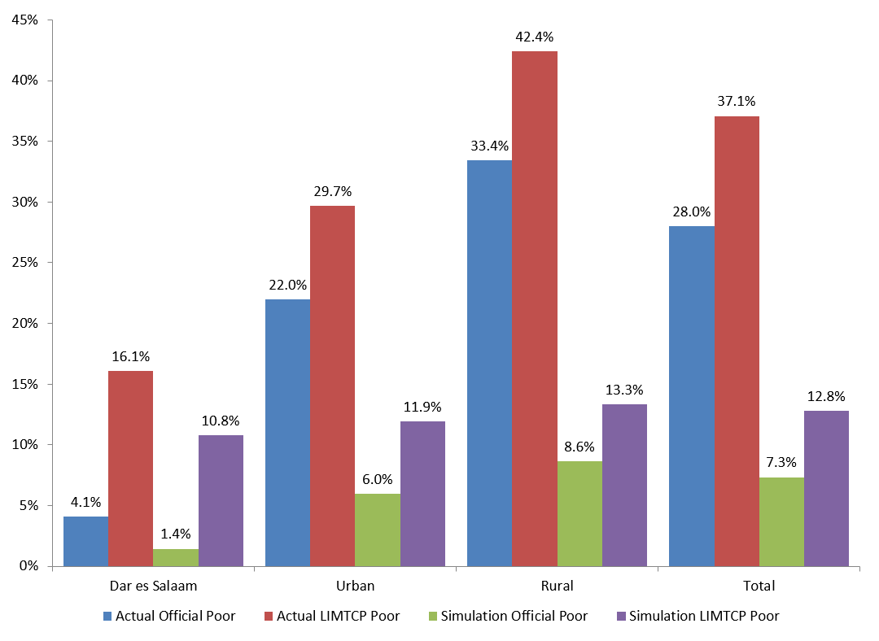

Table 6-5 shows the impact of the simulation on the consumption and time poverty of consumption-poor employed adults in Tanzania. Over two-thirds of employed consumption-poor individuals escaped consumption poverty in the simulation. The time-poor were less likely (63 percent) to escape consumption poverty than the time-nonpoor (72 percent). Most (88 percent) of the time-poor remained time-poor and 40 percent of those who were not time-poor became so. In fact, the simulation increased employed consumption-poor individuals’ likelihood of being time-poor by 14.5 percentage points, from 49 percent to 63.5 percent. Of those that remained consumption-poor in the simulation, the time-poor were very likely to remain time-poor, while nearly one in five of the time-nonpoor became time-poor. So although most employed individuals were in households that escaped consumption poverty, many became (or remained) time-poor in the process.

**Table 6‑5 Simulated Consumption and Time Poverty Status of Consumption-Poor Employed Adults, Tanzania**

|  |  |  |  |  |
| --- | --- | --- | --- | --- |
|  | **Consumption- and time-poor** | **Consumption-poor and time-nonpoor** | **Consumption-nonpoor and time-poor** | **Consumption- and time-nonpoor** |
| **Time-poor** | 35.3 | 1.8 | 52.3 | 10.6 |
| **Time-nonpoor** | 5.0 | 23.1 | 35.2 | 36.7 |
| **Simulation Total** | 19.8 | 12.6 | 43.6 | 23.9 |
| **Actual Total** | 49.0 | 51.0 | 0.0 | 0.0 |

In Figure 6-10, we see the actual and simulated time poverty rates of consumption-poor employed individuals by sex. As noted above, time poverty rates are higher overall in the simulation (by 14.5 percentage points, a 30 percent increase), but they increase more for men (18.7 percentage points, or 53 percent) than for women (10.4 percentage points or 17 percent), both in absolute and relative terms. Although the gap in time poverty rates between men and women has thus been reduced from 26.5 percent to 18.2 percent for those that remain consumption-poor in the simulation, employed women still face significantly higher time poverty rates than their male counterparts.

**Figure 6‑10 Actual and Simulated Time Poverty Rates of Consumption-Poor Employed Individuals by Sex (percent), Tanzania**

In Table 6-6, we present the distribution of simulation job recipients by their actual time poverty and job status. In the THBS, household farm workers were not separated into self-employed and unpaid family workers, so that almost all of the recipients were family farm workers: among time-poor recipients, 99 percent; and among time-nonpoor, 85 percent. Among the time-nonpoor, those not working made up 13 percent of the job recipients in the simulation. Of the time-nonpoor who were working, 98 percent were farm workers. It is noteworthy that most of the adults in consumption-poor households are employed in some capacity (those not receiving jobs were already engaged in paid employment or would not receive a job that made up enough of their current contribution to the household); only 8 percent of recipients in the simulation were not working in any income-generating capacity. As a proportion of potential recipients, we see little difference between time-poor men and women, while time-nonpoor women were slightly more likely to receive job assignments in the simulation than their male counterparts. As a share of employed persons, there is a larger gap by sex, especially among time-poor job recipients: time-poor employed women were nearly 8 percent likelier than time-poor employed men to receive jobs in the simulation. Time-nonpoor employed women were also likelier than their male counterparts to receive jobs in the simulation, though the difference was smaller (just 3.9 percentage points).

**Table 6‑6 Simulation Job Recipients by Actual Time Poverty, Sex, and Job Status, Tanzania**

|  |  |  |  |  |  |
| --- | --- | --- | --- | --- | --- |
|  | **Male** | | **Female** | |  |
| **Time-poor** | **Time-nonpoor** | **Time-poor** | **Time-nonpoor** | **Total** |
| **Not working** | - | 80,953 | 4,895 | 238,199 | 324,047 |
| **Paid employee** | - | 2,626 | 1,391 | 446 | 4,463 |
| **Nonfarm self-employed** | - | 15,345 | 1,401 | 8,902 | 25,648 |
| **Nonfarm family worker** | 1,685 | 14,045 | 9,591 | 10,886 | 36,207 |
| **Family farm worker** | 502,010 | 1,261,667 | 1,246,756 | 767,862 | 3,778,295 |
| **Total** | 503,695 | 1,374,636 | 1,264,034 | 1,026,295 | 4,168,660 |
| **Total as % of potential recipients** | 71.5 | 78.6 | 71.1 | 80.1 | 75.6 |
| **Total as % of employed** | 14.0 | 23.2 | 21.8 | 27.1 | 21.8 |

Next, we break down the changes in consumption and time poverty status for individuals who received jobs in the simulation by actual time poverty status and sex (Figure 6-11). A large majority of job recipients (87 percent) were predicted to help their households escape consumption poverty in the simulation. However, more than two-thirds of these recipients were time-poor. Among those that remained consumption-poor, more than three-quarters were time-poor. A greater share of female than male recipients remained consumption-poor in the simulation (15.3 percent versus 9.4 percent) and the time poverty rates were also higher for female job recipients than for their male counterparts. Four out of five female job recipients were time-poor in the simulation, both among those that escaped consumption poverty and those that did not. For male job recipients, the time poverty rate was higher for those who remained consumption-poor than for those who did not (69 percent versus 62 percent). So for job recipients, the likelihood of leaving consumption poverty is high, but the likelihood of being time-poor is also quite high.

**Figure 6‑11 Distribution of Job Recipients by Sex and Simulation LIMTCP (percent), Tanzania**

Finally, we turn to an examination of the results of the simulation on job recipients by sex and time poverty status in Figure 6-12. The total number of male and female job recipients in the simulation is 1.9 million and 2.3 million, respectively. There is little difference in the likelihood of leaving consumption poverty by the time poverty status of the job recipients: 87.8 percent among the time-poor and 87 percent among the time-nonpoor. The major difference between the two groups is the rate of time poverty among those that leave consumption poverty. For the time-nonpoor, 55.8 percent are in the latter category but become time-poor in the simulation, while for the time-poor, 71.6 percent remain so. Among the job recipients that remain consumption-poor, there is little difference in the time poverty rate between those that were time-poor and those that were not. So 9.4 percent of consumption-poor, time-nonpoor job recipients remained consumption-poor and also fell into time poverty as a result. We saw above the differences between male and female job recipients overall. Here we see that there is a difference between men and women in terms of the breakdown of those that remain consumption-poor in the simulation by their time poverty status. For men, both the share of those that remain consumption-poor and their simulated time poverty rates are similar by prior time poverty status, although for those that escape consumption poverty we see a larger rate of time poverty (by 9 percentage points) among those that were already time-poor. For female job recipients, we again note the higher rate of time poverty overall, but additionally, they are significantly more likely to remain consumption-poor than their male counterparts (nearly twice as likely among the time-nonpoor). Whether they escape consumption poverty or not, female job recipients are much less likely to avoid time poverty than their male counterparts. In fact, time-nonpoor females are less likely to end up neither time- nor consumption-poor than time-poor male job recipients (23.9 percent versus 36.6 percent).

**Figure 6‑12 Distribution of Job Recipients by Sex, Initial Time Poverty Status, and Simulation LIMTCP (percent), Tanzania**

Finally, we examine the impact of the simulation on the time and income poverty of job recipients by their initial time poverty and job status (Figure 6-13). Here we focus on the job status categories that comprise the vast majority of job recipients: farm workers and those not working. Nearly three-quarters of the latter category, although initially time-nonpoor, wound up time-poor as a result of their job assignments. In addition, they were significantly less successful in helping their households escape consumption poverty in the simulation: 77 percent compared to the overall rate of 87 percent. Of the 23 percent that remained consumption-poor almost all became time-poor, while the largest share of these nonworkers (52.3 percent) left consumption poverty but fell into time poverty. Similar shares of time-poor and nonpoor farm workers saw their families exit consumption poverty (87.9 percent and 88.7 percent, respectively). However their rates of time poverty varied significantly. Of those that were time-poor, 9.8 percent remained both time- and consumption-poor, while 71.6 percent escaped consumption poverty but remained time-poor. Of those that were previously time-nonpoor, 7.3 percent remained consumption-poor and fell into time poverty as well, while 56.5 percent traded consumption poverty for time poverty in the simulation. The greatest share of recipients that wound up neither time- nor consumption-poor in the simulation were the time-nonpoor farm workers (32.2 percent), while the smallest share was among the time-poor farm workers (16.2 percent).

**Figure 6‑13 Distribution of Job Recipients by Initial Time Poverty Status, Initial Job Status, and Simulation LIMTCP (percent), Tanzania**

### The Impact of Simulated Paid Employment on the Time and Consumption Poverty of Households

We move on now to a discussion of the impact of our simulation on time-adjusted consumption-poor households. We focus here on employed households (as defined above). As with employed individuals, we see significant reductions in consumption poverty, both by the official poverty measure and by our time-adjusted poverty measure. Overall, official poverty fell by 71 percent (15.2 percentage points) and time-adjusted poverty by 61 percent (19.1 percentage points). Hidden poverty thus fell by 40 percent (3.9 percentage points). While the reductions were evenly spread in official poverty, the same is not the case in terms of time-adjusted poverty. As we saw with individuals, time-adjusted poverty rates fell more in areas that had higher initial rates: a 66 percent drop in rural areas, compared to a 51 percent drop in urban areas and a 20 percent drop in Dar-es-Salaam. By the official measure the range was from a 64 percent reduction in Dar-es-Salaam to a 71 percent reduction in rural areas. This implies that hidden poverty fell relatively more in rural areas then in Dar-es-Salaam or other urban areas, and indeed the smallest decrease was in Dar-es-Salaam (which also had the highest rate of hidden poverty before and after the simulation). Most notably, by our measure, in over 12 percent of households, the hard-core poor (as defined above) could not escape consumption poverty via a transition to paid work.

**Figure 6‑14 Official and Time-Adjusted Consumption Poverty of Employed Households (percent), Tanzania**

These *hard-core poor* households made up 39 percent of the poor households. This indicates a lack of decent paid work opportunities for individuals in many poor households. However, it is also important to emphasize that many of these households had no adults eligible for assignment to jobs in the simulation due to age, disability, etc. (2 percent of hard-core poor households) or already had all eligible adults working for pay (7.4 percent). Over 90 percent of hard-core poor households already had all eligible adults working in some capacity. This last fact implies a lack of productive employment in general, whether for pay or for own consumption.[55]

**Table 6‑7 Hard-Core Poor Households, by the Composition of Eligible Adult Labor Force Engagement, Tanzania**

|  |  |  |
| --- | --- | --- |
|  | **Number** | **Percentage** |
| **None eligible** | 18,794 | 1.9 |
| **All paid employees** | 72,724 | 7.4 |
| **All employed** | 882,524 | 90.1 |
| **All hard-core poor** | 979,649 |  |

The change in time poverty and consumption poverty status for consumption-poor employed households in Tanzania by actual time poverty status is summarized in Figure 6-15. Same-sized majorities of time-poor and time-nonpoor households emerge from the simulation as time-poor only, 60 percent overall. Of course for the previously time-nonpoor this implies an exchange of one deprivation for another, albeit one they have the resources to cover with market purchases. Just over one-third of households were both time- and consumption-poor as a result of the simulation and another 5 percent were consumption-poor only. Just under 2 percent were neither time- nor consumption-poor, and just under 38 percent of time- and consumption-poor households remained both time- and consumption-poor in the simulation. Almost all the rest (60 percent) left consumption poverty but not time poverty. Thus, the bulk of time- and consumption-poor households (98 percent) remained time-poor. Among the consumption-poor but time-nonpoor employed households, 65 percent escaped consumption poverty, but most of these households (60 percent) became time-poor. For those time-nonpoor employed households that remained consumption-poor, most (23 percent of the total 35 percent) remained time-nonpoor as well.

**Figure 6‑15 Simulated Time and Consumption Poverty of Consumption-Poor Employed Households by Time Poverty Status (percent), Tanzania**

Next, we look at the estimated impact of the transition to paid employment on the time deficits of households. The time deficits of the time-poor, consumption-nonpoor households have not changed much, since none of them were a part of the simulation, and the households that became consumption-nonpoor were a small number compared to the total number of consumption-poor. Nevertheless, it is notable that there is a small decrease in the time deficit, although as a share of consumption expenditures, the change was negligible. Time-poor and consumption-poor households have significantly larger average household time deficits (by 12.4 hours or 26 percent) and a correspondingly larger average value of their time deficit. However, as a share of consumption expenditures, the value of time deficits for these households is lower in the simulation.[56] This drives the slight absolute increase in the household time deficits of time-poor households and the small decrease in their share of consumption expenditures. The picture for all households is similar overall, though the increases in time deficits were larger and the reduction in the share of consumption expenditures were smaller overall and for poor households. Households that could not escape consumption poverty did see their consumption expenditures rise, but also saw a significant increase in time deficits.

**Table 6‑8 Household Time Deficits for Time-Poor and All Households, Actual and Simulation, Tanzania**

|  |  |  |  |  |  |  |  |
| --- | --- | --- | --- | --- | --- | --- | --- |
|  | | **Actual** | | | **After Simulation** | | |
| **Time deficit (average weekly hours)** | **Value of time deficit (monthly, TSh)** | **As share of consumption expenditures (percent)** | **Time deficit (average weekly hours)** | **Value of time deficit (monthly, TSh)** | **As share of consumption expenditures (percent)** |
| **Time-poor households** | Nonpoor | 35.5 | 35,382 | 12.7 | 34.8 | 34,814 | 12.6 |
| Poor | 47.2 | 42,405 | 28.7 | 59.6 | 53,112 | 21.4 |
| All | 39.4 | 37,699 | 18.0 | 43.0 | 40,851 | 15.5 |
| **All households** | Nonpoor | 26.3 | 26,179 | 9.4 | 25.9 | 25,906 | 9.4 |
| Poor | 38.2 | 34,302 | 23.2 | 54.7 | 48,375 | 18.9 |
| All | 30.0 | 28,702 | 13.7 | 34.8 | 32,882 | 12.3 |

Finally, we examine the impact of the simulation on those households with job recipients by initial time poverty status (Figure 6-16). Overall, most (83 percent) households were able to exit consumption poverty in the simulation. However the rate of time poverty among these recipient households was 96 percent as a result (compared to 79 percent before the simulation). This result is driven by the time-poor recipient households, of which only 3 percent escaped time poverty. However, 16 percent remained both time- and consumption-poor. Of the time-nonpoor households, 15 percent remained consumption-poor and also fell into time poverty, while 75 percent traded consumption poverty for time poverty. Clearly a transition to paid employment carries with it a heavy price in time poverty.

**Figure 6‑16 Simulated Time and Consumption Poverty of Recipient Households by Time Poverty Status (percent), Tanzania**

The transition to paid employment of individuals in poor households is at best a partial solution to the problem of consumption poverty, once time is incorporated into the picture. More individuals and households fall into rather than escape time poverty as a result of the simulation. This is especially pronounced among women and those who were not already employed in some income-generating capacity. In order to more fully address the needs of people in Tanzania who are living around or below the official poverty line, more than a paid job will be required, at least given what is actually available in terms of paid employment. We will speculate on some possible complementary policies in the conclusion.

# CONCLUSION

Our analysis highlights the importance of time deficits in our understanding of what constitutes poverty. It reveals the prevalence of time deficits in Ghana and Tanzania, although it appears to be a greater concern in Tanzania than in Ghana. In Tanzania, 42 percent of the working-age population is time-poor compared to 27 percent in Ghana. In both countries, time deficits are mostly confined to employed individuals and affect women much more than men. In Tanzania, 61 percent of employed women and 38 percent of employed men are time-poor, while in Ghana 47 percent of employed women are time-poor compared to 23 percent of employed men. The gender difference can be explained by the gender disparity in the division of household responsibilities.

Consequently, accounting for time deficits raises the poverty rate. In Ghana, the adjusted poverty rate among employed persons is 8 percentage points higher than the official poverty rate of 22 percent, representing an increase of nearly a million people to the ranks of the working poor. In Tanzania, it is 10 percentage points higher than the official poverty rate of 26 percent, adding close to two million people to the ranks of the working poor.

Our analysis indicates that providing paid employment reduces official and adjusted poverty rates in both countries, with the drop being more sizable in Tanzania than in Ghana, and is driven by considerable reductions in the poverty rates in rural areas. In Tanzania, the official poverty rate drops by 20 percentage points, whereas the adjusted poverty rate drops by 24 percentage points, reducing the extent of hidden poverty. In Ghana, the official and adjusted poverty rates decrease by 14 percentage points, leaving the extent of hidden poverty unchanged. The stronger drop in the poverty rates in Tanzania brings the new poverty rates as a result of paid employment assignment to rates below those in Ghana.

Our analysis also highlights that the provision of paid employment can increase the incidence and depth of time poverty. In fact, in Tanzania time poverty rates among consumption-poor employed individuals spiked by 14 percentage points as a result of paid employment provision, whereas in Ghana the equivalent increase is close to 5 percentage points. Moreover, the time deficit in Tanzania increases by 4.8 hours compared to 1.6 hours in Ghana. Hence, the already high time deficits grow even more as a result of paid employment provisioning and this growth is stronger in Tanzania than in Ghana.

What enables the considerable decrease in official and adjusted time poverty rates in Tanzania is the increases in consumption made possible by income from paid employment. These increases more than compensate for the value of the additional time deficits, resulting in a sharper drop in the adjusted poverty rate in Tanzania than in Ghana. They are also more pronounced in Tanzania and are driven by a substantially higher share of farm workers among job recipients. Although proportionately more of them in Tanzania become time-poor, a higher proportion also transition out of consumption poverty. This development leads to the considerably stronger reduction in consumption and time poverty in the rural areas of Tanzania compared to the rural areas of Ghana, contributing to the stronger reduction in overall consumption and time poverty in Tanzania.

Nevertheless, our findings highlight that the “buying off” of time deficits may be challenging for many households that are above the adjusted poverty line and exercising that option even for many middle-income families may be viable only by cutting back on other expenditures (e.g., clothing or healthcare) or going into debt. Hence addressing time deficits would require approaches that are universal rather than targeted only at the poor.

Our analysis has strong implications for policies aimed at poverty reduction. It emphasizes the need to account for alleviating not only income but also time constraints. It also has strong gender relevance, as time poverty is more relevant for women due to their disproportionate burden of household responsibilities. Our study argues that policies aimed at improving women’s labor market outcomes can also succeed at improving their well-being only if time constraints facing women are addressed.

In the next phase of the project, we intend to assess the impact of two types of policies that are capable of both generating employment and addressing time deficits. These are investments that improve access to quality social care and physical infrastructure. These policies have the potential to reduce time deficits related to care and domestic responsibilities that stem from the poor state of social and physical infrastructure. We will assess their impact on the official and extended measure of poverty using a combined micro-macro modeling framework.

# REFERENCES

Andridge, Rebecca R., and Roderick J. A. Little. 2010. “A Review of Hot Deck Imputation for Survey Non-Response.” *International Statistical Review* 78(1): 40–64.

Arndt C., L. Demery, A. McKay, and F. Tarp. 2015. “Growth and poverty reduction in Tanzania.” UNU-WIDER Working Paper 2015/051. Helsinki: UNU-WIDER.

Awumbila, Mariama. 2006. “Gender Equality and Poverty in Ghana: Implications for Poverty Reduction Strategies.” *GeoJournal* 67(2): 149–61.

Berndt, E. R. 1996. *The Practice of Econometrics: Classic and Contemporary*. Reading, MA: Addison Wesley.

Budlender, Debbie. 2008. “The Political and Social Economy of Care: Tanzania Research Report 2.” March. Geneva: United Nations Research Institute for Social Development (UNRISD).

Citro, Constance, and Robert Michael (eds.). 1995. *Measuring Poverty: A New Approach*. Washington, DC: National Academy Press.

Collier, P., S. Radwan, and S. Wangwe, with A. Wagner. 1986. *Labor and Poverty in Rural Tanzania: Ujamaa and Rural Development in the United Republic of Tanzania*. Oxford: Oxford University Press.

Elu, J. U., and L. Loubert. 2013. “Earnings Inequality and the Intersectionality of Gender and Ethnicity in Sub-Saharan Africa: The Case of Tanzanian Manufacturing.” *The American Economic Review* 103(3): 289–92.

Eurostat, ILO. 2011.”Working time in the twenty-first century: Report for discussion at the Tripartite Meeting of Experts on Working-time Arrangements.” Conditions of Work and Employment Programme, Report No. TMEWTA/2011. Geneva: International Labour Organization.

Folbre, N. 2009. “Inequality and time use in the household.” In W. Salverda, B. Nolan, and T. M. Smeeding (eds.), *The Oxford Handbook of Economic Inequality*. Oxford: Oxford University Press.

Fontana, Marzia, and Luisia Natali. 2008. “Gendered Patterns of Time Use in Tanzania: Public Investment in Infrastructure Can Help.” Paper prepared for the IFPRI project on “Evaluating the Long-Term Impact of Gender-focussed Policy Interventions.” December. Available at: https://www.ids.ac.uk/files/dmfile/genderedpatternsoftimeuseintanzaniapublicinvestmentininfrastructurecanhelp.pdf

Fontana, Marzia, and Diane Elson. 2014. “Public Policies on Water Provision and Early Childhood Education and Care (ECEC): Do They Reduce and Redistribute Unpaid Work?” *Gender & Development* 22(3): 459–74.

Ghana Statistical Service. 2012. “How Ghanaian women and men spend their time: Ghana Time-Use Survey 2009.” Ghana 2009 Time Use Survey, Main Report. Accra: Government of Ghana. Available at: <http://www.statsghana.gov.gh/nada/index.php/catalog/53>

———. 2014. “Poverty Profile in Ghana (2005-2013): Ghana Living Standards Survey Round 6.” Accra: Government of Ghana. Available at: http://www.statsghana.gov.gh/docfiles/glss6/GLSS6_Poverty%20Profile%20in%20Ghana.pdf

Glewwe, P., and K. A. Twum-Baah. 1991. “The Distribution of Welfare in Ghana.” World Bank Living Standards Measurement Working Paper, No. 75. Washington, DC: World Bank.

Heintz, James. 2005. “Employment, Poverty, and Gender in Ghana.” PERI Working Paper Series, No. 92. Amherst, MA: Political Economy Research Institute (PERI).

Kabeer, Naila. 2012. “Women’s Economic Empowerment and Inclusive Growth: Labour Markets and Enterprise Development.” Supporting Inclusive Growth Program Working Paper 2012/1. Ottawa: International Development Research Centre.

Kim, Kijong, and Rania Antonopoulos. 2011. “Unpaid and Paid Care: The Effects of Child Care and Elder Care on the Standard of Living.” Levy Institute Working Paper No. 691. Annandale-on-Hudson, NY: Levy Economics Institute of Bard College.

Kes, Aslihan, and Hema Swaminathan. 2006. “Gender and Time Poverty in Sub-Saharan Africa.” In C. Mark Blackden and Quentin Wodon(eds.), *Gender, Time Use, and Poverty in Sub-Saharan Africa*. Washington, DC: The World Bank.

Kum, Hyunsub, and Thomas N. Masterson. 2010. “Statistical Matching Using Propensity Scores: Theory and Application to the Analysis of the Distribution of Income and Wealth.” *Journal of Economic and Social Measurement* 35(3–4): 177–96.

Lloyd, Cynthia, B. 1999. “Household Structure and Poverty: What Are the Connections?” In Massimo Livi-Bacci and Gustavo De Santis (eds.), *Population and Poverty in the Developing World*. Oxford and New York: Clarendon Press.

Maertens, Miet, and E. Verhofstadt. 2013. “Horticultural Exports, Female Wage Employment and Primary School Enrolment: Theory and Evidence from Senegal.” *Food Policy* 43(December): 118–31.

Masterson, Thomas N. 2010. “Quality of Match for Statistical Matches Used in the 1992 and 2007 LIMEW Estimates for the United States.” Levy Institute Working Paper Working Paper No. 618. Annandale-on-Hudson, NY: Levy Economics Institute of Bard College.

———. 2012. “Simulations of Full-Time Employment and Household Work in the Levy Institute Measure of Time and Income Poverty (LIMTIP) for Argentina, Chile, and Mexico.” Levy Institute Working Paper No. 727. Annandale-on-Hudson, NY: Levy Economics Institute of Bard College.

———. 2013. “Quality of Statistical Match and Simulations Used in the Estimation of the Levy Institute Measure of Time and Consumption Poverty (LIMTCP) for Turkey in 2006.” Levy Institute Working Paper No. 769. Annandale-on-Hudson, NY: Levy Economics Institute of Bard College.

———. 2016. “Simulations for Individuals in LIMTCP Consumption-poor Households in Tanzania and Ghana, 2012.” Levy Institute Working Paper No. 871. Annandale-on-Hudson, NY: Levy Economics Institute of Bard College.

McKay, A., J. Pirttilä, and F.Tarp. 2015. “Ghana: Poverty reduction over thirty years.” UNU-WIDER Working Paper 2015/052. Helsinki: UNU-WIDER.

Mueller, Bernd E. T. 2015. “Tanzania’s Rural Labour Markets: The Missing Link between Development and Poverty Reduction.” InCarlos Oya and Nicolas Pontara(eds.), *Rural Wage Employment in Developing Countries: Theory, Evidence, and Policy*. New York: Routledge.

National Bureau of Statistics (NBS) (Tanzania). 2014. “Tanzania Household Budget Survey 2011/12.” Dar-es-Salaam, Tanzania: National Bureau of Statistics. Available at: http://www.nbs.go.tz/nbstz/index.php/english/statistics-by-subject/household-budget-survey-hbs/367-household-budget-survey-main-report-2011-12

Orcutt, Guy H. 1957. “A New Type of Socio-Economic System.” *The Review of Economics and Statistics* 39(2): 116–23.

Osei-Boateng, C., and E. Ampratwum. 2011. “The informal sector in Ghana.” Accra: Friedrich Ebert Stiftung. Retrieved April 14, 2014, from http://library.fes.de/pdf-files/bueros/ghana/10496.pdf.

Rios-Avila, F. 2016. “Quality of Match for Statistical Matches Used in the Development of the Levy Institute Measure of Time and Consumption Poverty (LIMTCP) for Ghana and Tanzania.” Levy Institute Working Paper No. 873. Annandale-on-Hudson, NY: Levy Economics Institute of Bard College.

Rizzo, Matteo, Blandina Kilama, and Marc Wuyts. 2015. “The Invisibility of Wage Employment in Statistics on the Informal Economy in Africa: Causes and Consequences.” *Journal of Development Studies* 51(2): 149–61.

Rohaly, Jeﬀrey, Adam Carasso, and Mohammed Adeel Saleem. 2005. “The Urban-Brookings Tax Policy Center Microsimulation Model: Documentation and Methodology for Version 0304.” Research Report. Washington, DC: Tax Policy Center.

Short, Kathleen, and Timothy Smeeding. 2012. “Understanding Income-to-Threshold Ratios Using the Supplemental Poverty Measure: People with Moderate Income.” Poverty Measurement Working Paper. Washington, DC: US Census Bureau.

United Nations, European Commission, International Monetary Fund, Organisation for Economic Co-operation and Development, and World Bank. 2009. *System of National Accounts, 2008*. New York: United Nations.

Van den Broeck, Goedele, and Miet Maertens. 2015. “Female Employment Reduces Fertility in Rural Senegal.” *PLOS ONE* 10(3): e0122086.

Zacharias, A. 2017. “Measurement of Time and Income Poverty.” In I. Hirway (ed.), *Mainstreaming Unpaid Work: Time-use Data in Developing Policies*. New Delhi: Oxford University Press.

Zacharias, Ajit, Thomas Masterson, and Kijong Kim. 2009. “Distributional Impact of the American Recovery and Reinvestment Act: A Microsimulation Approach.” Working Paper No. 568. Annandale-on-Hudson, NY: Levy Economics Institute of Bard College.

Zacharias, A., R. Antonopoulos, and T. Masterson. 2012. “Why Time Deficits Matter: Implications for the Measurement of Poverty.” Levy Institute Research Project Report. Annandale-on-Hudson, NY: Levy Economics Institute of Bard College.

Zacharias, A., T. Masterson, and E. Memis. 2014a. “Time Deficits and Poverty: The Levy Institute Measure of Time and Consumption Poverty for Turkey.” Levy Institute Research Project Report. Annandale-on-Hudson, NY: Levy Economics Institute of Bard College.

Zacharias, A., T. Masterson, and K. Kim. 2014b. “The Measurement of Time and Income Poverty in Korea.” Levy Institute Research Project Report. Annandale-on-Hudson, NY: Levy Economics Institute of Bard College.

1. Our basic concern is that we should have information regarding household production by both spouses (partners) in married-couple (cohabitating) households, and information on older children, relatives (e.g., aunt), and older adults (e.g. grandmother) in multi-person households.
2. The GLSS was spread out over a year, between October 18, 2012 and October 17, 2013.
3. The survey was conducted between October 1, 2011 and October 12, 2012.
4. It should be noted that 10 hours per week was substantially less than the median value of the time spent on leisure (sum of time spent on socializing, cultural activities, entertainment, sports, hobbies, games, and mass media) in Ghana (by approximately 8 hours) and slightly more than the median value in Tanzania (by roughly one hour).
5. Part A, Section 4, Question 1, GLSS 6 Questionnaire. Supplementary questions seek to identify if the person was an apprentice or temporarily absent from employment during the reference period.
6. Form III, Section 12, Questions 4 through 8, HBS 2011–12 questionnaire.
7. Alternatively, we could have, in principle, treated the collection of water and firewood as unpaid family work. This would impose the substantial cost of compromising the compatibility of our estimates of the characteristics of the employed population with official estimates and hence we did not pursue this alternative.
8. One record that had both industry and occupation missing was given the modal industry and occupation couple.
9. Equivalence scales are generally used to account for differences in needs among households based on their size and composition. A system of weights can be applied according to which each individual counts as some fraction of a reference group, such as a working-age male. Weights can be further adjusted to account for scale economies. The equivalence scales employed in Ghana are based on the 10th Edition of the National Research Council’s Recommended Dietary Allowances (Ghana Statistical Service 2014). The equivalence scales employed in Tanzania are based on Collier et al. (1986) (National Bureau of Statistics of Tanzania 2014).
10. International Standard Classification of Occupations (ISCO) codes: 5121, “house stewards and housekeepers”; 5122, “cooks”; 5123, “waiters and bartenders”; 5132, “cooks, domestic”; 5133, “housemaids”; 5141, “child care workers”; 5149, “other personal care workers”; 9131, “domestic helpers and cleaners”; 9132, “helpers, cleaners and related workers”; 9133, “hand launderers and pressers”; and 9140, “building caretakers and window cleaners.”
11. A geographical classification similar to what we used for Tanzania could be employed, but, unlike for Tanzania, such a classification does not seem to be generally used in research on Ghana.
12. To identify domestic workers we first identified individuals who identified their main occupation as: 5120, “cooks”; 5131, “waiters”; 5132, “bartenders”; 5141, “hairdressers”; 5142, “beauticians and related workers”; 5151, “cleaning and housekeeping supervisors”; 5152, “domestic housekeepers”; 5153, “building caretakers”; 5162, “companions and valets”; 5169, “personal services workers not elsewhere”; 5249, “child care workers”; 5322, “home-based personal care workers”; 9111, “domestic cleaners and helpers”; 9121, “hand launderers and pressers”; 9122, “vehicle cleaners”; 9129, “other cleaning workers”; and 9613, “sweepers and related labourers”; and their industry as 9700, “activities of households as employers of domestic personnel.” This resulted in 44 observations for all of Ghana.
13. Effective monthly hours were calculated by multiplying the weekly hours of time deficit by four and then adding two-sevenths of the estimated weekly hours to sum to 30 days.
14. Annual hours were calculated by multiplying the weekly hours of time deficit by 52. Daily poverty lines are also available in the GLSS and this represents an alternative way to measure poverty that would, however, lead to essentially the same results as using the annual estimates.
15. The very small rate of time poverty among nonemployed women results exclusively from the higher burden of household production that falls upon them. An earlier study using the framework used here found that in Argentina, Chile, and Mexico, time poverty among nonemployed women, especially women in consumption-poor households, was much higher than the miniscule incidence among Ghanian women (Zacharias, Antonopoulos, and Masterson 2012: Table 4-2).
16. 51.3 percent of self-employed or unpaid family workers worked part time in rural areas, compared with 37.8 percent in urban areas (based on the authors’ calculations of data from the GLSS [2012]).
17. Latest available data for other African countries suggest that the incidence of excessive hours in Ethiopia, Morocco, Nigeria, and South Africa are, respectively, 40, 55, 43, and 25 percent of all employed people (Eurostat and ILO 2011: Figure 10).
18. This information was obtained from the ILO’s “The Database of Working Time Laws,” available at www.ilo.org/

    travdatabase.
19. It is important to note that the urban-rural difference in time poverty is reckoned hereafter by controlling for hours of employment. On average, the time poverty rate is higher in the urban than in rural areas because relatively more workers are found in the higher brackets of hours of employment in the urban than in rural areas.
20. Roughly 90 percent of male and female unpaid workers were employed in agriculture. It appears that males bear this status by and large during their youth, while for women it may very well be over their entire employed life. This is reflected in the huge gap in the average age by sex among these workers: 21 years for men versus 31 years for women. The age gap suggests that the difference in their hours of employment reflects the greater responsibilities that fall upon the older women in the running of the household farm compared to the younger men.
21. It may be recalled that we used the same procedure to diagnose the contrast between female paid employees and nonwage workers earlier (see the discussion following Figure 4-6).
22. As noted before (see footnote 13), a very small proportion of nonemployed women encountering a rather higher burden of household production experience time poverty. The proportion of such women was slightly higher in Tanzania than in Ghana.
23. Information on statutory limits on the workweek was taken from the ILO “Conditions of Work and Employment: Tanzania, United Republic of—Working time—2011” database, available at: http://www.ilo.org/dyn/travail/travmain.sectionReport1?p_lang=en&p_countries=TZ&p_sc_id=1001&p_year=2011&p_structure=2
24. Average number of adults in the rural and urban areas was, respectively, 2.18 and 2.13; average number of children, 2.04 and 1.60; and household size, 4.22 and 3.72. Note that these estimates are based on a subsample of households in which there was at least one employed person between the age of 15 and 70 years.
25. The formula will not hold *exactly* if all the employed persons do not live in employed households. But, as we have just noted at the start of this section, the vast majority do so in our case and hence the discrepancy would be tiny.
26. Consider the extreme case where all employed households are time-poor. In this case, the ratio will have the average number of employed persons in the numerator and the average number of time-poor employed persons in the denominator. For the ratio to be equal to one, every employed person in every household must be time-poor—an implausible scenario. In actual practice, neither is every employed person in every time-poor household likely to be time-poor nor is every employed household likely to be time-poor. Hence, the ratio would necessarily be greater than one.
27. Employed households made up 91 percent of the 6.43 million households in Ghana that were included in our study. Almost all employed persons (97 percent) lived in employed households.
28. Let be the total number of households, the total number of “hidden poor” households, and the total number of officially nonpoor households who are time-poor. Further, let and represent, respectively, the official and LIMTCP poverty rates. Then: .
29. For Ghana as a whole, 44 percent of all households were officially nonpoor, but time-poor. Of these households, 17 percent were hidden poor.
30. It is noteworthy that the poor-nonpoor gap in the time poverty rate among employed individuals was relatively smaller, at 7 percentage points (41 percent versus 34 percent; see Table 4-3).
31. By “social infrastructure” we mean facilities that provide for the care of persons (e.g., early childhood education centers). For a discussion of links between such infrastructure and unpaid care work, see, inter alia, Fontana and Elson (2014) and Kim and Antonopoulos (2011).
32. The categories are: alcohol and tobacco, clothing and footwear, housing (excluding rent), furnishing, health, transportation, communication, recreation, education, restaurants and hotels, and miscellaneous.
33. As is often the case with household survey data, the relationships that can be readily constructed are based on the relationship of each individual in the household to the head of the household. In conjunction with the convention of designating the husband as the head of household whenever a spouse is present, most household surveys pose several challenges for feminist economic analysis. Another difficulty is that the boundaries between households are rather fluid in terms of sharing nonmonetary resources, such as time, in many contexts.
34. It should be noted that as in many countries the head in a married-couple household in Ghana is almost always the husband. We define an “extended-family adult” as an adult (18 years or older) who has one of the following types of relationships to the head of the household: grandchild, parent or parent-in-law, son-in-law or daughter-in-law, or other relative.
35. We considered distinguishing households headed by a single person, especially single-female-headed households, on the basis of the presence of extended-family adults. However, that would have resulted in too many groups and consequently some groups with too few observations in the sample to produce reliable statistics. We do consider the effects on time poverty of the presence of extended-family adults in single-female-headed households with children later on in this section.
36. Studies from early 1990s onwards have arrived at a similar conclusion regarding the lower poverty rate of female-headed households. Ghana thus appears to be among the exceptions to the “general” rule of female headship being associated with greater vulnerability to poverty (see, e.g. Awumbila [2006, 152]).
37. We are considering separately only the three major groups of households with children for this analysis since they constitute the vast majority of consumption-poor households; the remaining households are grouped in the residual category of “Other households.”
38. In Ghana, the employment rate of wives is quite high (88 percent) in employed households. The so-called “male-breadwinner” type of household is conspicuous by its absence. Approximately 97 percent of all husbands in employed households are also employed.
39. Virtually all households included in our Tanzanian sample were employed households. They made up 98 percent of the 8.27 million households.
40. In Tanzania as a whole, 62 percent of all households were officially nonpoor, but time-poor. Of these households, 15 percent were hidden poor.
41. We are using the term “nuclear” rather loosely, for the group so characterized here may have extended-family members below the age of 18.
42. Compared to Ghana, the household structure in Tanzania appears to be skewed more toward married-couple households with children and less toward households with children headed by a single female.
43. This is exactly the procedure that we followed for Ghana.
44. The employment rate of wives in employed households in Tanzania is 87 percent. Thus, just as in Ghana, the so-called “male-breadwinner” type of household is rather rare.
45. Unlike in Ghana, there is no pronounced difference between the poor and nonpoor wives.
46. From Section 4, part A, question 20 of the GLSS 6: “What was the status of (NAME) in this job?”
47. From Section 12, question 10a of the HBS 2012: “Which of these activities is [NAMES] primary activity?”
48. The five categories are: less than 18 years old, 18 to 24 years old, 25 to 44 years old, 45 to 64 years old, and 65 or older.
49. We assume here that the relationship between operating costs (inputs) and family labor inputs is linear.
50. Less than 25 years old, 25 to 34 years old, 35 to 54 years old, and 55 and older.
51. Income share is included to reflect changes in bargaining power within the household and its impact on the distribution of household production work.
52. For details about the results of the stages of the simulation, see Masterson (2016).
53. Note that for 107 household records (representing about 35,000 households), consumption expenditures after the simulation were lower than the actual level by an average of 465 cedi, or about 9 percent.
54. Note that the universe of employed households is expanded in the simulated results: an additional 68,000 households are classified as employed, raising the total from 5.83 million to 5.9 million of the 6.4 million households in Ghana. Figure 6-6, however, includes only those households that are actually employed.
55. Nevertheless, the average poverty gap among hard-core poor households fell by 23 percent in the simulation.
56. Note that this might be considered a lower bound for the share of consumption expenditures in the simulation, since we assume that all of the change in income for the household is added to household consumption expenditures.